

Greetings Blazeman Warriors!

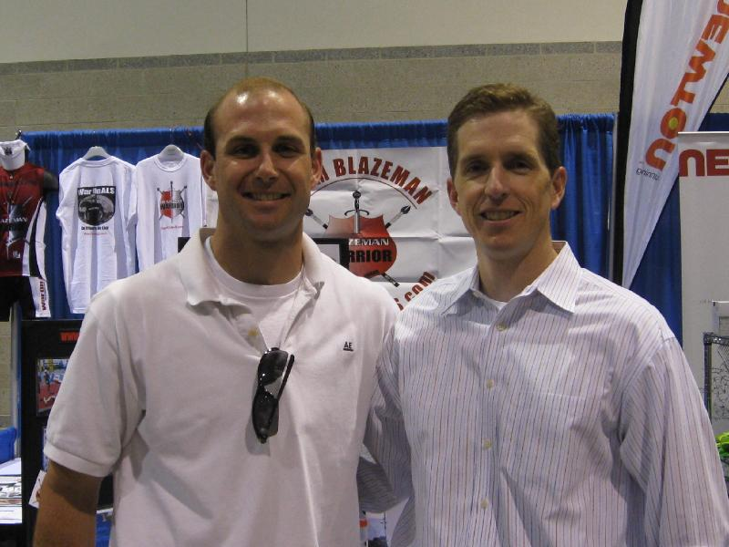
July has been a very busy month...as I sit here writing this letter with my feet up after spending the beautiful weekend at the Amica Prov. 70.3 meeting so many new people and old friends at the expo and race. The sun has finally come out here in Southeastern New England!! I can't believe we are already in the middle of summer and we have not had a 90 degree day.
The local paper and NBC affiliate channel 10 did a great job promoting Jon and the Blazeman foundation. Check out a great story online here and a video by clicking here. Our local weathermen and Blazeman Warriors Matt Lagor from Channel 6 and Mark Searles (photo left) from Channel 10 rolled the finish with pride.
Bob Vigorito(Vigo), our Captain wore #179 in Jon's honor and also looked great rolling across the finish. Vigo was interviewed on channel 10 along with Mark Searles...please check out the video...they did such a super job!!
For Bob and I each expo and race we attend gives us new resolve...we love meeting you all and hearing your stories. All the pictures in this newsletter are from the Prov. 70.3...you will see more throughout the year. Our other warriors competing were Rob Duguay, Derek Oberg, Jerry Nista, Mike Mathers and Thomas Simmons...thank you all!
I want to take a moment to welcome new Blazeman Warriors...Ben Mix, Wendi Platt and Brian Hoppy. Welcome to the War on ALS.
I hope you all got to see our ad with Chrissie in the August issue of Triathlete Magazine...what a beautiful ad and beautiful smile. Jon would have loved it! A special thanks to Brad and Oliver for a job well done and very appreciated...I can't thank you enough. Keep you eye out for the next ad...I am not letting on who is in it...you have to check it out.
August will bring us to Timberman in New Hampshire...a race we have not been to yet but have heard such wonderful things about. Please email me if you will be there and stop by our expo booth. Until we meet at a race...
Fondly,
Mary Ann Blais
Jon's Mom
Blazeman Foundation for ALS

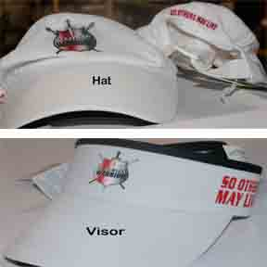
Get your Blazeman Gear!
Polos, Fleece, Pullovers, Hats and more! And be sure to check out the NEW long-sleeve t-shirts!
Shop our estore today, click here!
And no warrior outfit is complete without our titanium bracelet. Wear yours with the vow that it will not be removed until the day there is a cure for ALS.
Start the 2009 season off right. Buy yours today! Clickhere!
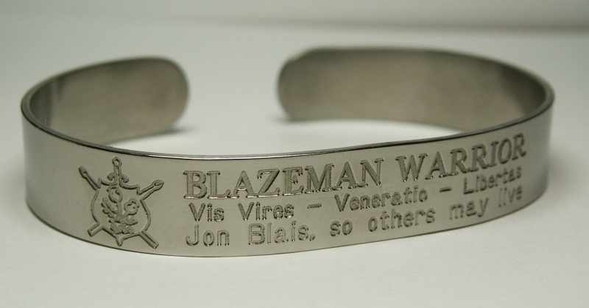

A Warm Welcome to our newest Warriors!
We are pleased to welcome the following newest warriors to our family. Thank you, and everyone else, for all you do to help our mission.
Ben Mix
Wendi Platt
Brian Hoppy

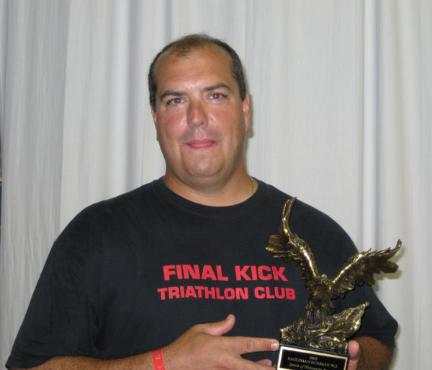
Blazeman Spirit Award Update
The Blazeman Spirit Award (BSA) recognizes an individual who has learned to overcome obstacles and became stronger through hard work and determination, inspires others to become a better person, leads by example, and has a passion for the journey of life.
Congratulations to
Cris Miller of Virginia Beach for
receiving the 2009 Blazeman Spirit Award at Eagleman Ironman 70.3.
Click here to visit our site and read more about Cris.

Photo Gallery
The 2009 season is well under way! Please keep sending your photos! We love hearing your stories and seeing you in action!
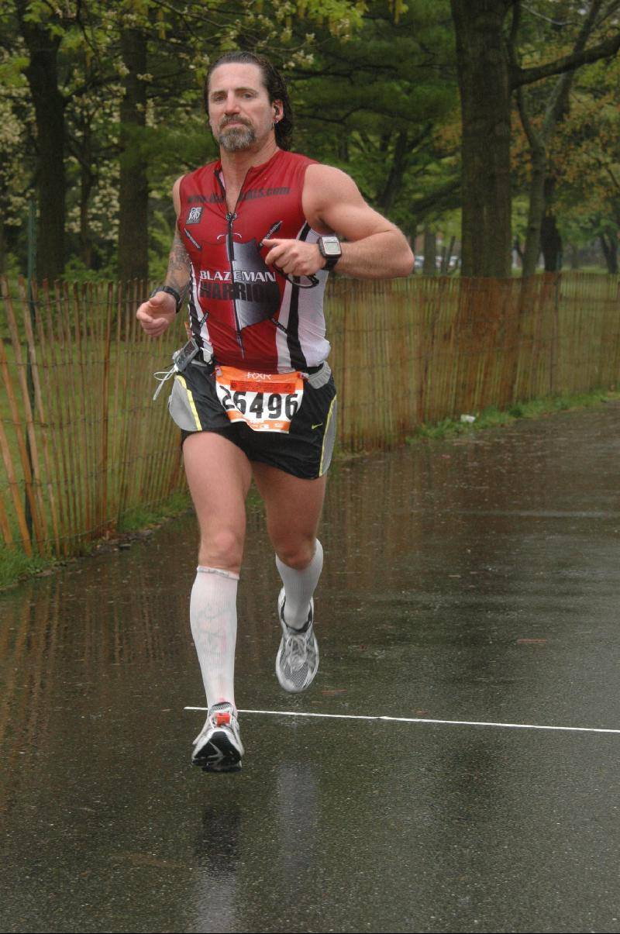
Sean McCarthy at Long Island Marathon
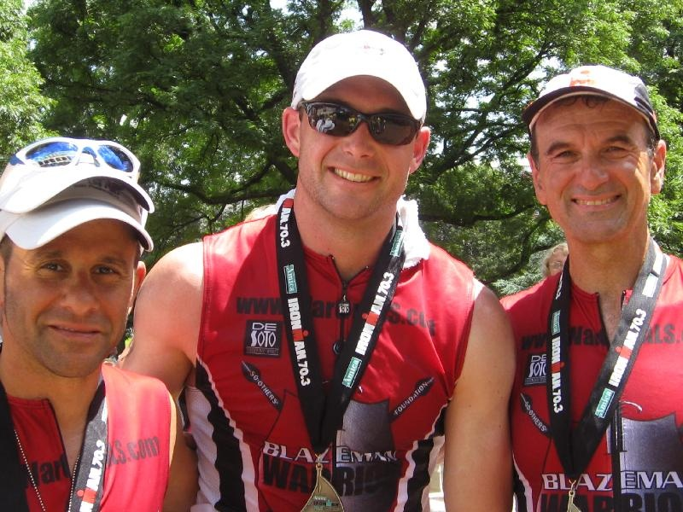
Jerry Nista, Matt Lagor and Bob Vigorito(Vigo) at Providence 70.3
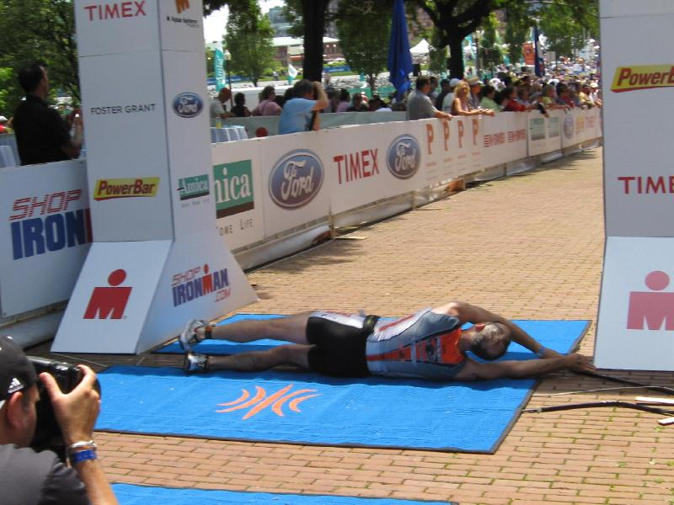
Tom Simmons rolls at Providence 70.3
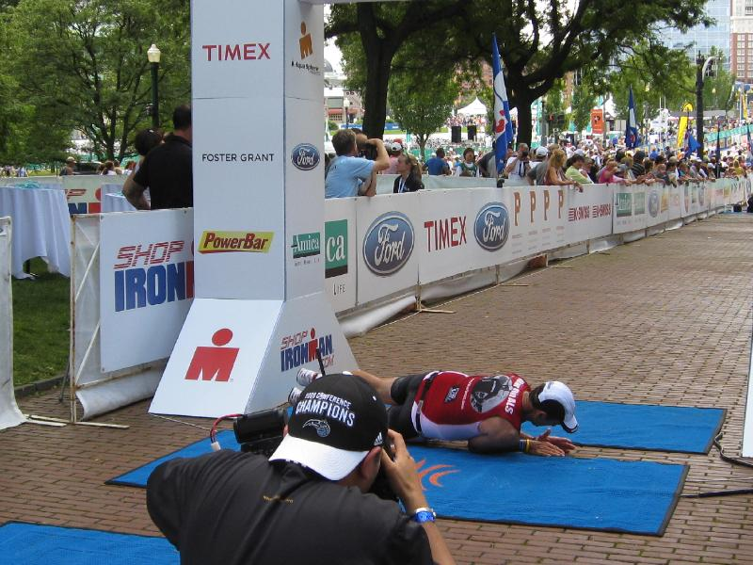
Vigo also rolling at Providence
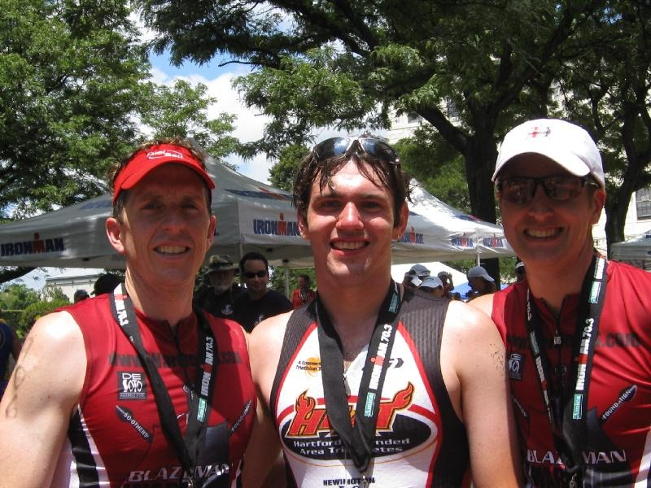
Mark Searles, Rob Duguay and Derek Oberg at Providence 70.3
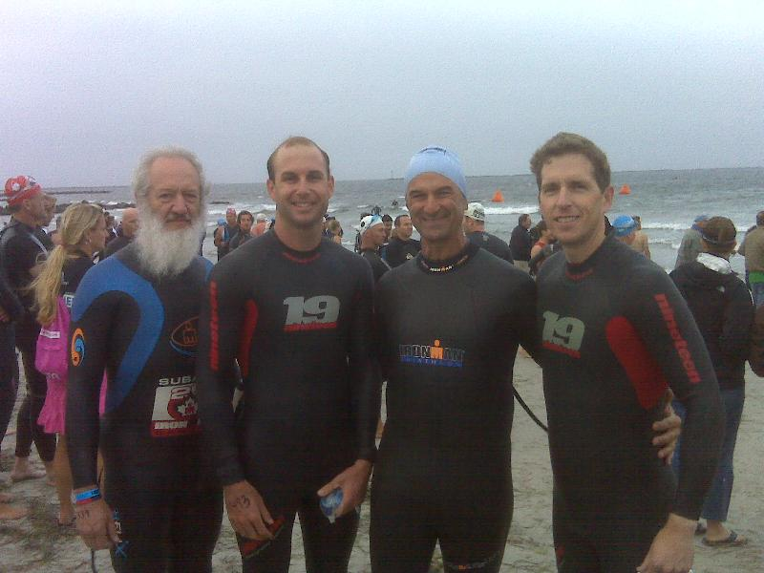
Mike Mathers , Matt Lagor, Bob Vigorito and Mark Searles at the start of Providence 70.3

