
June/July 2008

 | Blazeman Warriors,  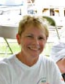  It has been a busy (and hot) summer for our warriors. The Foundation went to Eagleman Ironman 70.3 where Vigo and CTA extended their wonderful hospitality. We met many triathletes at the expo and presented Mike Lahey with the Blazeman Spirit Award. The race day weather was blistering hot; the medical tent was constantly full. We thanked all those who raced and rolled including Dede Griesbauer who finished second for the women and rolled her second race of the season. Jon's story continues to inspire so many.  Ironman Coeur D'Alene was also held in June up north and Blazeman Warrior Chris Parker had the honor of wearing #179 coming across the finish line with a roll in great time. Our Canadian Warrior Poet, Ryan Van Praet also finished while training for Kona this year where he will be a highlight for sure!  Again, thanks to all our warriors and please keep the correspondence and pictures coming. We love hearing your stories and seeing your pictures.  With strength, honor and affection,  Mary Ann Blais  Jon's Mom  Blazeman Foundation for ALS  Warriors of the Month-Meet the Ryan Family!  By Paul Fahey  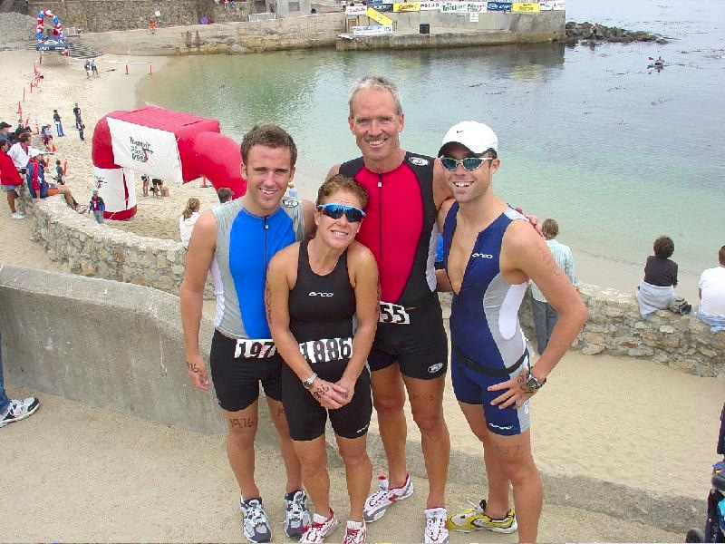  From L-R: Kyle, Dana, John and Keith  This month's Warrior of the Month is a bit different than most others. In the past, we've profiled individuals who truly embody the spirit of the Blazeman Foundation. Well, this month we're proud to introduce you to an entire family of four Blazemen! Meet the Ryans: John, Dana and their sons Keith and Kyle.  Triathletes for more than ten years, the Ryans like many of us, first heard the Blazeman's story in 2005 with the coverage of his race at Kona. Keith had been training for an upcoming IM race and having some pain. Jon's story helped him train through that pain and go on to a successful season. A year went by and they found themselves watching the 2006 coverage of Kona. Jon was profiled again, but this year in a wheelchair. A few days later while on a training ride together, John's son turned to him and said, "Dad, I've been thinking about Jon's story and, well, we've got to do something." They thought about it. Talked about it. Mapped it out and just did it. And so, in 2007, the OC Blazeman Triathlon was born. (For more about this event, read our coverage below). The race is in its second year, with more than three times the number of participants this year, raising more than $9,000 for the Blazeman Foundation.  The Ryans are no strangers to philanthropy through sporting events. In fact, they've produced and raced in a number of events that have raised thousands for the Challenged Athletes Foundation, the American Cancer Society and Multiple Sclerosis. John Ryan remarked, "it's nice to train hard and perhaps get a podium spot. But for us, being a Blazeman Warrior is an opportunity to train hard for a cause that's bigger than yourself. A real purpose rather than working to shave a few seconds off your time."  What's next for the Ryan's? Well, it's almost a year away but they're already planning for the 2009 OC Blazeman event. And John even has a few other ideas for events that will really make a splash (literally) and help raise awareness and introduce others to the Foundation.  John, Dana, Keith and Kyle; we are proud to have you on our team and grateful for your dedication to the cause. You train and race with integrity and passion, and in strength & honor.  The Blazeman Spirit Award and Update from Eagleman Ironman 70.3  By Jennifer Murphy  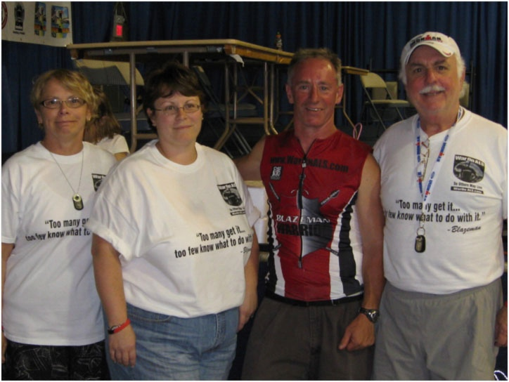The 2008 Blazeman Spirit Award was presented to Mike Lahey of Salisbury, Maryland on Saturday, June 7th during the pre-race forum at the Eagleman Ironman 70.3. Mike was nominated by his friend, Jay DeBerardinis. Mike is known for his sparking personality, contagious excitement and for drawing people to the sport of triathlon who may never have dared to venture into the world of multi-sport. He has a gift for getting others to step out and go places they would not normally go alone. Congratulations Mike!  The Blazeman Spirit Award is given out annually at the Eagleman Ironman 70.3 and recognizes an individual who inspires others to better themselves, leads by example, and has a passion for the journey of life. For more information regarding this award, to read about past BSA winners, and to see when nominations for the 2009 award will be accepted please click here.  Also at Eagleman 70.3...  This year, the heat and humidity proved to be the toughest challenge for triathletes at the 17th annual race held in Cambridge, Maryland. The 1.2-mile swim began in the Choptank River with over 1500 athletes. Swim conditions were favorable, with water temperatures in the mid-70's but the 83-degree air temperature quickly climbed as racers transitioned to the bike. "Today was the toughest day in Eagleman history," said the finish line announcer. Race director Robert Vigorito said the 97% humidity made conditions Kona-like. In fact, a tractor-trailer transported over 25,000 pounds of ice to the event! Congratulations to all of the Blazeman Warriors who competed that day, including Pro Dede Griesbauer (below) who rolled to a second place finish!  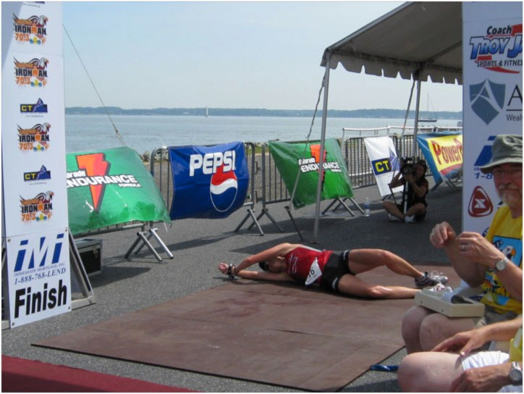  A Tribute to Jon  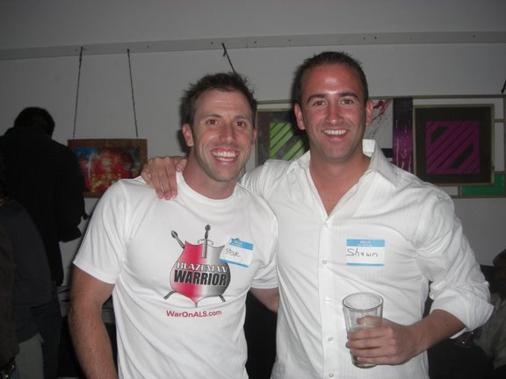  On May 30th, Steve Perunovich-Jon’s friend, neighbor and Warrior- hosted an event in San Diego celebrating Jon's life. And what an incredible job he did putting it together. Every attention to detail was solid and he was so respectful to Jon with the care and elegance he put into his work.  The evening was what you might expect: friends gathered to share stories and, in the process, help raise over $1,600 for the Foundation. Many Thanks to Brad Culp who helped secure items for the raffle that night. There was music, laughter and tears. But the most remarkable moment came when everyone watched the video of Jon.  Shawn Mahoney described it by saying, "The power of the story just grabbed people. It took them in and made them apart of the cause, the movement. It was perhaps the most incredible 10 minutes I'd seen in recent memory. It's kind of like what Curt Schilling said...silence in Yankee Stadium is more moving than cheers at Fenway. You could cut the tension in the room with a knife. Everyone was moved, and once again, watching the footage, tears came to my eyes."  Thinking back on the event, Shawn Mahoney remarked, "One thing is for sure, the Spirit of Blazeman is alive, well, and stronger than ever before. But most importantly, growing." Thanks to people like Steve, yes. Yes it is. Thank you.  Photo Gallery  Just a few photos submitted by your teammates from  recent events. Keep 'em coming!  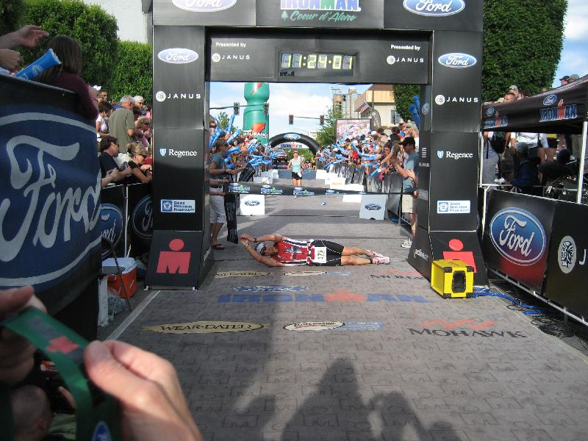  Chris Parker with a perfect roll at Ironman Coeur d'Alene.  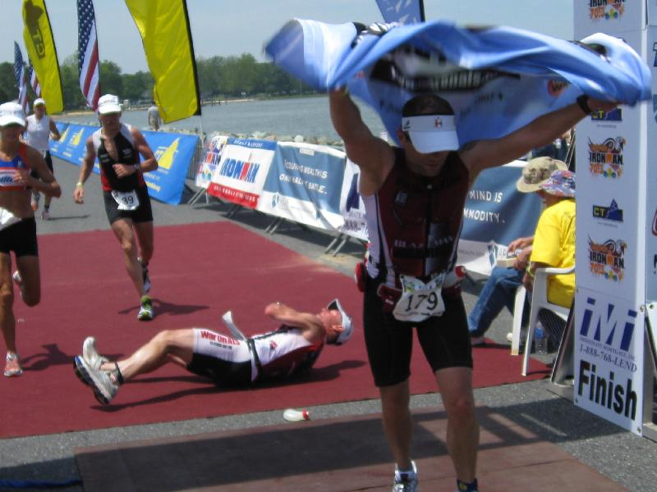  Dick Volpe with the Blazeman Foundation Flag and look! That's Mike Lahey rolling behind him.  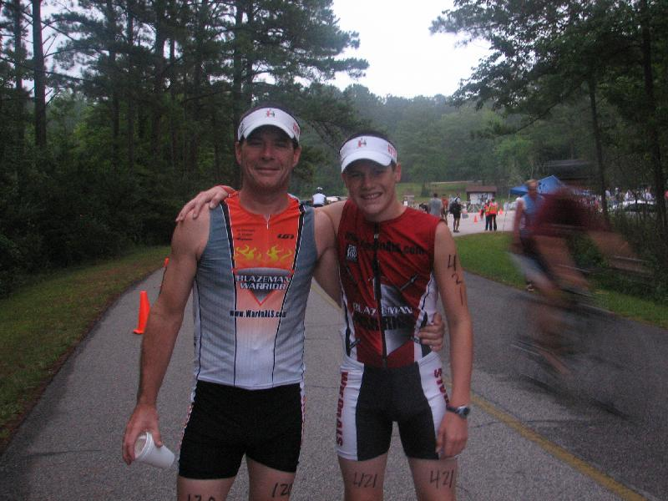  Mike and Brian Duffy at Westpoint Lake Tri  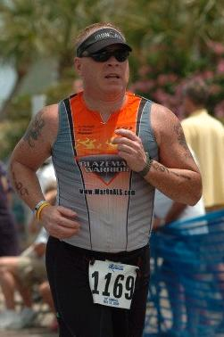  Great shot from David Knight at the Gulf Coast Half.  Update from the Battlefield - Nanticoke  On May 4, 2008, 220 athletes participated in the inaugural Nanticoke River Swim and Triathlon in Bivalve, MD. This multi-sport festival was inspired by one of our own. Nancy Sterling of the Delmarva Dogfish has been an inspiration to many friends as a nationally ranked Masters Swimmer. After years out of the pool, Nancy returned to swimming and inspires others with her love of life and sport.  Sadly, today Nancy is in the fight of her life battling ALS. This past May, Nancy swam at the YMCA Nationals in Ft. Lauderdale, FL. Her times have slowed, but she was beautiful and just as Jon Blais did, she used the occasion to selflessly call attention to a horrible disease.  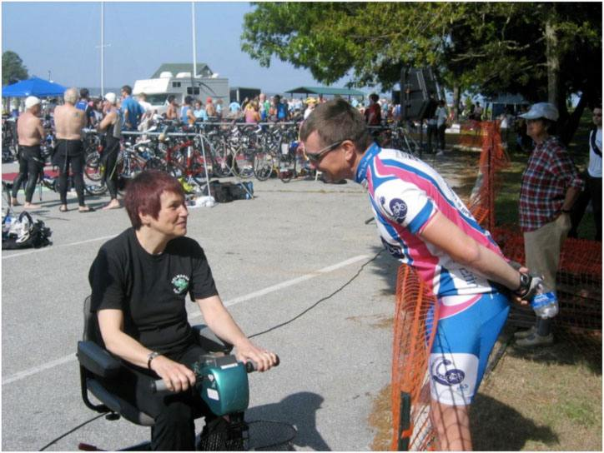  Her fight inspired ordinary people from five different charitable organizations to come together to host a big event. Fantastic commitment from volunteers and the unique network of multiple charities made our first year a huge success. Nancy was there to sing the National Anthem and be part of the beginning of what is certain to be a very popular regional open water and triathlon event.  The inaugural event generated revenues making it possible to make donations to each of the five charitable organizations involved. The Nanticoke River Swim and Triathlon Board of Directors was pleased to present The Blazeman Foundation with a check for $1,500.00 in honor of their teammate and beloved friend, Nancy Sterling.  OC Blazeman  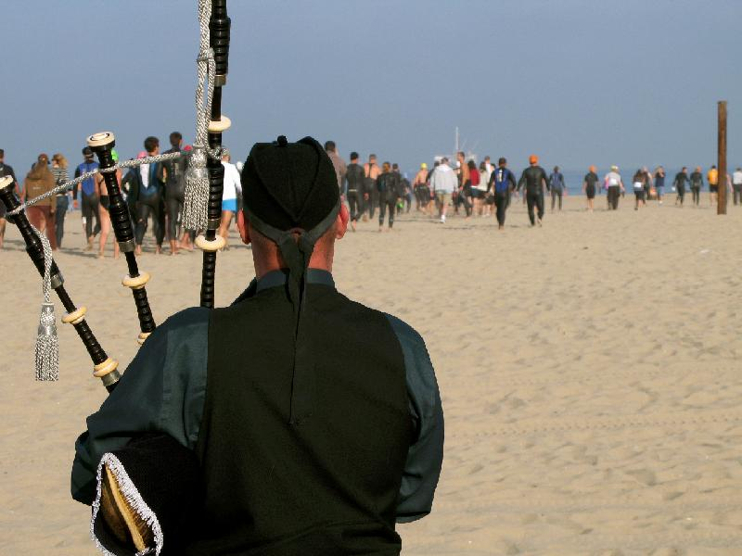  The second annual OC Blazeman Triathlon took place on a beautiful Sunday morning in Huntington Beach, California-one block away from the famous and busy Main Street of Surf City USA. The event was created in honor of Jon by the Ryan family (our Warriors of the Month!), who have drawn great inspiration from the courage of the Blazeman.  Athletes competed in varying distances of triathlons or simply did any of the events they desired. Without the burden of timing, a PR did not weigh on anyone's mind-but that is not to say personal bests were in short supply. Bob Blais noted, "You just can't have a bad race if you're doing something good for someone else." Certainly, personal bests were shown by more than 150 participating athletes without having to attain a personal time record.  The atmosphere of the event brought out the best of all the athletes participating. This year participation more than tripled from the event's inaugural run in 2007. As Bob Blais remarked "a triathlete 'gets it' when the cause is bigger than himself." This seemed to have been the mantra of OC Blazeman itself. All proceeds and donations were distributed among the Blazeman Foundation, National Multiple Sclerosis Society, and Challenged Athletes Foundation.  Why Triathletes are Rolling Across the Finish Line  Maggie Fitzroy, a writer for Shorlines recently wrote about Ken Fanelli's finish at the Lifestyles Realtors Beaches Fine Arts Triathlon. "After swimming a quarter-mile, cycling for 10.5 miles and running for 3.1 miles, Ken Fanelli dropped to his stomach right before the finish line. And rolled across. 'Are you OK?' a volunteer asked. 'I'm OK, Fanelli said, smiling."  If you're reading this newsletter, you probably know why Ken was smiling. But here's the rest of the article. It's a great read, despite a few minor factual errors. To read the entire article, click here.    Sponsor Discount!  The season is heating up, and the races are getting faster. I would like to offer to all Blazeman Warriors and family members an Online discount for SweatWipes. Blazeman Peelee has had fun with many of them, and I would like to offer out to all interested a simple Online deal. Buy 2 get 1 free. That gives you 1 for each hand, and one to pass along to a friend, or save for yourself. Follow the on-line ordering instructions by clicking here. Also while your there, take the famous faces quiz and see whom you recognize. They've all enjoyed SweatWipes.
  Our Sponsors
  Team Blazeman members get great discounts from some of the best brands!
  
  Get your discounts today!
  For more information on Blazeman Warrior Discounts, contact info@waronals.com
  Make a donation today!
  Join Team Blazeman!
  The list of registered
  Blazeman Warriors keeps growing! We are proud to have you representing us on the battlefields!
  Clark Archibald
  John Mcnamara
  Kevin Perkins
  Melissa Merson
  Thomas Martwinski
  Jennifer Bornemann
  Kathleen Fetissoff
  Linda Laird
  Chris Ellinghaus
  Fabrice Le Det
  Petra Le Det
  Nick Logan
  Ran Korolik
  Erik Feeney
  Christopher Giordano
  Charlie Dunne
  Karen O'Riordan
  Mia Richter
  Jennifer Tebbetts
  Debbie Ragals
  Brian Breen
  Dru Bornhoeft
  Cheryl Iseberg
  Richard Volpe
  Christopher Price
  Alexander Ha
  Gregory Hoots
  Tricia Ryan
  Domnick Nelson
  David Knight
  Caryn Blanke
  Douglas Munsee
  Alexis Andrianopoulos
  Glenn Hines
  Philip Clark
  Susan Langevin
  Karen Duffy
  Mike Duffy
  Brian Duffy
  Kevin Long
  Steven Perunovich
  Sean Dutra
  Michael Ricci
  Cathy Ruf
  Ed Bullock
  Ryan Van Praet
  Doreen DiMeglio
  Judy Pratt
  Michael Keim
  Barbara Altemus
  April Colescott
  Gabe Fiscus
  Ken Fanelli
  Larry O'Connell
  Caryn De Filippo
  Jennifer Brady
  Diego Avalos
  Megan Knepper
  Brian Kochanek
  Paul Nowicki
  Ron Salmon
  Barry Conrad
  Christopher Demers
  Jennie Eddy
  Marty Peterson
  Jack Keenan
  Dennis Joyce
  Rob Duguay
  John Plumley
  Kimberly Magee
  Sean Waklee
  Christine Suter
  Collette Bates
  Brad Culp
  T. Connelly
  Michael Carr
  Richard Higgs
  Sean McNamara
  Jason Biggs
  Henry Hoyle
  John Purvis
  Leah Roberts
  Robert Maldonado
  Bill Peloso
  Shelley Farmer
  Michele Solomon
  Daniel Molloy
  Michael Ireland
  Michael Hicks, Jr.
  Leanda Cave
  Ryan Close
  Courtney Greene
  Thomas Simmons
  Colin Lake
  Tim Smit
  Jordan Bryden
  Kim Williams
  Chris Parker
  Shawn Mahoney
  Lisa Unger
  John Ryan
  Dana Ryan
  Conn Jackson
  Michael Mathers
  JD Mathers
  Nancy Nicklas
  John Wolski
  Adolfo Roa
  Jen McGuiggan
  Charlie Komar
  Alexander Karn
  Tarcisco Alvarez-Rivero
  Rodney Ward
  Mark Helisek
  Paul Mandell
  Bob Gebbie
  Jerry Sappington
  Kimberly Daley
  John Daley
  Celeste Callahan
  Michael Swyt
  Kimberly Sass
  Jeremiah Crandell
  Christie and Mark Di Pietro
  Susanna Di Pietro
  Paul Fahey
  Vernon Johnson
  Mary Miller
  Cami Stark
  John Wright
  Chris Tidmore
  Anna Jenkins
  Chris Stafford
  Brian Layman
  Todd Verkest
  Brent Layman
  Sean Chick
  Kevin Davidson
  Jane Dempsey
  Fernando Sumaya
  TEAMS
  Beat ALS
  Canadian Triathletes
  Clan Westchester
  D3 Multisport
  OC Blazeman
  ParkCity Clan
  Providence Triathlon
  Steve Perunovich Family & Friends
  Team Kochanek
  Team Long
  Team Newton's War on ALS
  Team Polar
  Team raceAthlete
  Coonbottom Tri Club
  The Nelson for Blazeman Team
  Tim Smit's War on ALS

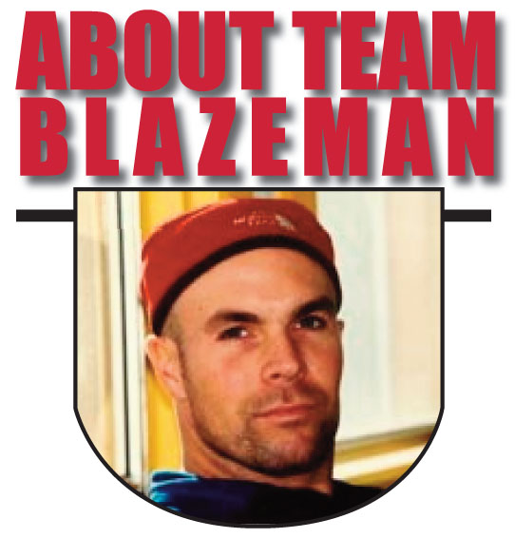
On May 2, 2005, twenty-year Multi-Sport veteran Jon Blais a.k.a. "Blazeman" at age 33 was diagnosed with the fatal motor neuron disease ALS (Amyotrophic Lateral Sclerosis). Blazeman dubbed himself the "ALS Warrior Poet" and brought his battle to the big island of Hawaii on October 15th that year, where he became the first person with ALS to complete the Ironman World Championships. It was his last race. In 2006, a number of athletes, inspired by Jon's 2005 efforts, rolled across the finish line in Hawaii in honor of Jon and his battle against ALS. In 2007, the Blazeman Foundation for ALS expanded Team Blazeman, comprised of "Blazeman Warriors" who have committed to raising awareness and funding a search for a cure for ALS..."So Others May Live."

Blazeman Foundation for ALS| 20 Commerce Way, Unit 12 | PMB 283 | Seekonk | MA | 02771

