Dear Blazeman Warriors, Friends and Supporters

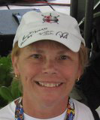
Well, this summer is on the wane. Many of you are finishing your season but some of you are gearing up for the big one in Kona. Jon's friend and executive producer for IM Kona 2005-2007 that highlighted Jon...Peter Henning, aka the "General", will be there with you as he is inducted into the Ironman Hall of Fame at this year's event.

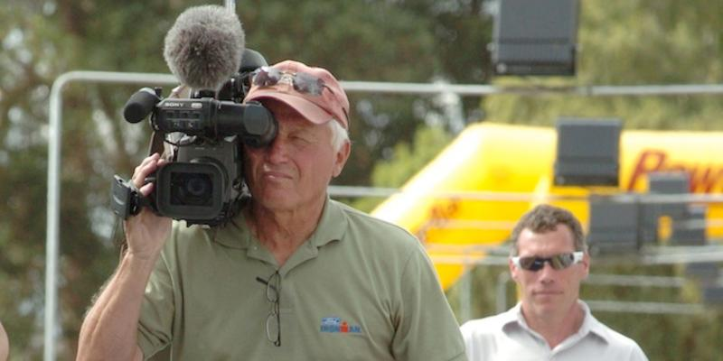 Peter with Kevin MacKinnon...

In 2006, Peter dedicated his Emmy Award to Jon and we were presented a replica with Jon's name on it as Associate Producer by Peter at his Celebration of Life on August 31, 2007. The statue has a special place in our foundation office. Peter's eye for putting together an inspirational story gave Jon a platform to demonstrate his courage and will to finish...as a result many athletes have told us they prepare for their races watching those videos...over and over again. Thank you ,Peter, for giving Jon's family the venue to always see him and hear his voice.

Bob Babbitt recently interviewed Peter where he talks about Jon as a truly inspirational young man. Congratulations Peter!! You will be missed every year at that finish line!

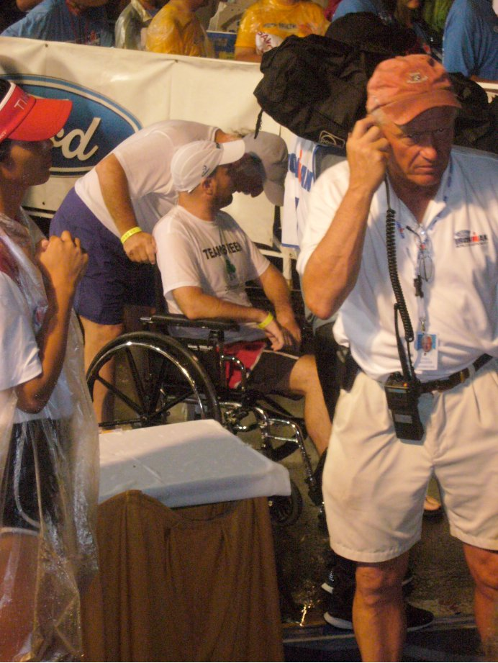
Thank you to all the warriors that have been fundraising through the summer. Without your effort and commitment we would not be successful in funding the research that is so important. Since 2005, there have been better understanding of the disease but we have far to go. If you have not started your fundraising yet, please remember the commitment made when you joined. Jon's words echo to this day. "Decision must be instant, Commitment must be total." All the PALS are counting on you.

I have highlighted some of our Warrior stories below...each one is special to us. Keep the pictures and stories coming! And a quick thanks to Kelly and Paul Fahey for the facelift on this newsletter! Change is good.

Jon's 42nd birthday is today, August 30^{th.} We can only imagine what his life would have been like had he not been touched by this horrific disease. Let's get that effective treatment and eventual cure. "...so Others May Live."

Take care 'til next time!
Mary Ann
Jon's mom

An Eagle Soaring Free
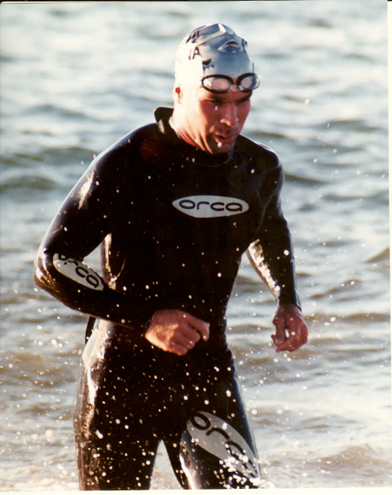
Recently, Bob and I were contacted by
Todd Civin, a friend of Laura Chagnon and Tom Damoulakis.
Laura is blind and a quadriplegic, the result of a senseless assault in 1989. Laura has written many beautiful poems and wanted to write one about Jon. How appropriate that we receive this just before what would have
been Jon's 42nd birthday. Thank you Laura and Tom for sending us this wonderful gift.

An Eagle Soaring Free ~ By Laura Chagnon
Upon the earth,
Each race before you,
Another journey to conquer.
You're an iron man.
Your heart overflowing with courage.
Your wonderful parents never far,
Always cheering you on
As you run for miles and miles,
Blazing the road with fire.
When you weren't able,
Your dad always there tying your laces.
You now soar on an angel's wings,
Flying high on heavens country road.
Each step higher than the one before,
A beautiful vision of glory and grace.
Your new home a breathtaking paradise.
A place where your pain vanishes.
You love every amazing moment of
Gentle laughter and the purest of joy,
Barking at the moon.
The shine of the sun lifting you up,
Racing into the twilight with stars in your eyes
And moonlight on your wings...
Your wings of an eagle...soaring free.

Blazeman Foundation for ALS Cycle 2014
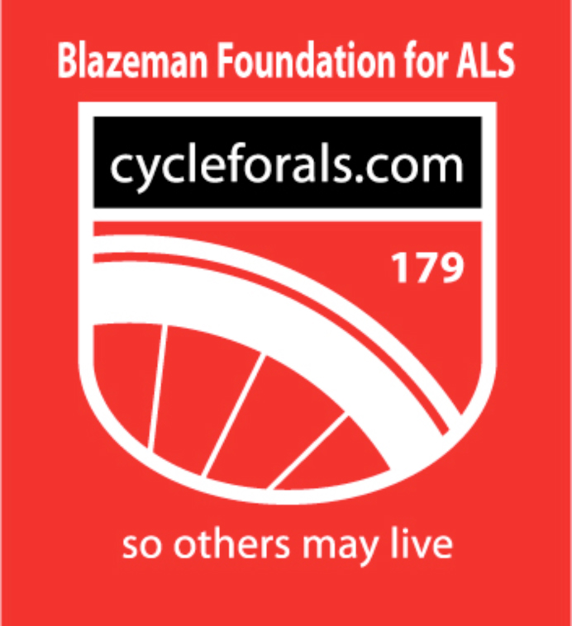
It's time again for us to start things rolling for the February 2014 cycle event! What better way to start moving in the dead of winter and at the same time fundraise for a cause bigger than yourself! I will be contacting last year's site organizers and also hope to recruit some new friends, too. This event is our main fundraiser and your support is needed for all PALS, current and future. ALS is one of the most underfunded diseases and at the same time the most devastating! We all need your help! Please contact me if you would like to get involved. "...So Others
may Live!

From the Battlefields
The World Championships in Kona is just around the corner! We are happy to report that we have some Blazeman Warriors and supporters toeing the line this year. Bishop Leatherbury has secured a lottery slot, Carrie McCoy secured her slot at IMLP,
Garen Riedel at IMLP, Martin Muldoon at IM Copenhagen,
Cherie Gruenfeld, our dear friend and age group champion,
Kat Donatello just secured her slot at Mont Tremblant, and last but not least IM legend Dave Orlowski. On the pro side, Blazeman Warrior, Leanda Cave, will be defending her title. We wish you all a great experience as you travel through the lava fields in Kona...we wish we could be there this year to support you all...We will be there in spirit...our goal is to return next year to honor Jon once again.

Brad Ettinger is raising awareness and funds for the BMF through Geared for Good...Brad's campaign is called Summer Cycling for ALS. Brad has a team of cyclists that raise funds and post their miles, creating ALS awareness. Thanks so much Brad!

From Blazeman Warrior Ingrid Hartman...
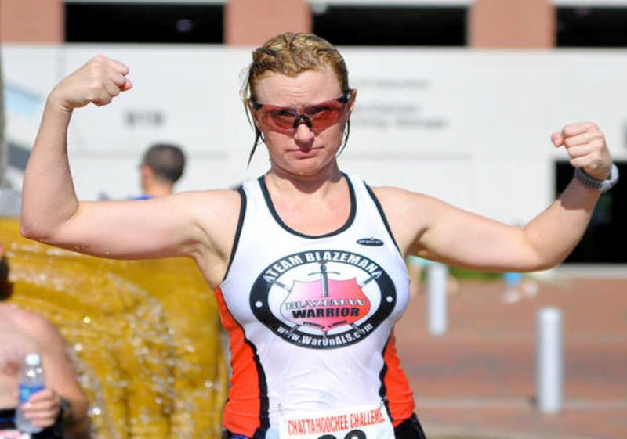
I finished my first Olympic tri this weekend in Columbus, GA. and did great... and had a ton of fun! Of course wearing my Team Blazeman Warrior tri top, I rolled over the finish line.

After I finished, a photographer for the local newspaper, The Ledger-Enquirer, pulled me aside and asked me about my tri top, Team Blazeman and the foundation. Then he took me over to the announcer, who basically handed me the microphone so I told the audience about Team Blazeman, Jon and the significance of the roll, and that I was racing in honor of my dad and ALS awareness. Afterwards, apparently it got some attention, because another participant told me that her father had recently passed of ALS as well. We spoke about how to get involved and I gave her the web site info.

I don't do half or full ironman triathlons but stick with the short course events. Most people at the shorter races, I have been told, have no idea why I roll across the finish line so it's a perfect opportunity to explain to people about the foundation and ALS! So no worries - the Warriors are being represented at the short course southeastern races.

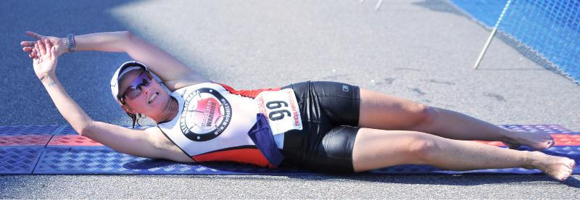

Congratulations Robert Vigorito!
Vigo was awarded The Lifetime Achievement Award at the USA Triathlon Athlete of the Year and Multisport Awards Banquet in Milwaukee.
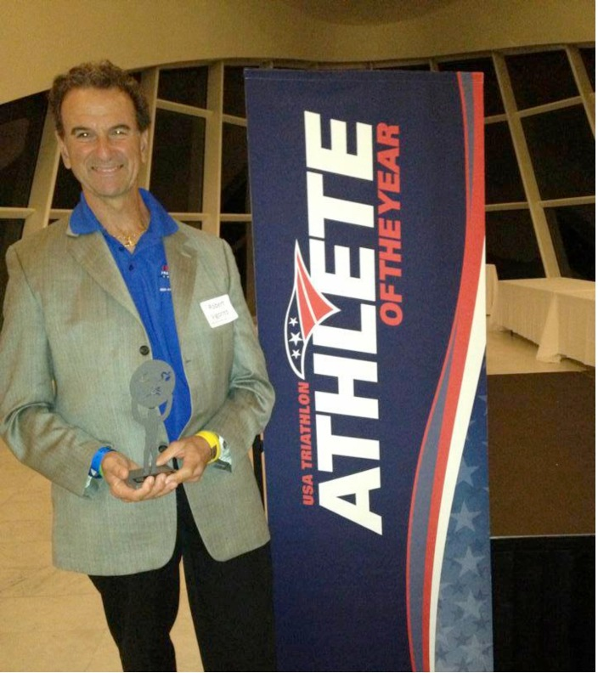

Some recent athletes wearing #179 at races this summer!
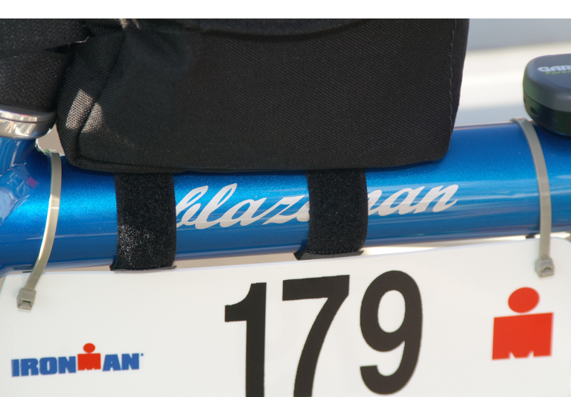
Dave Orlowski at Whistler, Canada
Danielle Liubicich for Lake Tahoe
Cherie Gruenfeld at Honu 70.3
James Garris at Raleigh 70.3
Brent Bieshaar at all 24 Xterra races!
George Pravda at the Charlevoix Triathlon
Don Soranno for Challenge-Penticton
Jeff Galvin at Eagleman

There may be others I do not know about...and remember, if you wish to request #179 for a WTC race I can help with the correct email contact. They do like to have a two month window before the event. The more athletes requesting Jon's number and sharing his message the better. ALS awareness is the first step toward funding the best research. Thank you all and please share your race pictures with me!

From Don Soranno at Challenge Penticton this past weekend

Hello Bmom and Bdad, I wanted to drop you an email and say what a day it was yesterday. Rough and tough race but we all finished.
I also want to say that it was an honor to be able to take Jon's ashes and spread them up here. I will send you pictures but I wanted I send you this video from the race finish. The Challenge organization has been great in spreading the word. Each time I came into and left transition and crossed the timing mat, they mentioned Blazeman and the ALS to the crowd.
I saved a little of his ashes and had them taped to my bike number as well as my racing bid - so Jon was with me on the course the whole way and was officially "Welcomed into the Challenge Family" with me when I crossed that finish line.
His spirit was with me out there and helped me find the strength to keep pushing and keep fighting.

Get Your Blazeman Gear Today!
Looking for some new blazeman gear? Check out what is available on our website made available through Nightmare Graphics.

A Warm Welcome to our newest Warriors!

We are pleased to welcome the following newest warriors to our family. Thank you, and everyone else, for all you do to help our mission.

Paul Larsen
Denise Cassella
Jason Bussey
Ray Micallef
Gina Perschbacher
Nemo Brauch
Bishop Leatherbury
Jady Simmons

A big welcome to you and we hope to see you at a race this year...please visit our ning website and start communicating with other warriors and supporters.

Remembering Les "Larry" Dawson

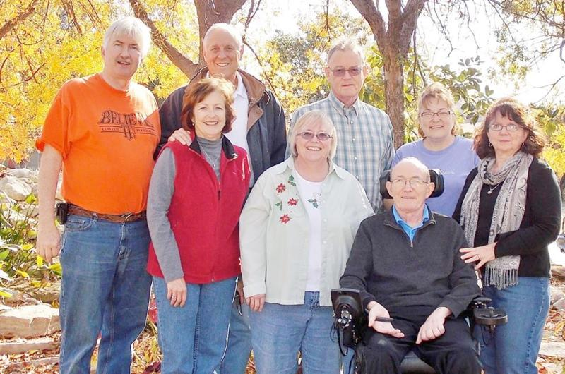
Les "Larry" Dawson and Family

Bob and I met this wonderful family after he was diagnosed when they joined Team Blazeman and began fundraising for Jon's foundation. Throughout this time we were in awe of the love and support this "big" family showered on Les. We should all be so lucky! Les, like many before him, has found his "Freedom" and we are blessed to know you all.

Jill Moses shared these thoughts after Les' passing...
Thank you to everyone who has been a part or Team Larry over the past 2 1/2 years. Uncle Les or "Larry" of Team Larry left us Monday evening ( July 15th). Our hearts are so sad and yet full of gratitude for the incredible support of friends, family and total strangers while we raced Ironman in his honor. Uncle Les lived his life both before and after his ALS diagnosis with kindness, compassion and grace. My hope is to honor his well lived life in big ways and small, an extra kind word, a little more compassion, and giving all my heart in a race. Thank you Team Larry!

The Team made this wonderful slide show.

The Team raced in Les's honor at the Boulder 70.3 recently. Here's their report:

"Team Larry will be competing as individuals and relay teams for Ironman Boulder 70.3 on Aug. 4, 2013. We also have a number of young warriors competing in the IronKids race the day before. They may not be old, but they understand our goals and race for ALS research as well. Please support us by donating funds for research to honor Les "Larry" Dawson who recently passed away from ALS. We now race in his memory and to gain even more awareness. The cure is out there, let's find it! Isaiah 40:29-31 "He gives strength to the weary and increases the power of the weak. Even youths grow tired and weary, and young men stumble and fall; but those who hope in the LORD will renew their strength. They will soar on wings like eagles; they will run and not grow weary, they will walk and not be faint." (NIV)"
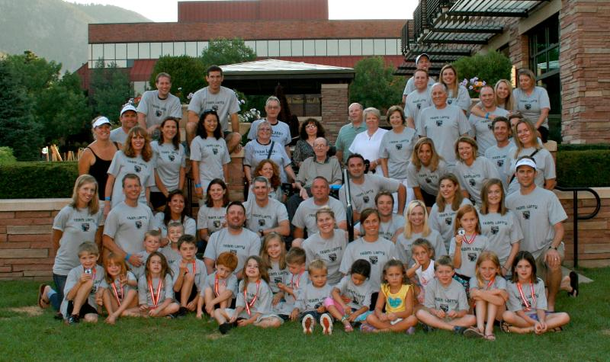

What a tribute at Boulder!

Xterra Across America and Brent Bieshaar

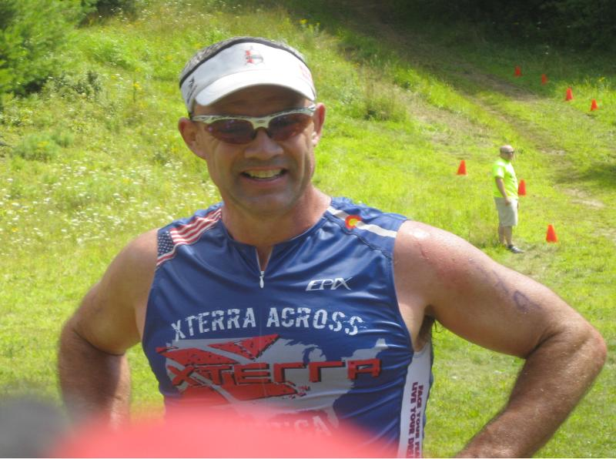
Brent is still at it! As I write this he has four races to go and will complete 24 races this season. Bob and I met up with Brent and his family plus a group of friends the second weekend of August in Hanover, NH. Brent was doing the Stoaked off Road Triathlon in Hanover.
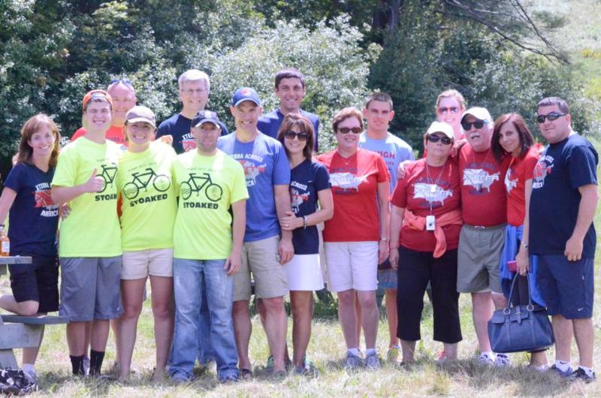
Brent placed 2nd in his age group and I am told this bike course was very difficult...lots of skids, flats and some blood thrown in there! It was great meeting Brent's family and friends. Brent, through this race series has created a lot of ALS awareness and we are all proud of him

Brent has blogged each race...he is down to the final few with the World Championships in Hawaii on October 27th...Congratulations and the best of luck at the Worlds! Stay tuned in our next NL for final race update! In the meantime, check out Brent and Paula's race update here.

Photo Gallery
Thank you so much for sharing your highlights and favorite moments from the 2013 season! But don't stop now! Please keep sending your photos of the many events coming up!

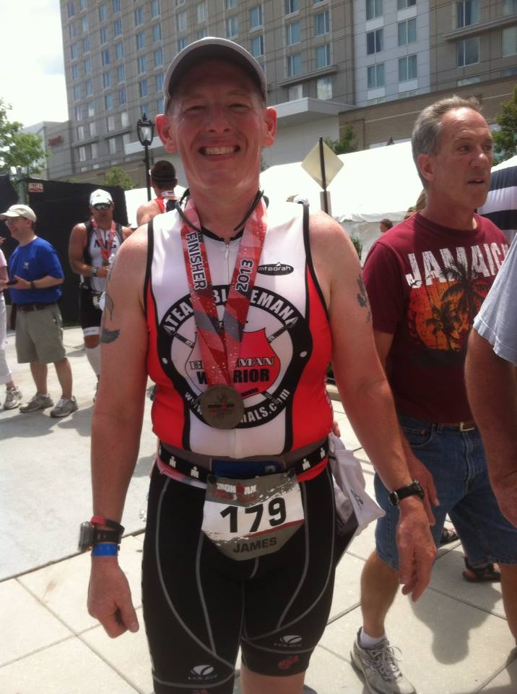
James Garris IM 70.3 Raleigh 2013 Finisher

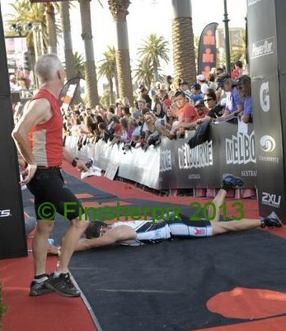
Brett Jenner rolls at IM Melbourne 2013

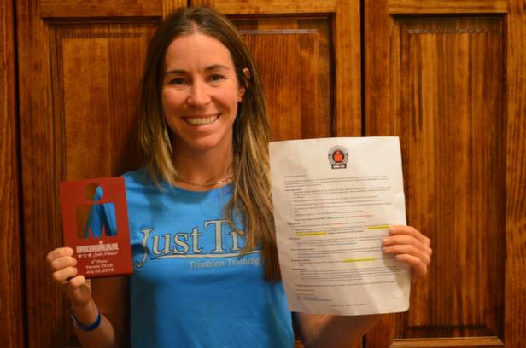Congratulations Carrie McCoy, Kona 2013 qualifer!

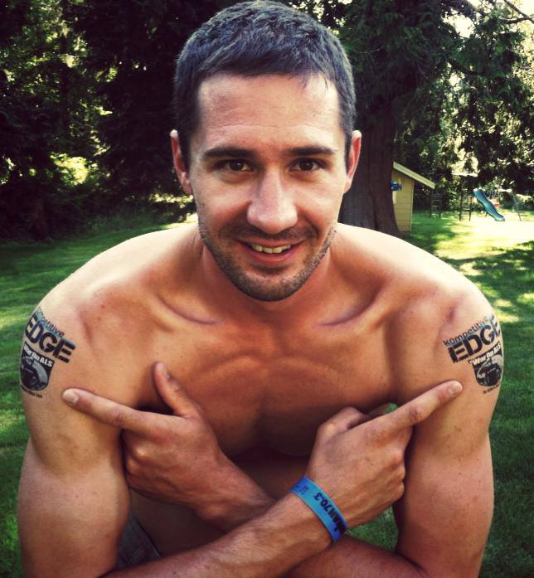Grant Bovee Lake Stevens 2013

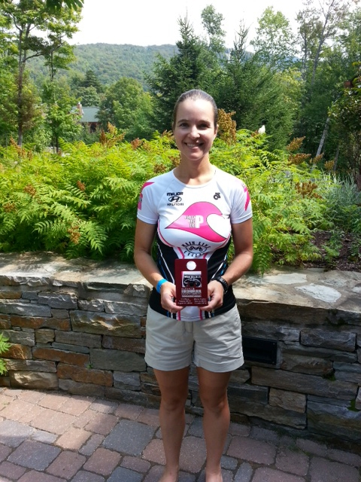Laura Straub posing at Mont Tremblant 2013

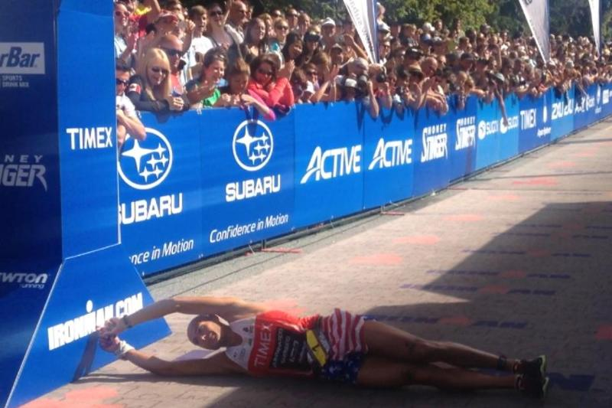Matt Russell rolling for an impressive 2nd place at IM Whistler Canada 2013

