Greetings Blazeman Warriors
and Supporters!
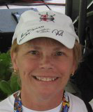
May is National ALS Awareness Month!

The month of May is a very personal month to us...and as I write this on the day of the seventh anniversary of Jon's diagnosis on May 2nd, 2005...I wish I could say there is a treatment for this horrific disease. Many people are still unfamiliar with the disease and yet it seems as though not a week goes by that we don't hear of yet another diagnosis or passing of someone with ALS. When I think back to those two weeks I spent with Jon in early May 2005, the emotion of that reality comes streaming back.

Seven years later the treatment plans for someone with ALS has not changed...there is no treatment, only some ways to extend life...not even the quality of life.

And while this is an emotional month for us, it is also a busy month. On May 7th, Bob and I will be speaking to the Mid-Maryland Tri Club. And the end of the month on the 27th we will have the 2nd Annual Run for Pals here is Seekonk. The 5k starts and finishes at Jon's old high school here in town; we hope to have an even better crowd there this year. Thank you Joe Goddard for making this race a reality! A big thank you also to the race sponsors and donors of the raffle prizes!

Many of you are gearing up for your race season...Bob and I wish you all a great and safe one...and if the spirit moves you as you approach the finish line...a roll for ALS awareness is always appreciated as it may start a conversation of why Jon did just that more than seven
years ago.

I'd like to leave you today in true Blazeman style. He always said it was, "good to end your thoughts with a quote. Someone else has said it best, so it's better to steal from them and go out strong." Jon called it his "Scooby Snack" ending. So here's to you all... "Hope is a good thing, maybe the best of things, and good things never die. Never let die the competitor that lives within you. For Blazeman and his war on ALS, it's about fighting for better days so others may live." ~ Jon Blais (a.k.a.-blazeman)

Till next time...

MaryAnn
Jon's mom

Good Will Hunting by John Segesta...Remembering the Blazeman

This links to a funny and touching piece written by John Segesta in 3GO Magazine about a trip to the Grand Canyon with Dave Stepp, John Segesta and Jon...please take a moment and enjoy! Thank you John for this gift...

In May of 2005 when I traveled to San Diego for that life changing diagnosis of Jon's ALS, I noticed a great framed photo in Jon's condo. As Jon started giving his things away I told him I wanted that beautiful picture. All I knew about it was it had been taken on a hiking trip ...I do not remember if he told me more details.

After Jon passed away and I went back to work, that picture hung on the wall by my desk so I could see it daily. I still love the picture...it sits on a cabinet along side of the sofa where I usually sit typing on the computer. One day, when going through Jon's photos I came across the picture that is included in the article...I set out to find Jon's friend that took the picture...it took awhile...I came across a picture of a younger John Segesta and the rest is history...
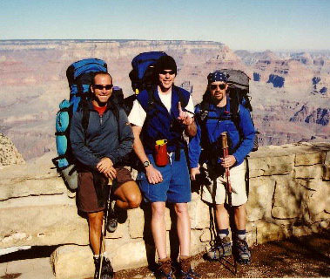
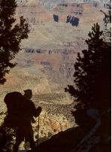
The Grand Canyon

Remembering Shane Fitzmaurice

Back in February we highlighted Shane in this newsletter.
At the time, he felt he had not done his part to contribute
to the War on ALS. I answered him to the contrary.

Shane found his FREEDOM on April 24th. Shane wrote a letter back in December for his family to read when he passed. We have an opportunity to share it with you:

Dear Family and Friends,
I am glad to announce that I have been released from my pain and suffering, I have passed away...Please know that I am happy to be out of that prison, God gave me a wonderful body, I could do any sport I wanted. And then ALS hit me...the slow decline and loss of the use of the body was extremely painful. But that is all over now, so please rejoice and share my happiness at being released.
My faith in God is strong...hope to see you on the
other side!

Much Love,
Shane
(written in December 2011)

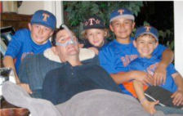
Shane you will be missed by many...

Please visit treatalsnow to learn about ways to help ALS patients get investigational drugs. Your vote counts!

Research Update

The Blazeman Foundation for ALS and the NICHD Brain and Tissue Bank has joined efforts to speed research on ALS (Amyotrophic Lateral Sclerosis, commonly referred to as Lou Gehrig's disease).

The study of post-mortem tissue from individuals with ALS is critical to finding the cause of ALS. If you have decided to become a potential tissue donor, you are encouraged to register with the NICHD Brain and Tissue Bank. Preregistration allows for speedy recovery of tissue. Time is critical for the recovery of tissue and should be completed within 24 hours after death.

More information and how to register is available on the University of Maryland website.

The funding for this great project is generated mainly by the Charity Slots at the EnduraFit Ironman 70.3 EagleMan and the donations we receive earmarked for this project. We could not provide this important research endeavor without the support of you all...the costs to the family are covered by the Blazeman Foundation for ALS. Jon led the way with his donation in May of 2007..."so others may live".

The 2nd Annual RunforPals 5k on May 27th

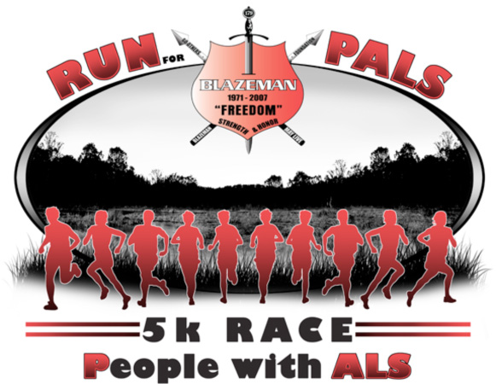
This year's race at Seekonk High School will have two very special additions...Mike Capone; the Rhode Island State Trouper that played the bagpipes at Jon's celebration of life, will be playing the same beautiful music that Jon liked from Braveheart at the race start. In addition to that we have a raffle planned with great donations from some pro triathletes and great companies...something for everyone! Please share this event with all your friends and come join us not only to celebrate Jon's life but also to show support for all PALS (people with ALS) past, present and future...

Click here to register online

We hope to see you all on May 27th.
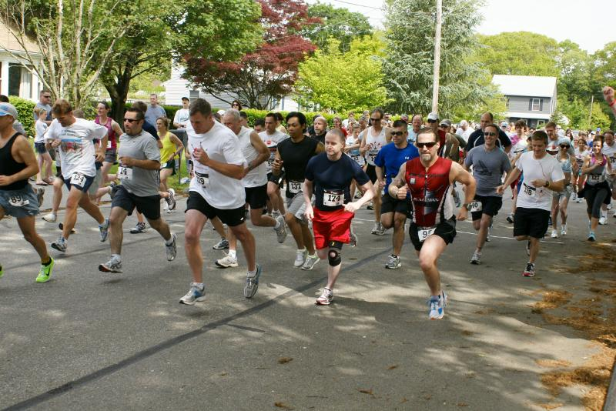

Warriors Working Wonders
There are so many people we meet whose lives have been touched by ALS. Sometimes their stories of courage capture the Blazeman spirit. Here are two stories we wanted to share with you.

Meet Heather Wajer
Heather entered the Kona Inspired contest to try for a slot in this year's Ironman World Championships in Kona! If she wins, she plans to use it as an opportunity to raise awareness and raise money so we can find a cure for ALS! She will even petition Ironman to race using Jon's
number 179.

Heather needs help to spread the word to get votes. Watch her amazing story online and click the share button below the video.

Meet Drew Comeau
Drew Comeau is tackling ALS
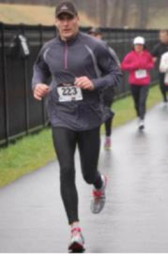
Drew never got the chance to know his Grandfather, Robert K McMillan, because ALS took him when he was very young. He also lost two high school classmates to this disease. As a result, Drew grew up with a passion to find a cure on behalf of the family members that had to deal with this disease.
Drew recently met Bob and learned about the Foundation at the Hartford ¼ Marathon where he raced in support of ALS research. Since then, he's officially signed up for the
PALS race.
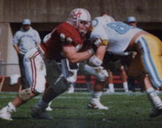
Running and racing is great. But as it turns out, Drew knows how to (literally) tackle ALS and hit this disease where it hurts. Comeau was a four year letterman for UMass from 1986-1989. The former UMass football star recently started a group called UMass Football Alumni and Friends against ALS that will raise funds that will go towards purchasing season club seats for ALS patients that would like to get away for a day and go to Gillette and see some UMass football. Drew is also working with the Head Football Coach at UMass to make it an extra special day for our ALS guests with some possible player greets or sideline access for a bit.

Drew's vision is for this spilling over to the Patriots and having an awareness day for a Patriots home game with 75,000 people in attendance. He will keep us posted on that. You can help Drew and support his work online and on their Facebook page. Please share his story with your friends!

Say hello to them!
And take a moment to send Heather and Drew an email with a few words of encouragement. I'm sure they'd love to hear from you!

From the Battlefields:
From BW Steve Ribeck...
The timing of receiving your newsletter couldn't have been better timed as I read it from the shores of Kona! Wendy and I took a little vacation here and I thought of Jon a lot while here. To stand at the finish area knowing where one of my heroes once stood (rolled actually) was quite amazing! We drove the coast up past Hawi and kept thinking how grueling of a course it is and the tremendous effort by Jon to complete it. I know what his physical condition was at the time as and his lack of time to properly train...nothing short of a miracle and so inspiring. He defined what a true warrior was in general but specifically that day as well!

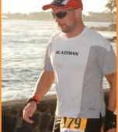
City Bikes Ironman 70.3 Miami continues supporting the Blazeman Foundation for ALS
The City Bikes Ironman 70.3 Miami is honored to continue supporting the Blazeman Foundation for ALS. Through this partnership, athletes who are participating in the race have the opportunity to make a contribution to the foundation when registering for the event and support the fight against ALS (Amyotrophic Lateral Sclerosis). The Blazeman Foundation will also be featured at the event EXPO so not only athletes but everyone attending has a chance to know more about the War on ALS.

Athletes may also register for Blazeman Slots online.

Treat us Now!
This is from Shane Fitzmaurice prior to his passing...
"I'm involved in this Pilot-1 program, if you are not aware of it please take the time to check it out." The immediate goal is to get you to use your social media and your personal contacts as well as your professional contacts to help spread the word and get people to sign the petition. The petition is requesting the FDA and the drug manufacturers to work together and allow ALS patients access to the drugs that are in trial now and showing positive results! Treat Us Now! Please share this web address with anybody and everybody to get them to sign the petition!
Blazeman Foundation profiled on Slowtwitch website this week. Check it out!
War on ALS
The War on ALS is most likely the best known foundation to triathletes because quite a few folks, including but not limited to Chrissie Wellington and Leanda Cave have become Blazeman Warriors for this group. All Blazeman Warriors help raise awareness about ALS and raise money to find the causes and cure for this deadly disease. When you see someone rolling across the finish line at a race, that is in memory of Jon Blais who did so when he finished the Ironman World Championships in Hawaii in 2005, while already dealing with the disease often also called Lou Gehrig's disease. Jon passed away in 2007, but you can keep his memory alive.

A Warm Welcome to our newest Warriors!

We are pleased to welcome the following newest warriors to our family. Thank you, and everyone else, for all you do to help our mission.

* Jeremy Owens
* Stacie Tracey
A big welcome to you and we hope to see you at a race this year...please visit our ning website and start communicating with other warriors and supporters.

Photo Gallery
Thank you so much for sharing your highlights and favorite moments from the 2011 and 2012 season!
But don't stop now! Please keep sending your photos!

Celebrating the lives, past and present,
of our ALS family
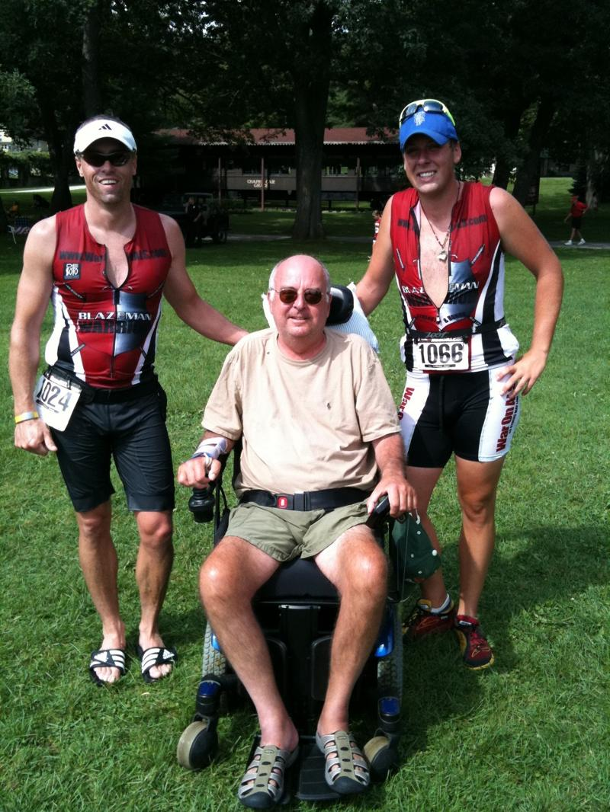 Jacob Marquardt and his dad

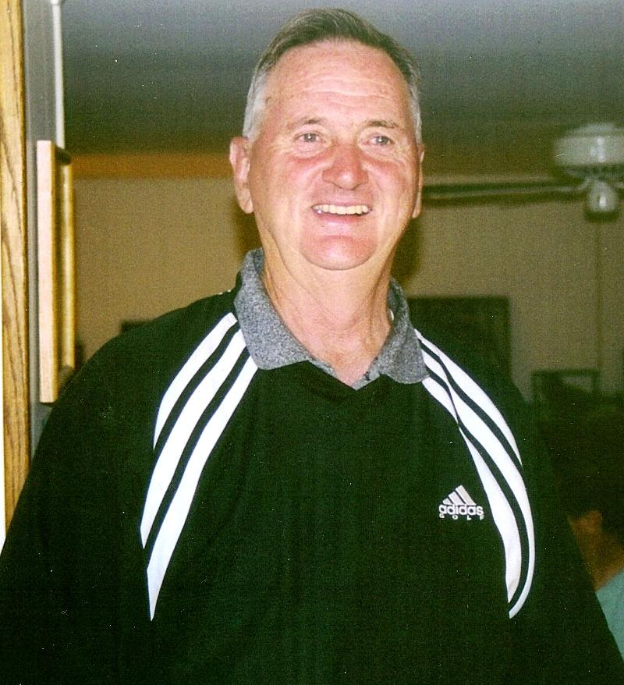Charles Dourney...the dad of Donna Dourney, blazeman warrior, another lost alswarriorpoet
to this disease.
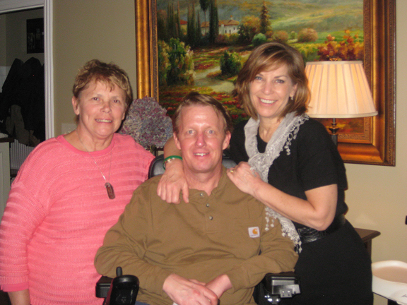Blazemom, Doug and Sue Macinnes
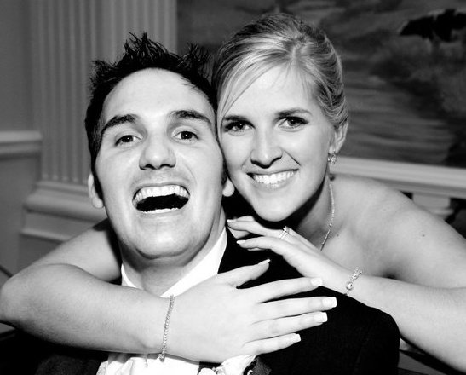Brian and Kasey Williams
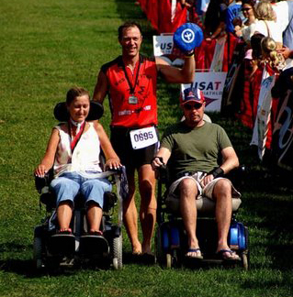
Claire Collier and Jon
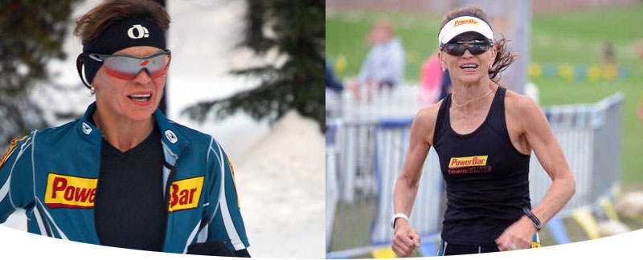Diane Proud
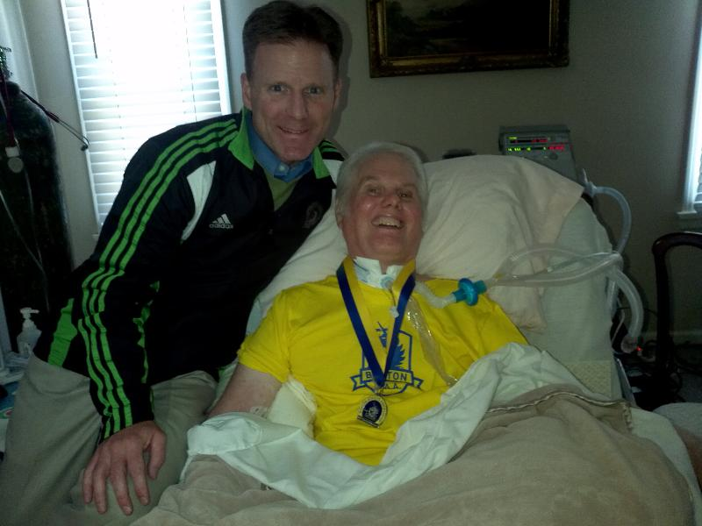Blazeman Warrior Dr. Jeff Galvin and good friend
Greg Knittel. Greg is sporting Jeff's Boston Marathon medal!
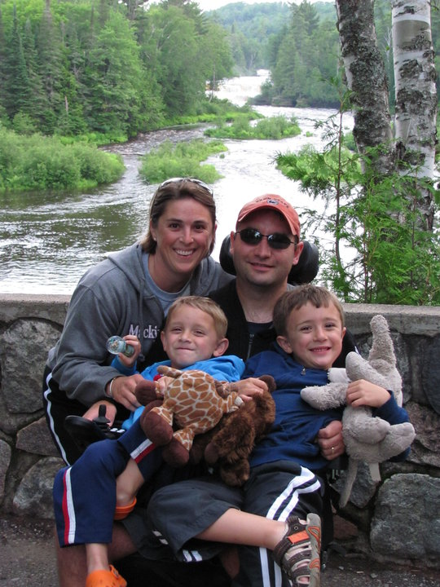Phil Hutchins and Family
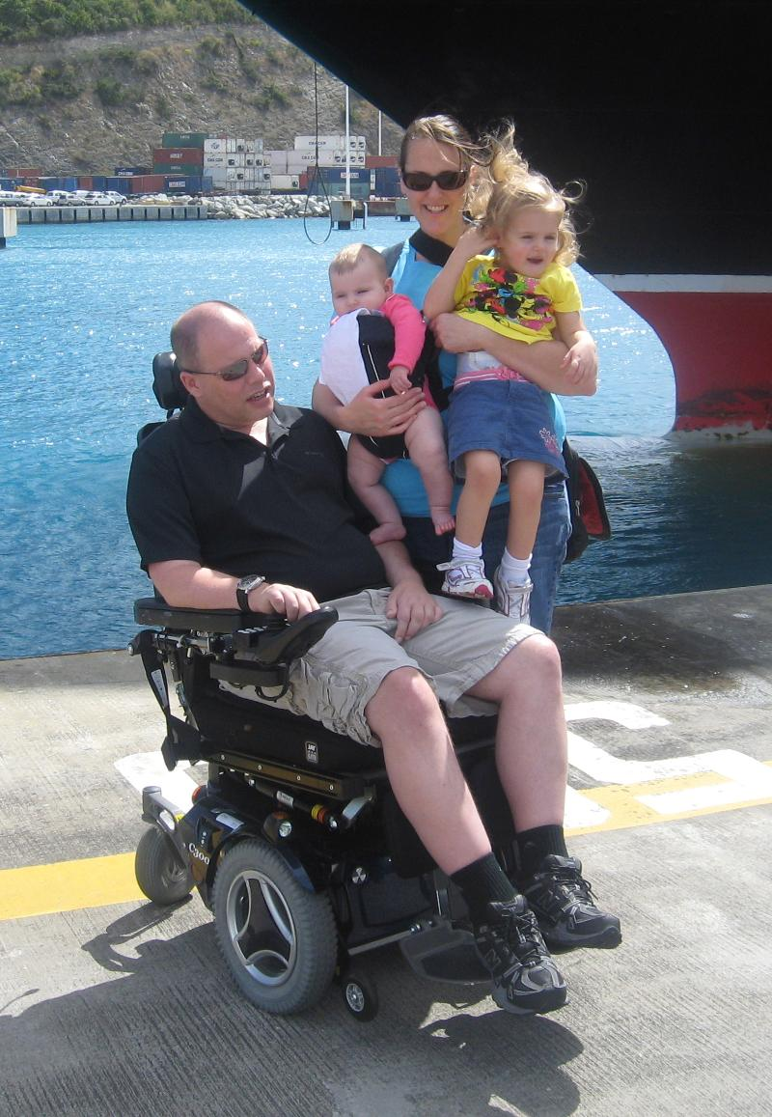Scott Wertz and Family

