Greetings Blazeman Warriors
and Supporters!
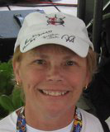
It's hard to believe another summer is upon us and yet another year has passed since Jon has gone. This year the 2nd Annual RunforPals 5k was held on May 27th the fifth anniversary of Jon's passing. For the Blais Family this event was a good distraction and a great way to celebrate his life. A big thank you to our major race sponsors, Major Hyundai, Adaptive Mobility, and Webster Bank! Your support means a great deal to us in this War on ALS. RI Multisport, headed up by Joe Goddard, made the event run very smoothly!

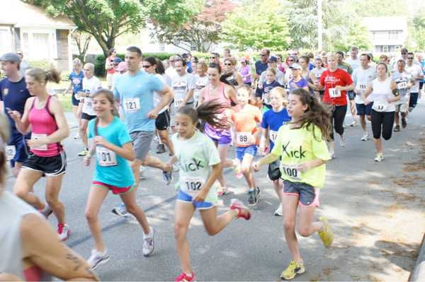We loved the fact that this year we had many athletes in the 13 and under group and the 8th overall runner was 10 year old Max DiNuccio!!! Check the results online.
Please save the date for next year's event which should be the Sunday of Memorial Day weekend!

June has brought us back to where our foundation began...The EnduraFit EagleMan 70.3 Ironman in Cambridge, MD. Rob Vigorito's team and races have grown over the years but his commitment to Jon and his foundation is as strong as ever. This year Craig Alexander and Mirinda Carfrae, both world champs honored Jon by spreading his ashes in the Choptank River off the Riverboat on the Friday evening before the race. Thank you both for doing that!
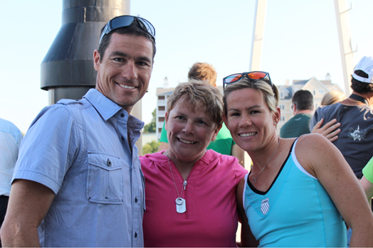The Blazeman Spirit award winner this year was Stephen Brown (more on Stephen below) and race day did not disappoint for those looking for a sunny and hot day! A special thank you to Meredith Kessler, the female winner, who in blazeman style went back and rolled the finish line! We had numerous rolls that day...not an easy feat on hot asphalt!

This year's wearer of #179 at EagleMan was Kat Donatello, the race director at Pumpkinman. Bob and I will be traveling to Kat's event in September where there are Blazeman Slots available. We hope to see some of you there.

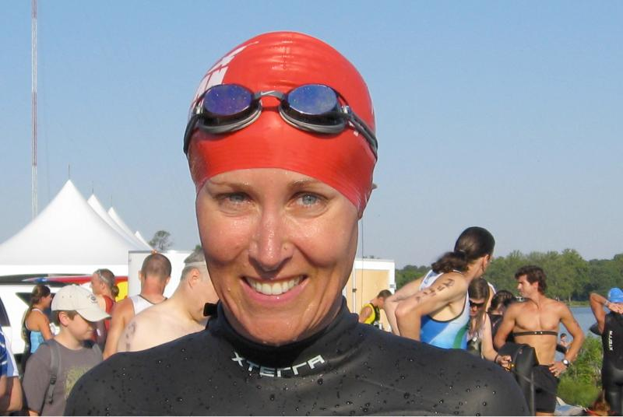Thank you Kat for wearing #179 so well and for supporting Jon and the Blazeman Foundation for ALS!!!!

Wishing you all a great race season and remember to "get it on film" and email them to me!

Till next time...

MaryAnn
Jon's mom

The 2012 Blazeman Spirit Award

This year's award was given at EagleMan to a most deserving individual, Stephen Brown, aka Remissionman. Stephen has chronic lymphocytic leukemia, a disease that he continues to keep at arms length while as Jon would say, "lives life to its fullest." CLL does not rule Stephen's life and to learn more about Stephen please visit his website.

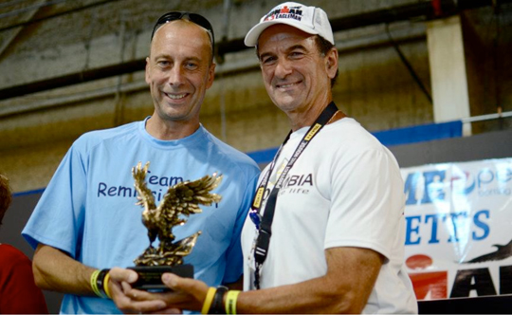In Rob Vigorito's words, "Stephen Brown through his work ethic as an athlete, coach, cancer survivor, mentor, teacher, and motivational speaker to all those he encounters, clearly has the tenets, passion and emotion, that so moved "Blazeman" to establish his "WarOnALS". Steve lives his life as an example of the 'can do' attitude, and never looks back at what might have been but looks forward to every new day, one filled with hip and life's dreams."

Congratulations again, Stephen, you truly embody the essence of the Blazeman Spirit Award.

Remembering Doug MacInnes
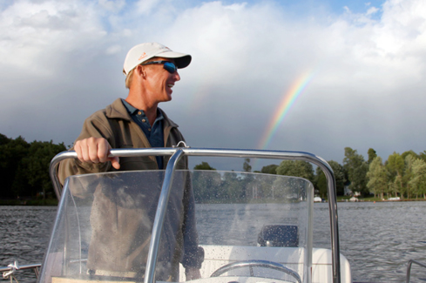This past March I met the MacInnes Family; Doug, Sue, Chris, Emily, Molly and all the rest of the clan. Doug's ALS was diagnosed in October 2010. Spending that weekend with them in Cary, Illinois not only brought back memories but it reaffirmed to me how the disease progresses differently. Doug, although left handed, had been spared of losing the use of his right arm. We spoke of that huge gift that he was still able to have the independence of feeding himself along with many of the tasks we all take for granted. It was a weekend I will never forget.

On May 22nd, after a short hospitalization for pneumonia, Doug passed away surrounded by his loving family. I am truly amazed how quickly he left us. I expected him to enjoy another summer with us but he lived 1 yr. and seven months after his diagnosis.

Sue had brought him home for Hospice care which allowed some comfort to Doug and his family. We hope you rest in pace, Doug. You will not be forgotten by me and I hope your spirit has been introduced to Jon.

Doug's family has put together a beautiful tribute to Doug, both in pictures and video. Please take a few minutes and watch how this man enjoyed life...both raising his children and competing in the sports he loved.

For more on my visit with Doug, please visit the website and read the March 2012 newsletter article.

From the Battlefields...in the War on ALS
From Mike Lahey's race at Nanticoke...

"I hope this email finds you well and look forward to seeing you guys at EagleMan again this year.I just wanted to give you a brief update on our race.

The Nanticoke River Swim and Triathlon went off without a hitch and we had a wonderful day with no incidents - as race director that is my #1 concern. Nancy Sterling is now in her 5th year and came out for the entire event. She was at the start / finish line when the children started at 8:45 and did not leave until the last finisher crossed the finish line after 12:00pm in 80 plus degree weather.Her nephew, Bryan White, came all the way from Austin, Texas to race as his first event in her honor and it was a very touching experience. He watched all of the videos about ironman and had no idea what he was supporting until then - he said it was very inspirational!

In my pre race I challenged every athlete to roll across the finish line and I am proud to say over 50% of our athletes rolled across the finish line."

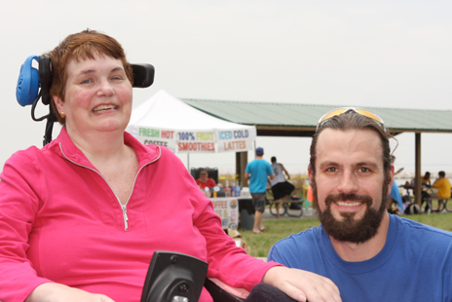
Nancy and her nephew Bryan on race day

In Bryan's own words about his experience...what we take for granted in life has profound meaning in the life of a person battling ALS.

"I never thought I'd compete in a triathlon. Swimming for me was an activity for fun and games, not training and competition. While I'm not certain when it occurred, I've recently found indescribable inspiration in a slogan of the ALS Association - "because I can". My aunt Nancy Sterling has been battling this horrible disease for five long years. I've learned from this not to take my life and health for granted. I decided I would enter the water - because I can.

It's no coincidence that the event I chose to be my first triathlon was Nanticoke River Swim & Triathlon. The organizers of this event were friends and training partners of Nancy's prior to her diagnosis and have remained committed to her in the days since. My race experience was outstanding and I will never forget race day. Nanticoke is a "sprint" triathlon - 750 meter swim, followed by a 12.4 mile bike ride, finished with a 3.1 mile run. We arrived early so Nancy could cheer on the athletes competing in the kid's tri (an event she is credited for conceptualizing and encouraging). It was great to see the excitement and desire on their young faces. The moments leading up to my heat were nervous and long. I was eager to get in the water - feelings I never dreamed of having and that I can only attribute to the confidence Nancy had instilled in me over the past several weeks. I knew no matter how fast I swam/rode/ran, no matter how quickly I transitioned, regardless of how many people I finished ahead of, that she and the rest of my family could not have been more proud of me. I'd already won.

As I made the final turn and the finish line came into view a sense of joy and enthusiasm grew within me but it was soon replaced with more nerves. The Nanticoke Tri has a custom I wasn't familiar with - rolling across the finish. I was fully aware that waiting for me at the finish was my aunt a champion swimmer and international award winning singer in her own right, now fully involved in the fight for her life against ALS. It was with a very heavy, emotional heart I made that roll across the finish. I had accomplished what I came to Maryland to do - share time with my family and push myself past limits I previously knew, while representing Nancy in this event. There was relief and satisfaction in the embrace we shared post-race and there were tears. Words were not spoken that I recall. Nothing needed to be said.

This experience has changed me for the better. I have established new groups of friends and found a greater appreciation for goals, training, persistence and most importantly, for life. You don't have to compete in triathlon but I would encourage you to make the most of life and ensure you live without regret. If you want to, do. Because you can."

Research Update from Ireland

Irish research team makes major breakthrough in Lou Gehrig disease

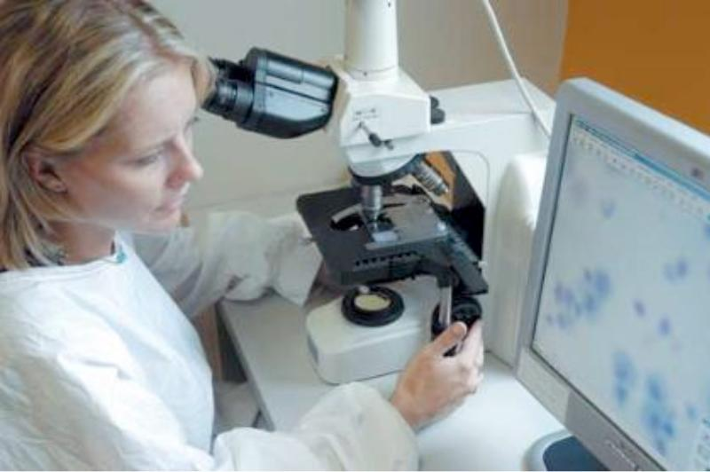Irish researchers have made a major breakthrough in the treatment of the deadly motor neuron disease, or Lou Gehrig's disease, as it is often known.

The research team at the Royal College of Surgeons in Ireland has discovered how the body protects itself against the onset of motor neuron disease.

A report in the Irish Times says that the breakthrough will immediately open up new treatment options.

Further research is already showing that symptoms can be reduced and life expectancy can be increased in mice that develop motor neuron disease according to research team leader Professor Jochen Prehn.

He told the Irish Times, "It is significantly better than the best current treatment. You can significantly delay the onslaught of the symptoms and improve survival."

Motor neurone disease is a progressive and fatal degenerative disease where the nerve cells that carry information between muscles and the brain - motor neurons - begin to die. Medical research has yet to discover how this happens.

The report states that five years ago, Irish geneticists Professor Orla Hardiman and Professor Andrew Green discovered a mutated gene that seemed to be associated with motor neuron disease. The gene produced a protein called angiogenin.

Prof Prehn's group has since focused on angiogenin and became the first to explain how the protein was involved in protecting motor neurons from becoming damaged.
Their research is published in the current issue of the Journal of Neuroscience.

Professor Prehn said: "The work related to angiogenin is a completely Irish success given the initial discovery and later work happened here.

"If motor neurons break down in a healthy individual, angiogenin is released. It acts like an instant survival factor.
"The protein machinery is turned on. It helps the surrounding tissue to regenerate or grow new blood vessels or deliver more energy.

"Several factors are released by this machinery, helping to keep the motor neurons healthy so they can continue to support muscle control. Angiogenin in those who develop motor neuron disease is absent or might not work properly."
The Irish Times report states that Professor Prehn's group were the first to reveal how angiogenin works to protect the neurons. But this also threw up possibilities for new kinds of treatments.

He added that the researchers now plan to study the various protective factors released by the neurons to better understand how they help neighbouring cells.

Rob Spinosa, Blazeman Warrior
Rob has once again secured a spot in Kona this October. Rob lost his mother, Fern, to ALS in March of 2010...please take a moment and read Rob's story online about his inspiration and the road back to Kona..

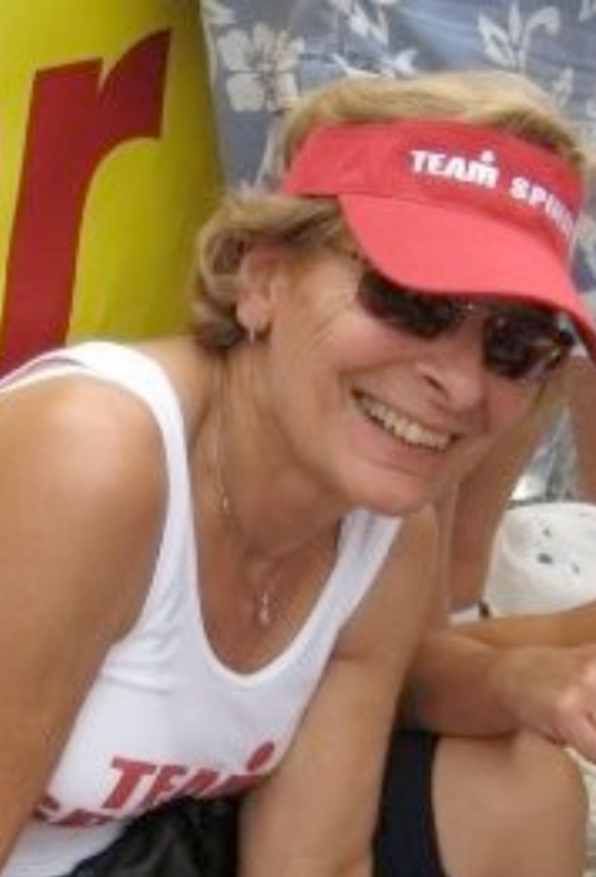
Fern Spinosa in 2008

An Update from Drew Comeau
UMass Football Alumni and Friends against ALS

Hey, All! I wanted to share an update on our progress. We have great news: We have raised enough money to purchase and donate four club season tickets in our group name for the upcoming football season for ALS patients & their families. If anyone would like to volunteer as an ambassador for our group for a home game with duties of meeting/ greeting /welcoming & other stuff like that, let me know. For those that would still like to donate, we can still use all the help we can get. I would like to have some funds available for donating some keepsake stuff like UMass jerseys, t-shirts, hats, etc. Please invite people to our group on Facebook. For those that have already donated, a big UMass Football thank-you. We look forward to brightening an ALS patients day. For more information, click here. More news to come as we get get closer to the season.
Thanks, Drew

Remembering the Blazeman
Aseltine School is where Jon taught the last 5 years before he was diagnosed with ALS. Those kids meant the world to him...so, one can see how ALS not only effects the person and family but also in Jon's case...all those young students. Some of these young boys and girls had never experienced the world of sport and nature itself before Jon arrived on the scene at Aseltine...the hiking trips, swiming in the ocean and getting new sneakers every year thanks to some great businesses are just a few of the new adventures he brought into their lives.
So this year they celebrated Jon's life with ice cream...thanks to Anna and Dick from Mariposa Ice Cream (Jon's favorite)...and watched the video from the 2005 Ironman. The newer students had the opportunity to learn about the man on the Conrac Wall...and Bob and I are pleased to share this all with you.
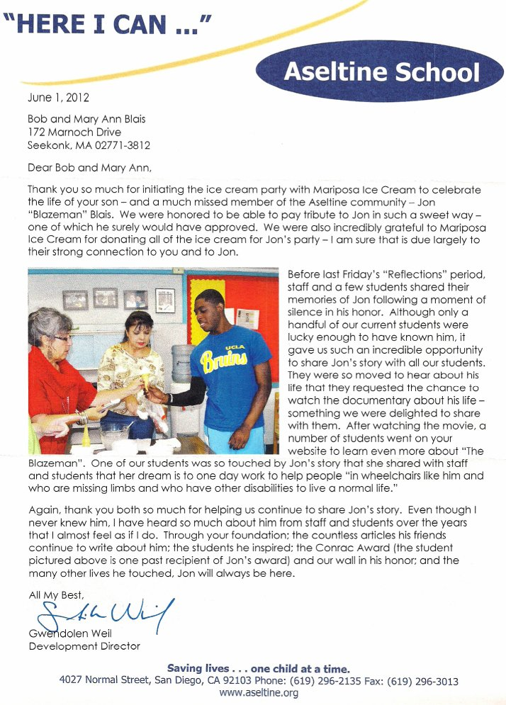

A Warm Welcome to our newest Warriors!

We are pleased to welcome the following newest warriors to our family. Thank you, and everyone else, for all you do to help our mission.

* Jim Megin

* Nathan Reid

* Robert McCallion

* Samuel Farnsworth
* Aaron Mills
* Karen daSilva
A big welcome to you and we hope to see you at a race this year...please visit our ning website and start communicating with other warriors and supporters.

Photo Gallery
Thank you so much for sharing your highlights and favorite moments from the 2011 and 2012 season!
But don't stop now! Please keep sending your photos!

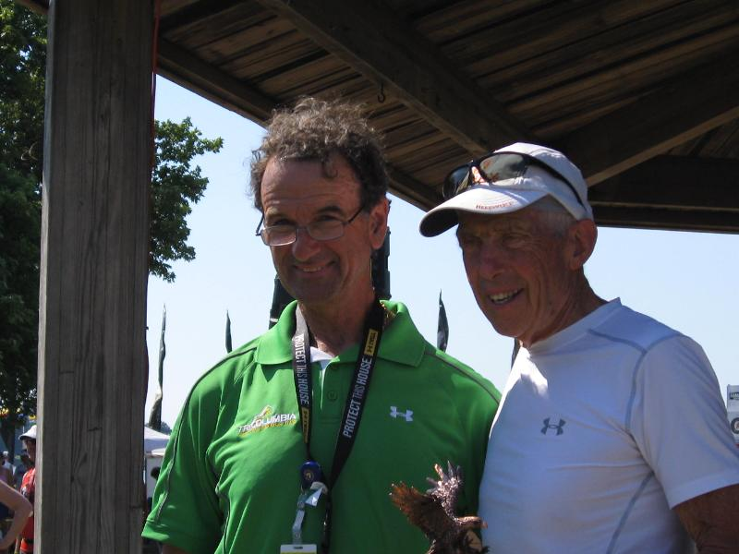Blazeman supporter Bob Scott with Vigo at EM...winning his age group(Bob is a young 82!) and on his way to Kona again!!!

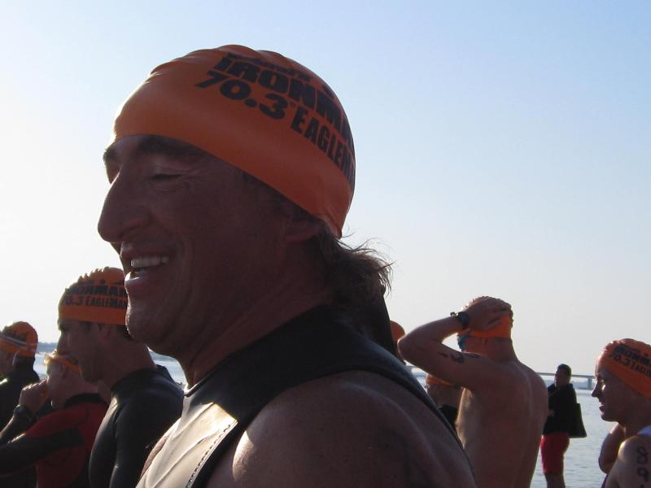Blazeman Warrior Francois Moreau waiting for his wave start at EagleMan

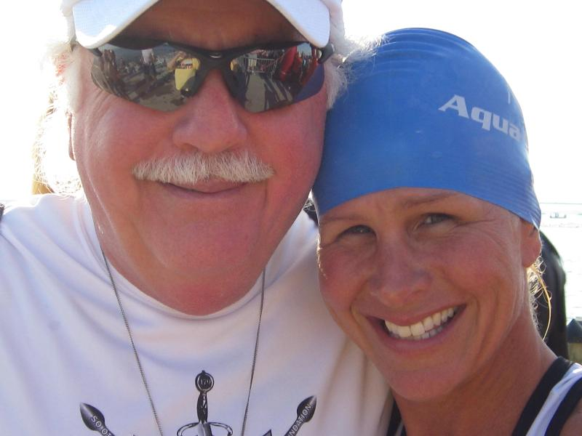Blazeman Warrior Princess April Harstook and Bdad at EagleMan swim start

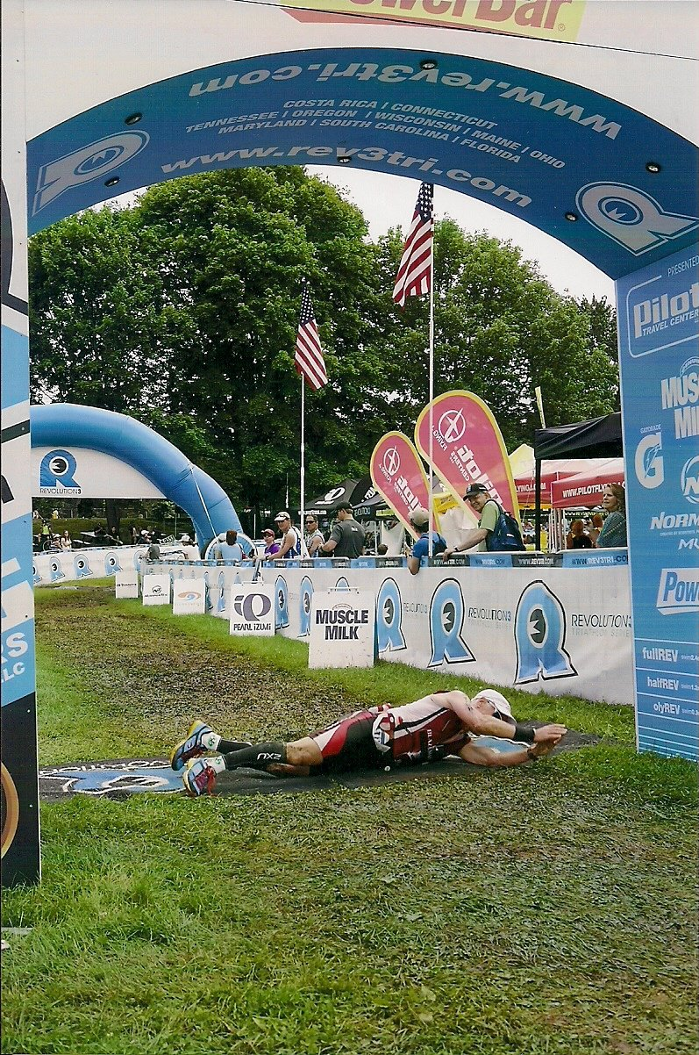Bob Heins rolling at Quassey 2012

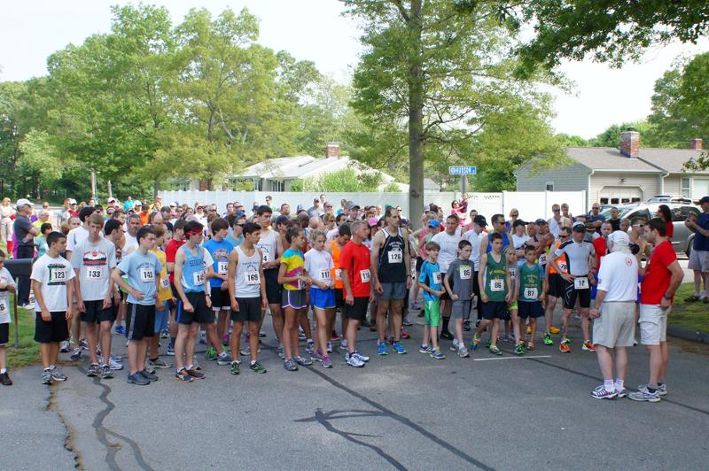Bob with the runners at the RunforPals 5k start

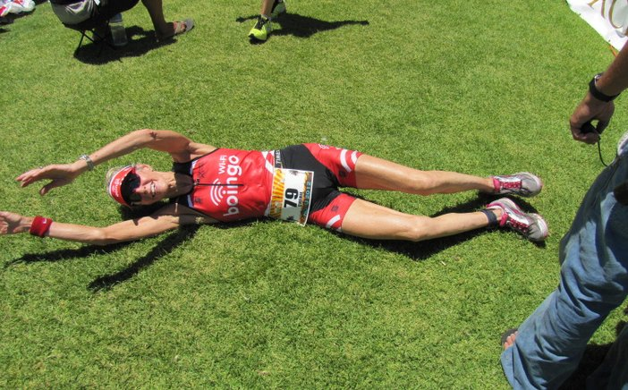Cherie Gruenfeld...age group champion as always rolling at Honu 70.3

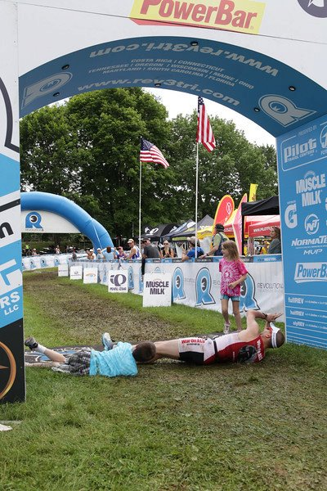Dan Kazup rolling with the kids at Quassey 2012

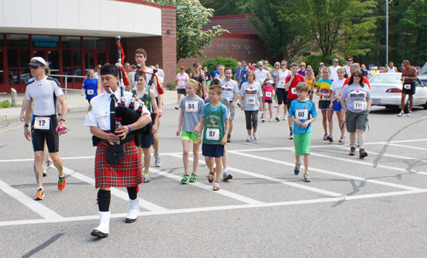The bagpiper leading the way to the race start at the RunforPals.on May 27th

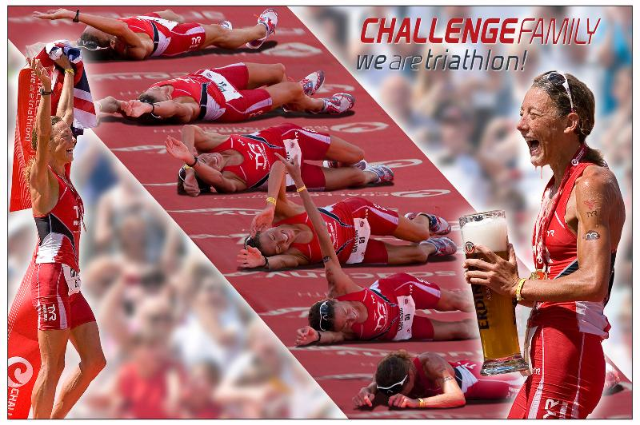We are triathlon...courtesy of Stegerwald, Michael taken at Roth, Germany 2012...Chrissie Wellington

