Happy New Year Blazeman Warrriors
and Supporters!
The weather here in Florida has been terrific...we are not missing the coats and mittens!
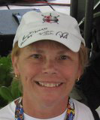
There is a lot going on as we prepare for the 2012 season...February is the month of our main fundraiser for our research projects...please consider hosting an event or if you can't a donation to one of the many sites would be greatly appreciated! Visit the website or contact Donna Dourney.

Jon attended the very first Cycle for ALS back in 2006 in the Chicago area and we're glad to see the tradition continue again in 2012!

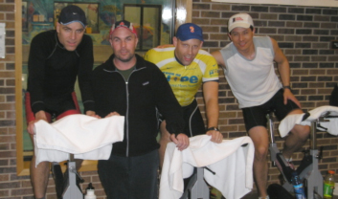

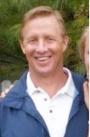
Well, we have learned about another triathlete with ALS...Doug Macinnes, an age grouper with a great family. Scott Tinley first contacted us in early December and in communicating with his wife, Sue, he is so much like Jon and just a great guy!

Please check out this piece on LAVA Magazine online. Some of you may know Doug and I would be happy to put you in touch with him...

Doug lived in the Maryland area for several years and is now residing in Indiana with his wife Sue and his children are all close by. I cannot tell you enough how much it saddens us every time we learn about another diagnosis...although we are very encouraged by the recent ALS research...we want, with all our heart to hear those words that play over in our minds: "I am an ALS survivor!" That can't happen soon enough. We need to keep the pressure on how important the funding is for ALS research...Bob and I promised each other when that day comes we will close up shop and become full time retirees!

Our Blazeman Foundation for ALS Tissue Collection endeavor has received its funding for 2 years and we are finalizing our web site announcement and press release...anyone interested in more information please contact blazedad and he will connect you to Ronald Zielke, Ph.D. at the University. We all realize the need for ALS tissue for research. Jon made that decision instantly and his commitment was total. More about this endeavor later in this newsletter.

We look forward to seeing many of you this year at the races!

Mary Ann
Jon's Mom

Request #179 - Keep the Spirit Alive!

For those of you who've recently joined us, I thought I'd share a story from 2007. It's a simple way to help raise awareness of our cause. I can tell you from experience, it's been a source of energy and inspiration for me on the last few miles of the race. Just looking down at that number, then glancing up at the sky...gives me such a rush of emotion and inspiration.
- Paul Fahey, Newsletter Editor and Blazeman Warrior

World Triathlon Corporation Pays Tribute
to Athlete Jon Blais
June 21, 2007: Today, World Triathlon Corporation announces a new initiative where all domestic Ironman, Ironman 70.3 and Iron Girl events will reserve race number 179 for athletes racing for a charitable cause. The race number was made famous by athlete Jon Blais, who made Ironman history in 2005 by becoming the first athlete with ALS to complete the world's toughest endurance event, the Ford Ironman World Championship, in Kailua-Kona, HI.

"The event always has been and always will be so important to me. When I am sitting in a wheelchair down the road, I will look back and know that I fought the great fight," said Blais.

In a short time, Blais became an invaluable member of the Ironman family, opening eyes and hearts to the seriousness of ALS. *After his participation in 2005, he returned to the 2006 event in a wheelchair to cheer on a fellow triathlete who was racing on behalf of the ALS cause. Although Blais passed away on May 27, 2007, his memory and the contributions he made to the sport will last forever.
Prior to being diagnosed with ALS, Blais was an avid triathlete and shared his passion for triathlon with activities such as mountain climbing and hiking. Blais applied his love for the outdoors to his profession, teaching students with special needs. Two years after his diagnosis in May of 2005, Blais founded the Blazeman Foundation, an organization dedicated to promoting awareness of and fundraising for those battling ALS. The foundation continues to grow and has expanded this year to include Team Blazeman, a group of athletes called "Blazeman Warriors" who have committed to raising awareness and funding a search for a cure for ALS... so others may live.

"Jon inspired Ironman staff, athletes and spectators on many different levels. From his outlook on life and the wisdom he exuded while battling ALS to his passion for Ironman, the impact Jon made will stay with us for the rest of our lives. Indeed, he fought the great fight, and we will miss him," said Ben Fertic, president of Ironman.

Athletes interested in racing with number 179 should contact the respective race director of the event in which they wish to participate.

Thanks,
-blazeman

*Jon's main reason to return to Kona in 2006 was to show the multisport community what one year does to an ALS patient...he did just that and the following year as he said..."I will be gone".
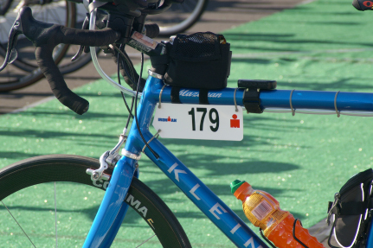

To Chrissie and Brooks, Thank You!

Bob and I want to extend our personal thank you for the generous donation to The Blazeman Foundation for ALS. The 200 pairs of shoes sold out quickly! For us, the support echoes Jon's vision of the multisport community coming together to help support ALS research...

When we see the enormous response by both athletes and people who have been touched in some way by ALS...it is quite humbling. Every time those shoes are laced up the wearer has the opportunity to not only share Jon's story but also to talk about ALS...what it is, who it affects and the research that is ongoing.

For two years now these shoes have been worn at races and events everywhere...spreading ALS awareness...the response has been overwhelming to us...we cannot thank you enough!!!

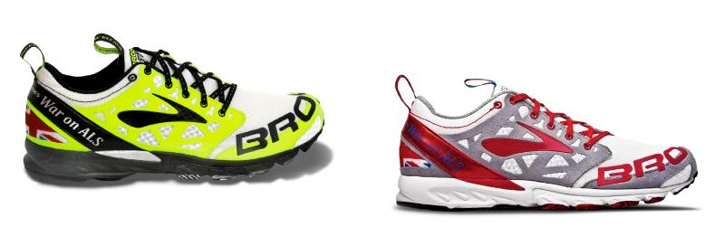
Best wishes for 2012 to all of you and we look forward to seeing these great shoes at the races!

The Blazeman Foundation for ALS has charity slots available at the EnduraFit Ironman 70.3 EagleManTriathlon!!!

The slots are $500.00 and the proceeds are earmarked for our soon to be formally announced research project at the University Of Maryland's Brain And Tissue Bank.

Before Jon passed away he made arrangements with Rob Vigorito, race director and neurobiologist at the Brain and Tissue Bank to donate his brain, spinal column, peripheral nerves and spinal fluid for research. Jon felt that this was a very important and little known aspect of ALS research. What makes this unique is this facility does not restrict any researcher from getting this valuable tissue. Any researcher, from anywhere in the world, working on ALS research, can request ALS tissue for the University of Maryland's Brain and Tissue Bank.

To our knowledge we will be the only family foundation to fund such a project. Athletes that purchase these slots will be playing a great role in allowing us to fund this project.

A special thank you to Rob Vigorito and the CTA for giving us this opportunity. Please visit Tri Columbia for more information.

Anyone interested in obtaining a Blazeman slot please contact me directly via email.

The Blazeman Foundation for ALS is proud to announce the finalization of the Establishment of the Blazeman ALS Tissue Collection at the University of Maryland Brain and Tissue Bank

Thanks to the support of the Columbia Triathlon Association and the generous supporters of Jon's foundation we are ready to start the process of ALS tissue acquisition. As we have mentioned before Jon donated his own tissue to this institution...he realized the need for ALS tissue for research and he readily donated upon his passing.

Please take a moment to read the final proposal online dated December, 2011. This is your support making a difference through research! THANK YOU!

Upcoming Events February and March 2012!

Cycle for ALS 2012

Please join us for the Cycle for ALS. For Further information on organizing an event please contact Donna Dourney.

Help us raise funds for our research..."so others may live" We are striving to surpass last years Goal! A great way to gather with friends, exercise and Support ALS research!!!!
Check out the sites on our website and join one or start your own! Need more inspiration, check out this amazing video from one of last year's events!
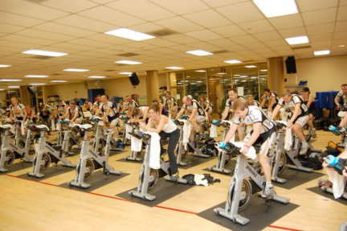

Greater Hartford 1/4 Marathon
Saturday, March 31, 2012
MDC Reservoir, West Hartford, CT

Register online today! Last years race sold out before race day...register early!!
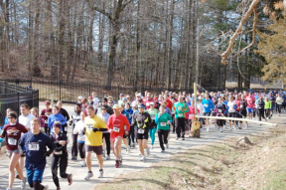
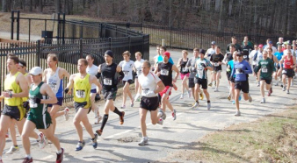

Our Dear Friend and Supporter Chrissie Wellington is Taking a Break from Ironman!

Chrissie recently announced on her web site that she's talking a break from the sport. We wish Chrissie the very best as she explores new opportunities inside and outside the sport of triathlon. Her immense talents far exceed the sport and she will be taking the road untraveled.

We all will be watching and enjoying her new ventures and look forward to opportunities that will allow us to see her more often. She will be starting her new book tour in the spring and we are so pleased that Jon has been included in her new book.

The Book is titled "A Life without Limits" and will be available on Amazon and in Book Stores soon.

Exciting times ahead!

Report from the Battlefields...
Paul Phillips, from Competitive Image Photography, donated six WC Chrissie Wellington's autographed prints and they sold immediately on eBay to benefit the BMF...Paul has been a wonderful supporter of the foundation and we are touched that he shipped them to Chrissie while she was in Seattle for her signature. The dedication of these two wonderful people brings a very warm feeling to our hearts. We know the people that purchased them are thrilled also!

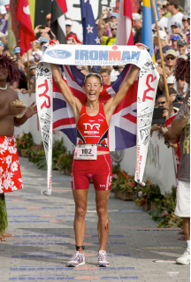
Courtesy of Paul Phillips...

Memorial Herman Kemah Triathlon race series in Texas has approached us to be a part of the chosen charities this coming race season...

We are pleased to be a part of this series which helps us to spread ALS awareness and help raise funds for our research...
to learn more about this opportunity please check out the following site...

You can also check out The Blazeman Charity link.

A reminder to visit the Blazeman estore. As always, your feedback is helpful!

Blazeman warrior, David Tinklepaugh, MD and supporter Garen Reidel are competing in the Boston Marathon this April...if any other warriors or supporters are doing this event...please let me know and "whatever you do...get it on film " and send to bmom!

A message from the heart...it sure warmed mine...

Had a wonderful message today on utube...Jon's video...warmed my heart...

Thank You
To: blazemanmom
I was really touched by Jon's story. I am an undergrad at the University of Texas at San Antonio and have done a lot of research in neurophysiology; specifically, Sudden Infant Death Syndrome (SIDS). When I saw this video last year, I had decided to complete an Ironman and have been training ever since. I am now signed up for the 2012 Ironman Western Australia and watch this video every day before my workouts. His story has helped me push through some hard times and has also inspired me to get a master, then a PhD in the field of ALS research. Funny how someone you have never met or never will meet can inspire someone they will never know. His story and family have changed my life. Words can't express my thanks to him and his family.

A Warm Welcome to our newest Warriors!

We are pleased to welcome the following newest warriors to our family. Thank you, and everyone else, for all you do to help our mission.

Amy Campbell
Felicia Long
Bradley Waller
Lucy Kammer
A big welcome to all of you and we hope to see you all at a race this year...please visit our
ning website and start communicating with other warriors and supporters.

Photo Gallery
Thank you so much for sharing your highlights and favorite moments from the 2011 season! But don't stop now!
Please keep sending your photos!
We love hearing your stories and seeing you in action!

Denise Hildebrandt Hiller wearing t7 for her wedding!
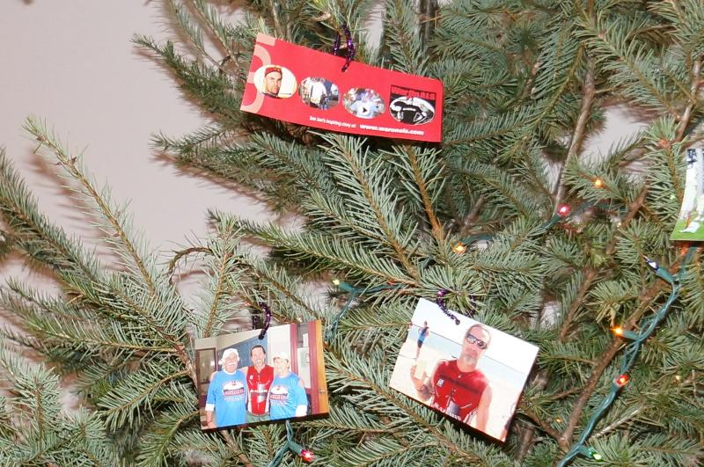
Sean McCarthy's Blazeman Christmas Tree!
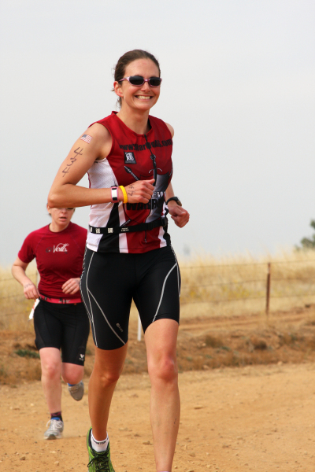
Danielle Liubicich Luna Tri 2011
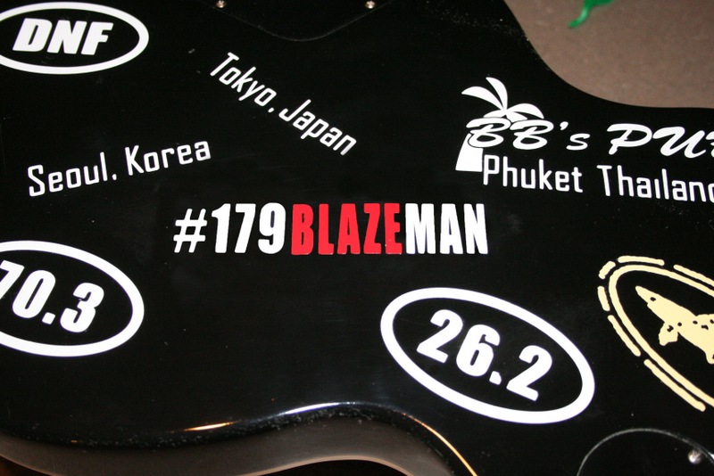
David Schultz 179
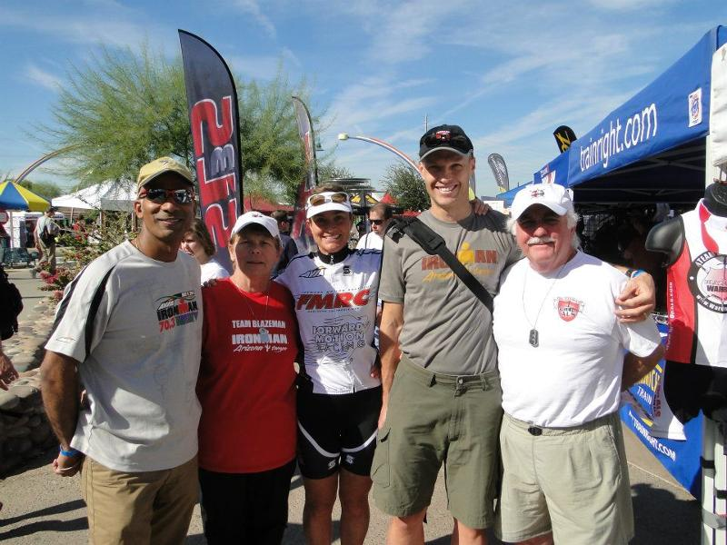
IMAZ with FMRC athletes !!!!!
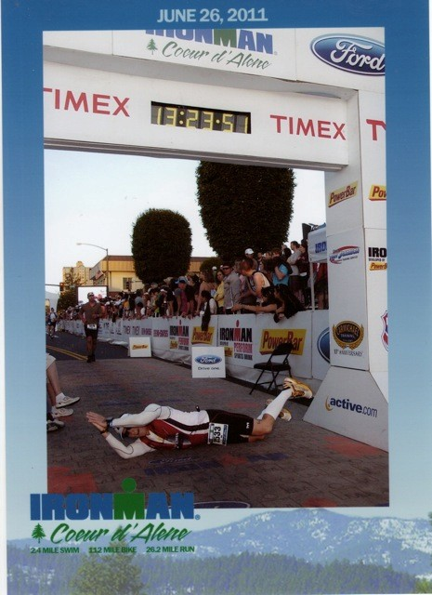
Joe Devorick CDA 2011
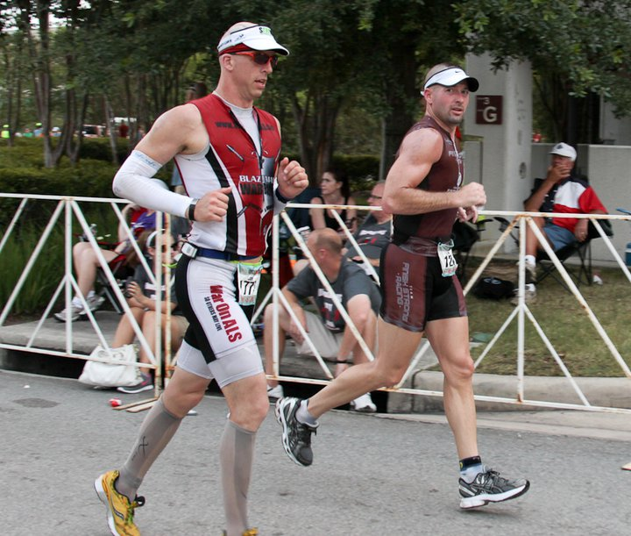
John Laskowski at Texas Ironman
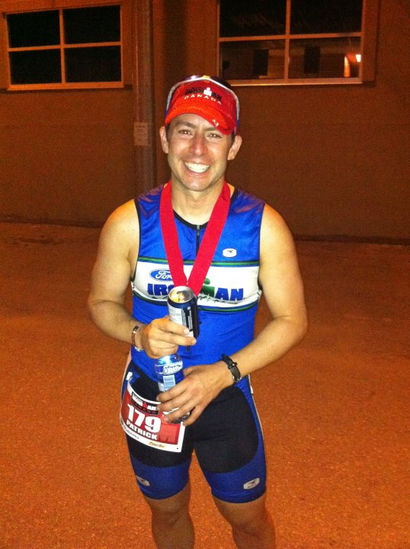
Patrick Nardi #179 Canada 2011
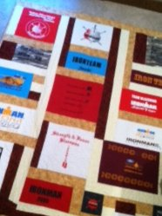
Trevor Waagner's wall of ALS

