Happy Holidays Blazeman
Warriors, Friends and Supporters!
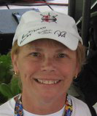
Another year coming to an end. It always makes me very reflective of all the wonderful people that we have met on this challenging journey to battle ALS. I remember saying shortly after Jon's diagnosis that all the people we connected with that had ALS were all so nice. Not a bad person among them. That still rings true almost seven years later. It seems to be a nice person's disease. I guess the question is WHY?

For us, this was a different kind of year as we focused on strengthening the foundation's "bones" and to do that we reallocated the travel fund budget. For the first time since 2005 we did not travel to Kona and had to be satisfied watching many races online. It wasn't not easy but we felt it necessary. Our other focus was to secure funding for new research projects. As I write this I am reminded that I purchased a few extra Powerball lottery tickets today. Oh, what we could do with that jackpot! I am smart enough to know my chances are slim to none! (Postscript: we did not win, so back to the drawing table for us.)

I would like to take this opportunity to thank everyone that has "rolled" a finish line this past season. I know deep in my heart that Jon would be so pleased that for every roll ALS is remembered and it honors all PALS with this disease. We desperately want to help at least find an effective treatment, if the cure is so elusive. Reflecting again back to Kona, Jon knew he had but one chance. There would be no repeat trip to race. Only one more time to watch in a wheelchair and as he said in 2007 he would not be in front of any camera, he would be gone...that is the reality of ALS.

Since the last enewsletter, Blazeman Warrior, Leanda Cave, became the 2012 World Champion at both the 70.3 and Ironman in Kona...congratulations Leanda! Leanda has been an ambassador of the Blazeman Foundation since she met Jon back in 2006 when we took him back to Kona. Her support has been unwavering and we are blessed to know her!
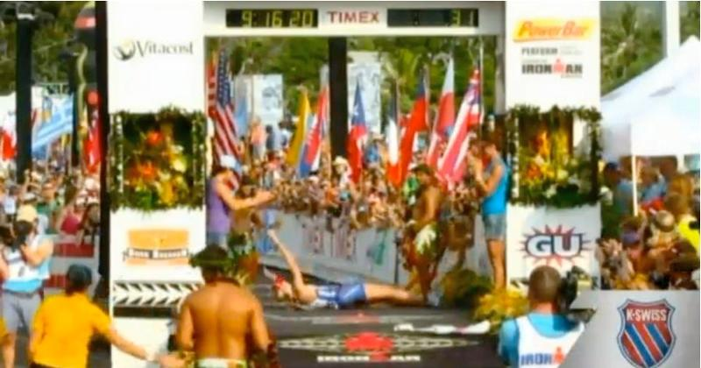
Leanda Cave rolling finish line win in Kona

This year, Garen Riedel, had the honor of wearing #179. Garen lost his mom to ALS in October of 2009 and we know he carried his mom, Leslie, with him through to the finish line in Kona. Thank you Garen for your continued support!
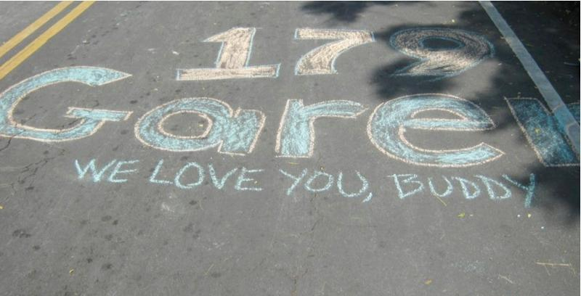
Below are a few more pictures from Kona and other races that you all have sent. The more I get the more we can post! We love everyone of them and hope you continue sending them to me. Check out the web site's home page image scroll as the pictures changed this month. They change often, so keep checking back! Also, visit the estore for some great Blazeman gear. They make nice gifts!

Merry Christmas, Happy Chanukkah and New Year to you all!
Mary Ann
Jon's mom

Save the Date! Dinner, Concert and Silent Auction to Benefit Blazeman Foundation.
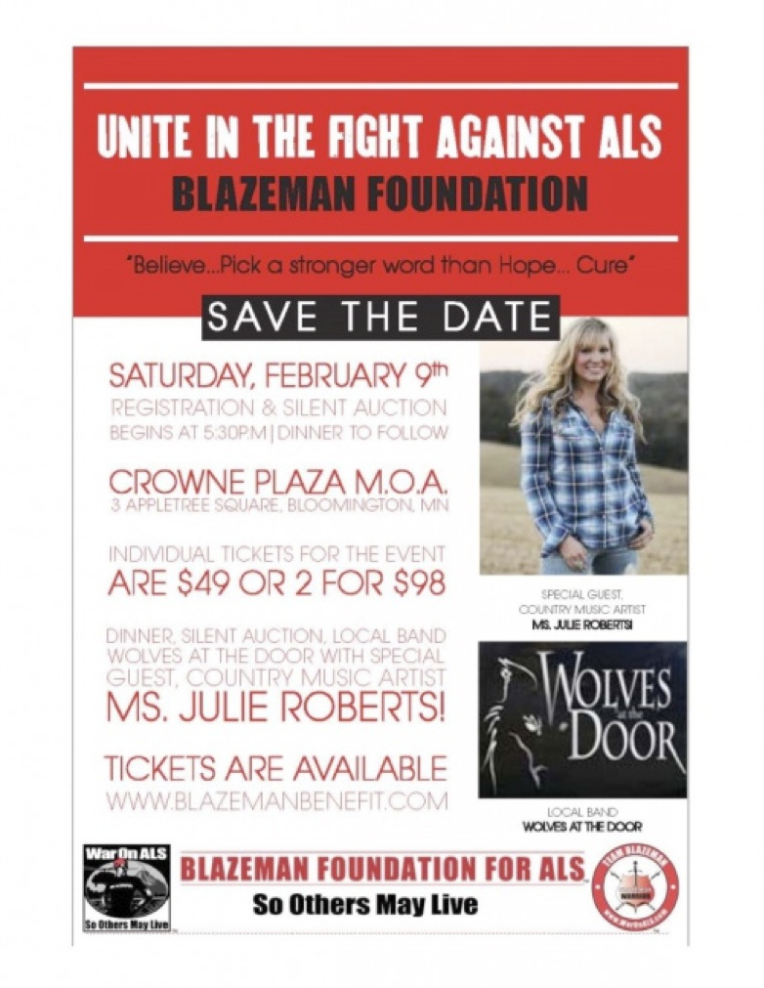In honor and remembrance of all of those who have battled with ALS and in support of all their loving family and friends, we invite you to join us on Saturday, February 9th at the Crowne Plaza-Mall of America in Bloomington, MN for an exciting evening to help raise awareness and help win the War on ALS with the Blazeman Foundation. We have a great evening planned for you including live performances by the local band, Wolves at the Door and country music recording artist, Julie Roberts. Whether you are a rock & roll or country fan, this evening is sure to please.

If you can't make the event, donations are being accepted through the Donate Now link below. Please feel free to tell your friends - this event is "the more the merrier" and we'd like to raise as much awareness and funds to support Winning the War against ALS as possible.

The benefit is being coordinated by Danielle Johnson and Becky Zamora with the help of family and friends. If you have any questions or would like to make a donation, please contact them.

Thanks you Danielle and Julie! Your continued support in the War on ALS is so appreciated by us and all PALS!

Wishing Chrissie a great new beginning (after a fantastic finish!)
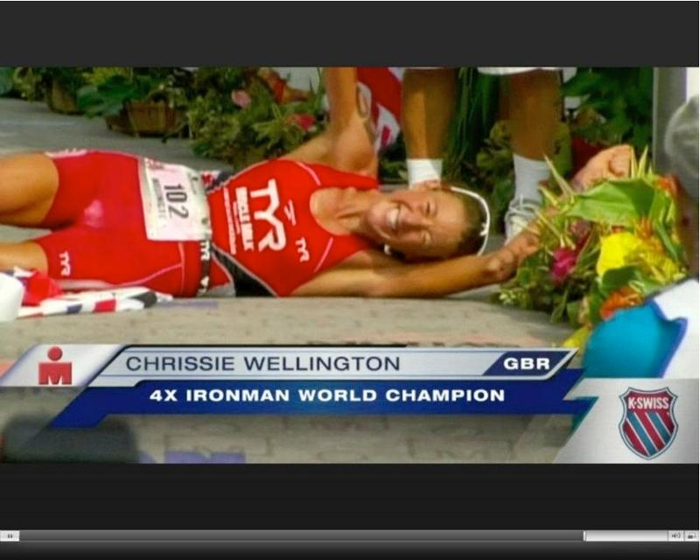
Chrissie had the perfect race and touched the hearts of all of us along the way. We look forward to watching her follow a different path and know she will conquer that as well. We shall miss your talent and smile on the race course.

In Chrissie's own words, "As an athlete I sought 'the perfect race.' That race where I dug to the depths mentally and physically...and that hard fought race with my competitors. The World Championships in 2011 was the icing on the cake for me as an athlete. It was my "perfect race" and it completed me."

Chrissie has been a great ambassador not only to the sport of triathlon but also to the Blazeman Foundation for ALS. We thank her for her time and generosity. In my recent communication with her, Chrissie has stated she wants to remain an ambassador to the Foundation and we welcome her continued support. She has given Jon's parents many warm memories and we have always felt a part of her family.

And speaking of retirement...

Well, I did not think I would be writing about another dear friend retiring but Rob "Vigo" Vigorito is doing just that. Kevin MacKinnon wrote a fitting article for Ironman describing him best.

Jon met Vigo in 2005 when they both did Ironman and the rest is history. Only a few people know that Vigo was the last person to be with our son as he harvested his brain, spinal column, peripheral nerves and spinal fluid for ALS research. That truly was the beginning of our commitment to the University of Maryland's Brain and Tissue Bank.
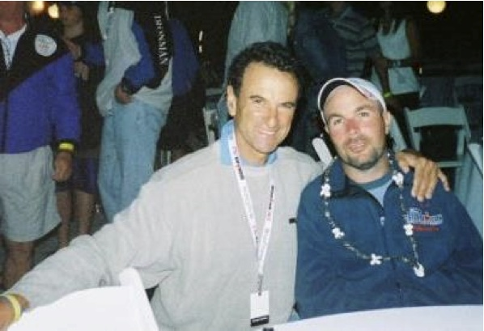
Vigo and Jon in Clearwater Nov 2006

Thanks, Kevin MacKinnon, as always for capturing the essence of the person. This time "our Vigo" who has been more than a friend to us. You are right, he still will be involved in the sport, just a bit more time to do other things.
Bob and I look forward to celebrating with you in Columbia in May!


The Blazeman Foundation for ALS Charity Slots Announced for EagleMan 2013

The slots are $500 each and 100% of the proceeds are earmarked for the University of Maryland's Brain and Tissue Bank, a program for ALS patients to donate their tissue postmortem for research. This is a much-needed area that most ALS patients and their families are not aware of. Jon donated his organs, realizing how important and underfunded this area is. Of note, Robert Vigorito, TriColumbia President and Race Director harvested Jon's organs; they had met in 2005 competing at the Ironman World Championship together.
For more information on racing at the Ironman 70.3 EagleMan Triathlon "for a cause bigger than yourself" please contact Blazemom via email or online.

Bob and I look forward to seeing you all at EagleMan in June!

ALS Research Update

Dec. 7, 2012
- The debilitating symptoms of amyotrophic lateral sclerosis, or ALS, appear to be increased by a lack of inflammation-reducing T cells, report scientists from the Methodist Neurological Institute in an upcoming print issue of the journal EMBO Molecular Medicine. The researchers found that expression of the gene FoxP3-which helps control the production of anti-inflammatory T cells-was an indicator of disease progression in 80 percent of the patients they studied. Low FoxP3 levels were likely in patients whose ALS would develop rapidly, and vice versa. Read more about this exciting breakthrough online.

Cycle for ALS coming in February 2013
(be a part of it!)
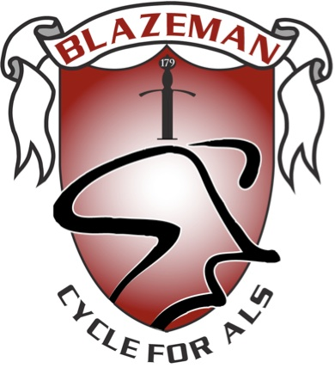
Ride for a Cure. So Others May Live!

Organize your own Cycle for ALS event or take part in one of the planned events in your area. We encourage folks all over the country to organize their own event, it's a simple process and can be accomplished with very little effort and lots of help from us. It can be scheduled any time in the month of February. All you need to do is find a place to spin and invite as many people as possible to participate. If you're lucky enough to live in a warm climate, an outdoor ride is also easy to organize. Indoor facilities such as YMCA's, health clubs, cycle chops, sporting goods stores or spin studios are great locations for visibility and the use of spin bikes. Enlist the help of spinning instructors to make it creative and motivating.

Use your imagination, be creative and make it different than a regular spin class and you'll have a line of people waiting to be a part of it.

We're here to help you organize a successful event and will provide each event organizer with the following:
- A Blazeman Foundation Fleece
- A Cycle for ALS Banner
- Information on the Blazeman Foundation for marketing & sponsorship
Please contact Clayton Tebbetts or Blazemomif you would like more information and would like to organize a ride!

From the Battlefields

Thoughts from Blazeman Warrior, Dr. Jeff Galvin:
...here's the thing, sooner or later we're all going to die. The question is, how much life do you plan to squeeze in before you do so? I can tell you this, after watching two friends wither on the vine with ALS, I'm going out fighting. No one can say when my date with destiny will come. What I do know is, I won't be sitting in a wheelchair somewhere wishing I'd done that one last race, or taken that one last trip, or said that one last "I love you" to my girls before I couldn't speak anymore. Ten years ago I was 40 pounds overweight. Four years ago I hadn't run more than 5 miles at any given time. Since then I've got 4 marathons under my belt (including Boston), 4 or 5 half marathons and a half Ironman triathlon. Anyone can do this, anyone. The only question is when can you start, or rather, when will you start? "The meaning of life is to live."

News from our friend Sue Macinnes who lost her husband Doug last May to ALS...congrats Sue!
Sturdy Trees, published Nov. 18th, all proceeds go to StepsforDoug Foundation. Co-authored with a friend, Michele Demeo who has ALS. Michele asked me to write a chapter about Doug and so I did.
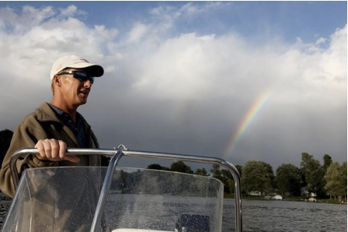
Recently, we sent out our end of year letter outlining what we do with the generous support of our donors and how judicious we are in our spending. If you are considering an end of year charity donation, we are a 501c3 and your donation is fully tax deductible. Donations are gladly accepted through our website.
Time to register for the Greater Hartford ¼ Marathon. We thank you for your continued support!


As you plan the end of your fiscal year...
Recently, we sent out our end of year letter outlining what we do with the generous support of our donors and how judicious we are in our spending. If you are considering an end of year charity donation, we are a 501c3 and your donation is fully tax deductable. Donations are gladly accepted through our website http://www.active.com/donate/blazemanAlso checks can be made to "The Blazeman Foundation for ALS" and mailed to our secure address:The Blazeman Foundation for ALS
18 Maple Ave
PO Box 121
Barrington, R.I. 02806
Thank you all again for your continued support!
Keep your stories and pictures coming...we love hearing from you all!

A Warm Welcome to our newest Warrior!

We are pleased to welcome the following newest warriors to our family. Thank you, and everyone else, for all you do to help our mission.

Andrea Torrico
Don Soranno

A big welcome to you and we hope to see you at a race this year...please visit our ning website and start communicating with other warriors and supporters.

Photo Gallery
Thank you so much for sharing your highlights and favorite moments from the 2012 season! But don't stop now! Please keep sending your photos!
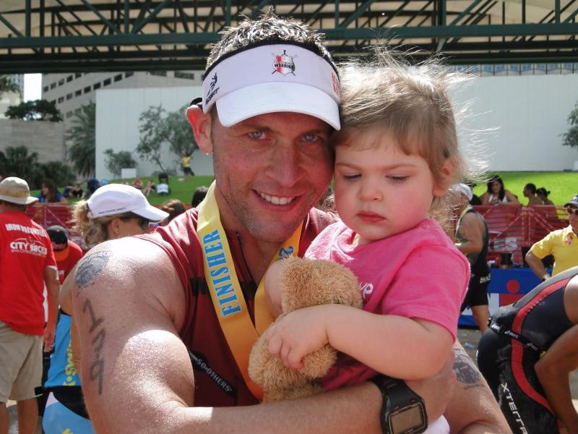
Yair and his daughter Mia at Miami 70.3 2012
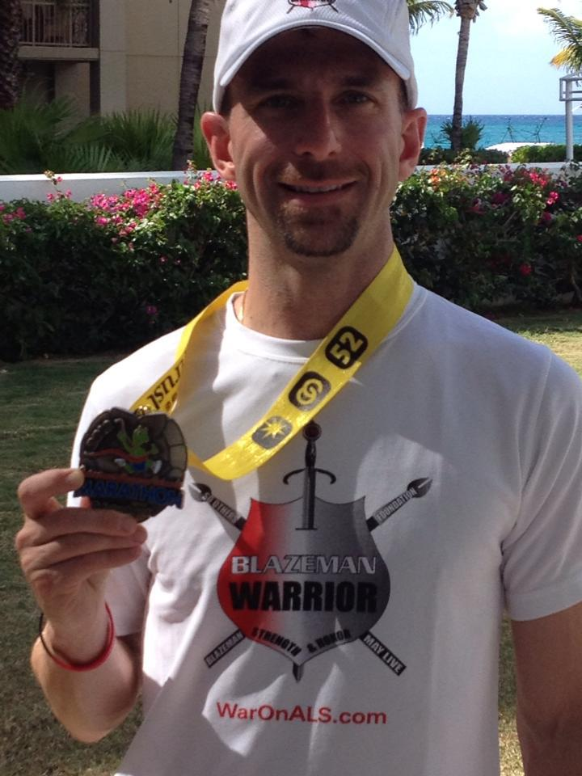
Don Seranno at Grand Cayman 2012
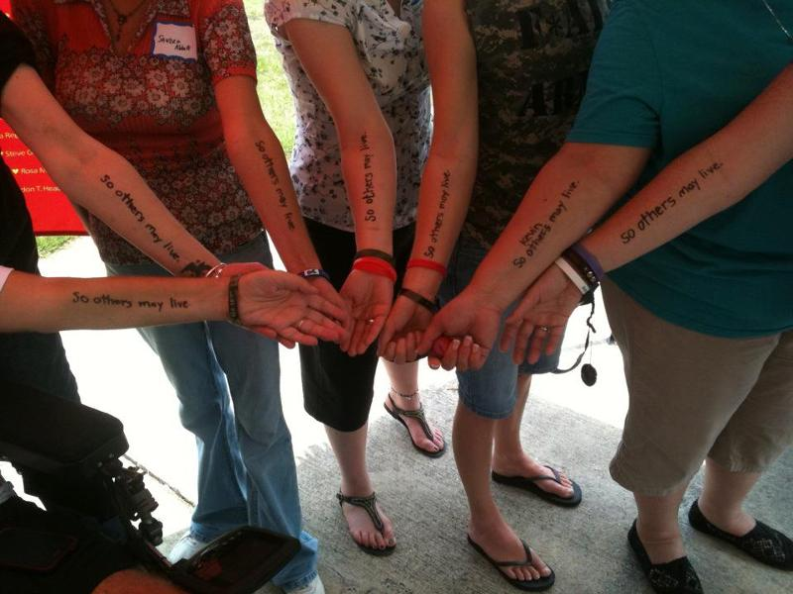
"...so others may live."
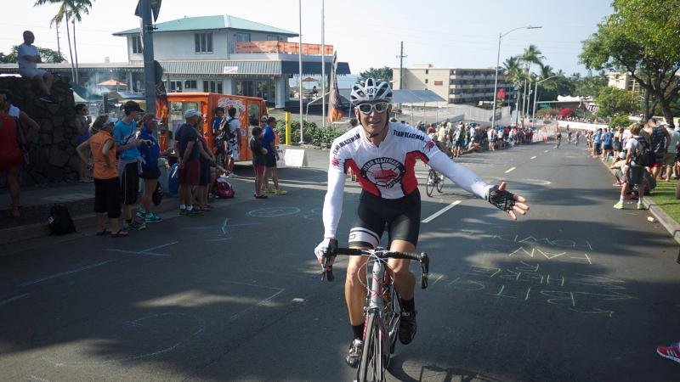
Darin Nellis looking good on the bike at Kona 2012
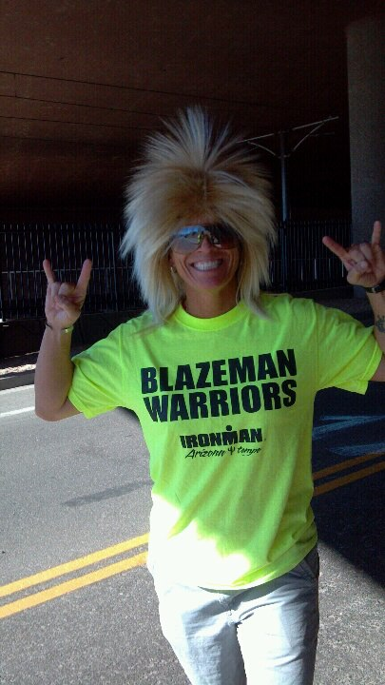
Deanna DeMarino at IMAZ 2012
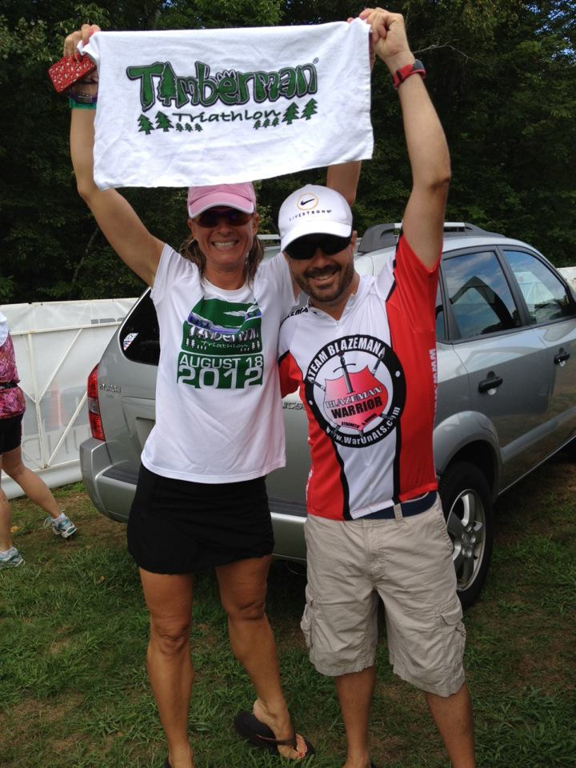
Kirstin and Dennis celebrate their personal best at Timberman!
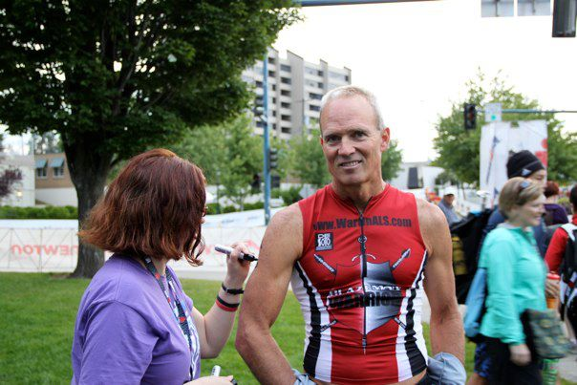
John Ryan at Ironman Canada 2012
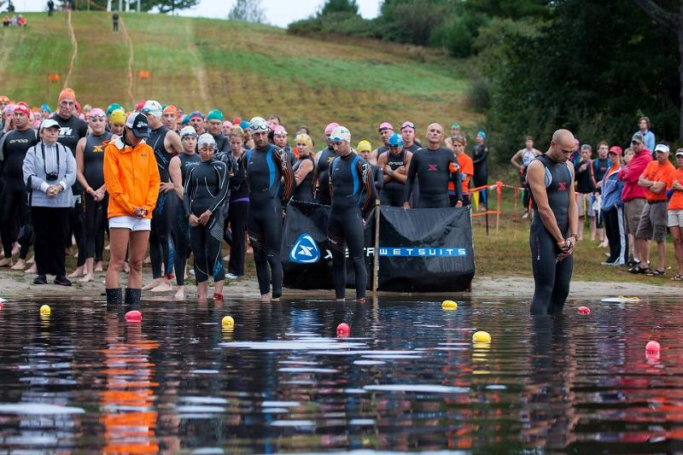
Matt Russell leaving Jon at Pumpkinman (Photo by Davis)

