Greetings from Sunny Florida!
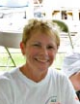
Having spent the winter here with Bob after my knee surgery, we happily avoided all the cold and snow back home in Massachusetts. Bob returned home a few weeks back to attend the local spin events. I have stayed so I can get out every day and walk and quietly work on the newsletter. Being here still brings me back from December 2006 to the end of May 2007 when Bob, Jon and I spent our last months together. Jon remained so strong to the end... Every time he laughed I was in awe that he could...so many memories...

We are happy to report that Jon came out on top in the Facebook contest on the most inspirational story from Ironman... He was in the company of some great and inspiring people. The WTC made a donation to the Blazeman Foundation for ALS of $750.00 as the winner. The awareness this created is so welcomed and the donation has been put toward our awareness budget. Thank you WTC!!!!

The 6th annual Cycle for ALS events throughout February were a wonderful success under the direction of Donna Dourney. A full recap of the events is below...please share our thanks to the wonderful groups of people that helped make it the success it is...the combined monies raised are still being totaled. If this is an event you would like to host next year please contact Donna through the website.

Bob and I are busy planning our expo events for the year...the events have exploded to the point there are multiple races every weekend. Please check our website for where we shall be.

Two of our warriors are planning events that benefit the BMF...Tim Smit and locally Joe Goddard...more info below on these events.

If your plans have you in the Hartford, CT area in early April, be sure to cheer on the runners at the Quarter Marathon on April 2nd!

Bob and I hope to see you all at one of these events this year. Remember, you can always email or call us on our toll free number...we always welcome hearing from you! Last but not least quoting Jon...whatever you do "get it on film"!

Mary Ann Blais
Jon's Mom
Blazeman Foundation for ALS

PS - A reminder on the Blazeman Slots still available for the Subaru EagleMan Ironman 70.3, but they're going fast. I can help you with that. Just send me an email.

Update on the 6th Annual Cycle for ALS

Throughout the month of February our warriors and supporters had their super cycle events for the Blazeman Foundation for ALS. From Rhode Island to California there were 16 sites, cycling for the Blazeman Foundation for ALS!!

This year's campaign was coordinated by Blazeman Warrior, Donna Dourney, who lost her own dad to ALS in 2009. Donna did a fantastic job and we can't thank her enough for the smooth and organized way she put this event together.

Bob, Donna and I thank the following friends and planners for making this year another great success!

Pro Triathlete, Leanda Cave, again participated at the Club Sport San Ramon, leading a sold out class. Jenn Sereque was the site coordinator this year which for this club was very personal. One of the club's members Pete Zucker was diagnosed a year ago with ALS.
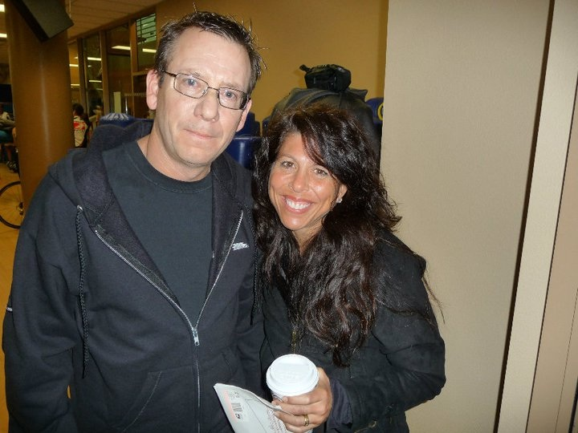
Pete had contacted us around that time and we have been in touch with him and his wife Monica throughout the year. Pete and his wife are both triathletes, again reminding us how much this disease knows no boundaries. Their good friends Chris McCrary, president of the club and John Fulton have been very supportive. John put together a great slide show of the event which summarizes the commitment they have for their friend.

Donna's event was held at the Somerset Hills YMCA in New Jersey on a snowy day but a success nonetheless! Carrie McCoy's group at the Premier Athletic Club in Columbus, Ohio spun also that weekend.
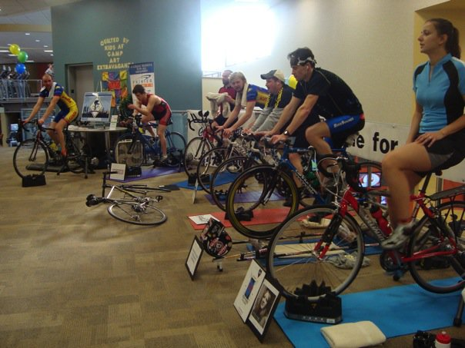

Also on the West Coast, Catherine Rochat, had an outside ride where the weather was beautiful!!
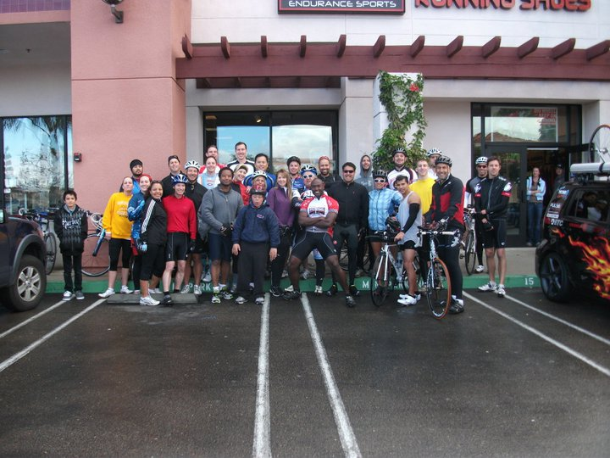
Among the events was Joe Goddard at Spinworks in Rhode Island...right in our back yard.
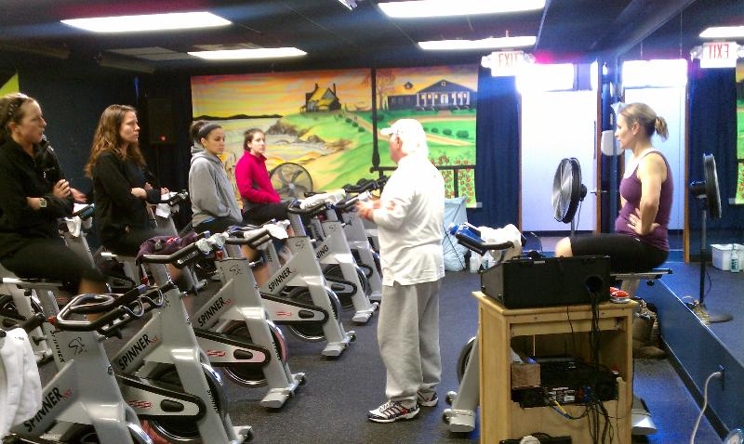Bob was able to attend that event, enjoying all the heat in that room on a cold winter day. Joe is also planning a road race in Seekonk, Mass. More on that below!!

Ray Mullen and Lisa Decker hosted the Denver event again at M Lone Tree Fitness and quoting Ray..."Our event was better this year than we could have imagined it. Lisa is a great partner and we both feel that our lessons learned and the traction gained from this year's event will position us for a great event next year".
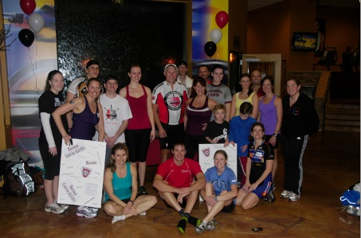

Our Blazeman Warrior Princess, April Colescott Hartsook, took her event at the RobinHood YMCA to the airwaves as she was interviewed by her local TV station. April's high energy and love of her sport has motivated many of her members in her classes!
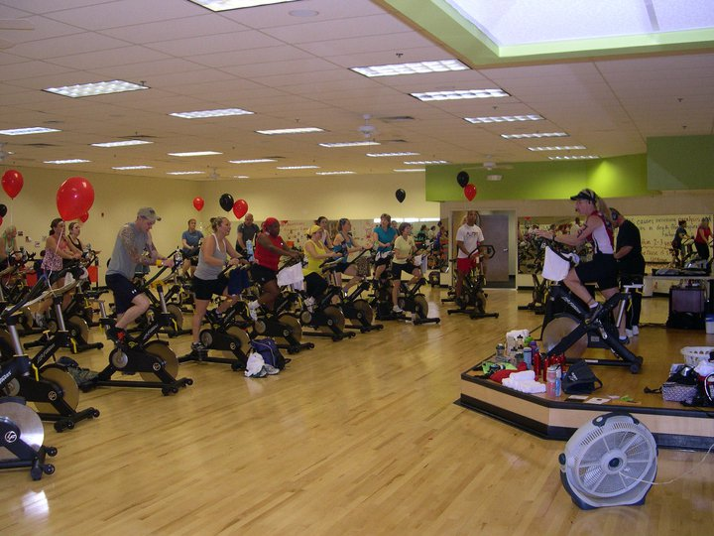

The Twin Cities Cycle was held at Optum Health Performance , in Minnesota, hosted by Marta Lewinski was an event that I had the opportunity to call into and talk a bit about our on-going research projects. Thank you, Kris Swarthout, for assisting me with that!
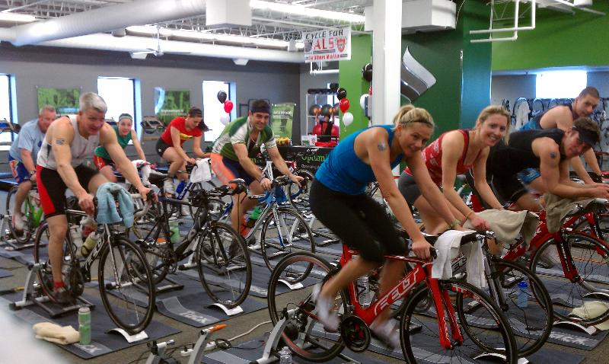

Bob attended the Soul City Cycle event headed up by Phil Gormley again this year. Phil lost his sister Claire Collier to ALS and is committed to finding a cure. Jon and Claire met each other back in 2006 at the Westchester Triathlon. Attending this year was Roger Petrone, a PALS who is a constant at Claire's climb at the Westchester Triathlon. The Greenwich police force attended in support for Roger.
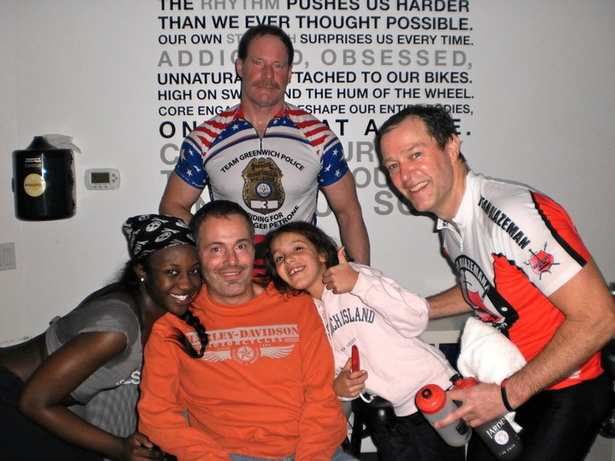
Each class ended with the call for "FREEDOM!!!!... This is what we wish for all ...Freedom from ALS.

Bob Mitera's event was held this year at the Village Cycle Sport who has agreed to have the event their again next year.
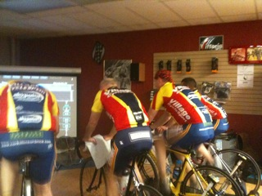
Thanks Bob for continuing the cycle event in the Chicago area!!!

Jeff Hadwin shared this photo of their team riding the bikes in the break room at their Frito Lay plant. As you can see, they had some funny bets involving the Chester the Cheetah head if enough people donated to you.
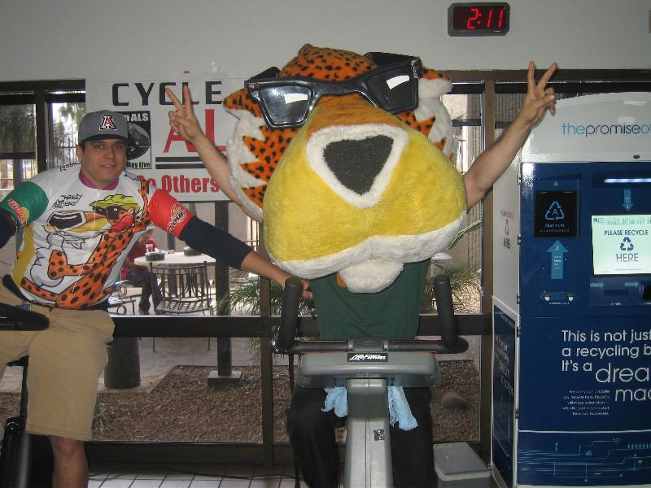

Rounding out the events are Villa Sport Athletic Club hosted by John Laskowski, Inspire U hosted by Ryan McCready, Snap Fitness hosted by Bret Corn, Momentum Fitness hosted by Lisa Peterson, Matt Chauvin and Fitness Center at Southshore Harbor, TX. Please send me pictures when you get them...

The Blazeman Foundation for ALS is grateful for the support of all the athletes and clubs that have participated in our annual event. Without your support we would not be able to fund the research projects that we are funding. Thank you all again and we shall update you all when the monies are totaled.

Check out all of the slideshows online here. They're located on the "find an event" dropdown.

Greetings from Blazeman Warrior David Tinklepaugh!
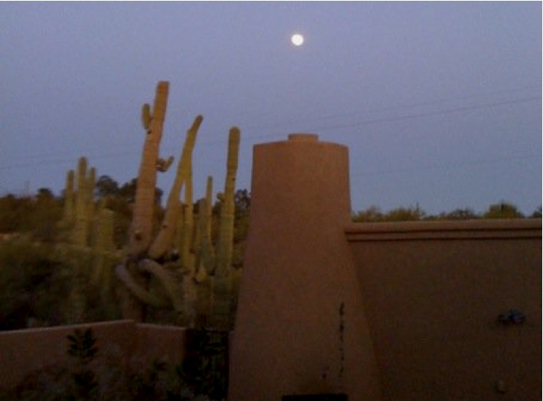
Greetings Blazeman warriors, I am gauging interest in a winter triathlon training camp in Tucson, AZ in 2012. Hopefully it will be the inaugural camp of an annual event. The camp is hosted by The Cycling House. For the sake of brevity let me say, this camp is a fully supported 3 sport mecca for training and slaying the winter doldrums. It is run by professional cyclists, triathletes and mountain bikers who lead the rides, runs and swims. They cook all the food, one of them is a professional chef, and answer all your questions about training, racing and nutrition. I'd like to aim for a camp of about 15 of us the first year, but if we get more interest, the camp could certainly expand. If you are interested, please email me. I can give you first hand information. I am working with the owner to secure the best deal, but as an all inclusive camp, it is well worth the money I have spent in the past.

A Warm Welcome to our newest Warriors!
We are pleased to welcome the following newest warriors to our family. Thank you, and everyone else, for all you do to help our mission.
Lenore Convery Jannalyn Luttrell
Linda Watson Plummer George Pravda
Kerry Hutchins Justin Plummer
Barry Sopinski Carolyn Perry
Collen Bennett John Clark
Josie Orrick Gregory Walsh
Bob and I welcome all of you and wish you success in your races and fundraising and we hope to meet you all at one of our events.

Blazeman Warriors Tim Smit and Danielle Johnson
Like many of us, Tim Smit was drawn to the Blazeman Foundation from the IM TV coverage in 2005 and 2006. "I was fresh off my own Ironman and was watching the show when they profiled Jon Blais. I don't think I ever cried in front of a TV before, but that story moved me beyond words, recalled Tim. "I ran with it and got involved."

But Tim and Danielle had another connection to ALS. Around the same
time, Tim and Danielle watched the progression ALS took on their friend John Schleppenbach. Separated geographically and never knowing one another, John Schleppenbach and Jon Blais lived their final years out very similar along with their families. Now, they have become a part of one larger family, knowing they are not alone and that the Blazeman Warriors' are fighting this War on ALS for the ones who have lost the battle. Today, Tim Smit and Danielle Johnson are two Blazeman Warriors working together to carrying that torch and fight the War on ALS.
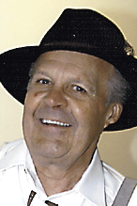
John Schleppenbac

In honor and remembrance, they are hosting an event on Friday, May 13th in Tracy, MN. It's an exciting evening to help raise awareness and help win the War on ALS with the Blazeman Foundation. They have a great evening planned including a silent auction and live performance from local artist Kayla Daniels and from country music recording artist, Julie Roberts (including a meet and greet opportunity).

"When I race with number 179, I know that Jon is with me on the course. It's sounds kinda strange, but it's true. I keep telling Bob (Blais) that Jon is still with us. He still has an impact of many lives. Whether it's on the course or at our event...he's with us."

Tickets are available online. If you can't make the event, donations are also being accepted through the donate now button.

Run for PALS in Seekonk, MA on May 29!
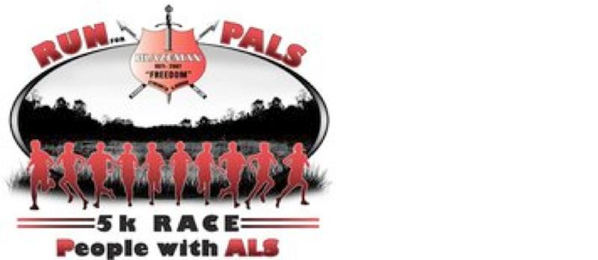
The 1st annual Run for PALS 5K will be held on May 29th at 10:00AM starting from Seekonk High School. Blazeman Warrior Joe Goddard and team are the organizers and the event will benefit the Blazeman Foundation for ALS. This is the high school Jon attended and we hope to see many of the students, former and present, come out for the race!

The race course is a flat out and back course. Set a new PR and enjoy family and friends while helping find a cure for ALS. Course calibrated by Ray Nelson. Map is available on Facebook at RI Multisport.

Please check out the website and we hope to see many of you there!!

Nominations open for the Blazeman Spirit Award, presented at EagleMan 70.3
"People do not follow titles, they follow courage. If you will just lead them onto the battlefield, they will follow you." - Bravehart

The Blazeman Spirit Award is given annually to a participant in the EagleMan Ironman 70.3 who most exemplifies the spirit of Jon "Blazeman" Blais. While many are familiar with Jon's heroic performance in the 2005 Ironman World Championships in Kona, Hawaii, few are familiar with Jon's professional life as a special education teacher at the Aseltine School in San Diego, CA. Here, Jon focused his energy on helping kids who were emotionally challenged and learning-disabled. This is also where he became better known as "The Blazeman." Jon did amazing work with the kids. Through summer recreation programs and outdoor activities, his students learned to overcome obstacles and become stronger through hard work and determination. The Blazeman Spirit Award keeps Jon's memory alive by recognizing an individual who inspires others to become a better person; leads by example; and has a passion for the journey of life.

The winner will receive:
· A complimentary 2012 entry to the SUBARU Ioronman 70.3 Eagleman
· An Eagle Award, the emblematic symbol of Eagleman called, "Blaze," and certificate.
· Complimentary Ironman level membership to Team Blazeman.

Nominations are due by May 1, 2011. The winner will be announced during the pre-race expo/event expo on Saturday, June 11, 2011. The nomination form is available online by clicking here.

To read about previous winners visit our website.

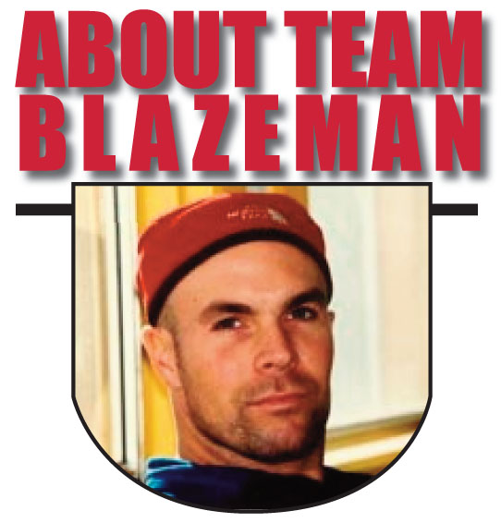
On May 2, 2005, twenty-year Multi-Sport veteran Jon Blais a.k.a. "Blazeman" at age 33 was diagnosed with the fatal motor neuron disease ALS (Amyotrophic Lateral Sclerosis). Blazeman dubbed himself the "ALS Warrior Poet" and brought his battle to the big island of Hawaii on October 15th that year, where he became the first person with ALS to complete the Ironman World Championships. It was his last race. In 2006, a number of athletes, inspired by Jon's 2005 efforts, rolled across the finish line in Hawaii in honor of Jon and his battle against ALS. In 2007, the Blazeman Foundation for ALS expanded Team Blazeman, comprised of "Blazeman Warriors" who have committed to raising awareness and funding a search for a cure for ALS..."So Others May Live."

