Happy Summer Blazeman Warriors,
Supporters and Friends!

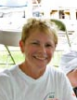
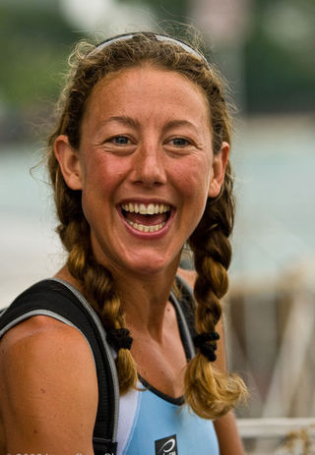
It has been a very busy month for the foundation...Since our trip to St. George, Utah we have been to the Rev3 at Quassy and just recently EagleMan. Both events were very successful and it is always great renewing friendships we have made on this journey. A heartfelt thanks to the Gollnicks and Bob Vigorito and their staffs for making us feel welcome.
I am writing this letter just prior to Father's Day...as many occasions are for us, this too is bittersweet. By the time you read this July will be approaching and we are in the midst of race season...don't forget to hug those most important in your life!
We have had many athletes wearing Jon's number recently...Yair Shalev at St. George, Cherie Gruenfeld at Honu 70.3 and Tom Lowe at EagleMan. Tom is the first pro to wear Jon's number and that is a milestone for us! Their pictures are below...
We have been fortunate to have the friendship and support of Chrissie Wellington...as an ambassador to the Blazeman Foundation for ALS, she has been very busy lately. May brought an anonymous donor that flew in to Boulder to have lunch with her and Dave Scott. The proceeds ($10,000) were divided between Jane's Appeal and the Blazeman Foundation. Thank you Chrissie and donor for your generosity and that will be put to good use in our research fund. I keep thinking of the phrase "through the kindness of strangers". Bob and I find ourselves saying that a lot as time goes by.
At the Kansas70.3 where Chrissie went back to defend her title there was a pre-race dinner dedicated to the Blazeman Foundation. Paul Phillips, the wonderful photographer, contacted me and offered to take photos of the event and proceeds from the sale will go to support the BMF..
Thank you also to Ryan Robinson, the race director at Kansas for his support. Bob and I look forward to getting that race on our calendar...
The link here to Chrissie's web says it all.
Speaking of calendars, Bob and I would love nothing better to attend more races but the reality is keeping a tight rein on expenses so we can fund more research. Awareness is important and that is part of our travels but we have to be judicious in spending. Having the foundation's office in our home and no salaries are a must. I chuckle to myself when I say social security and savings are what we live on...we truly are a couple of little material things. Losing a child to ALS has put that into perspective.
At EagleMan last weekend, Tom Lowe, pro athlete, back after a knee injury did Jon proud.
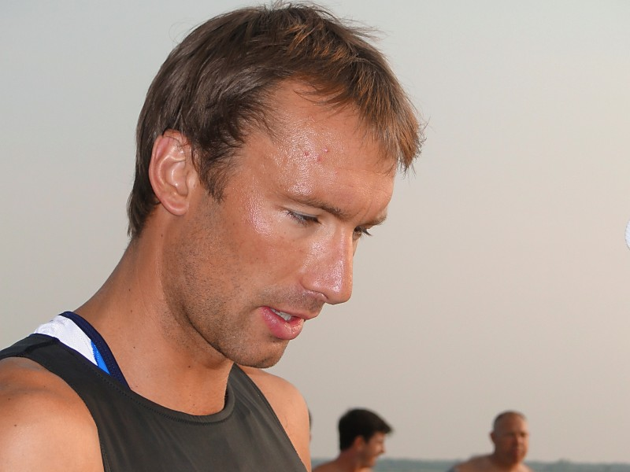
Tom spread some of Jon's ashes pre swim, then went on to place 7th overall! His roll at the finish speaks for itself! Thank you again Tom for being with the blazeman and rolling for awareness and a cure!
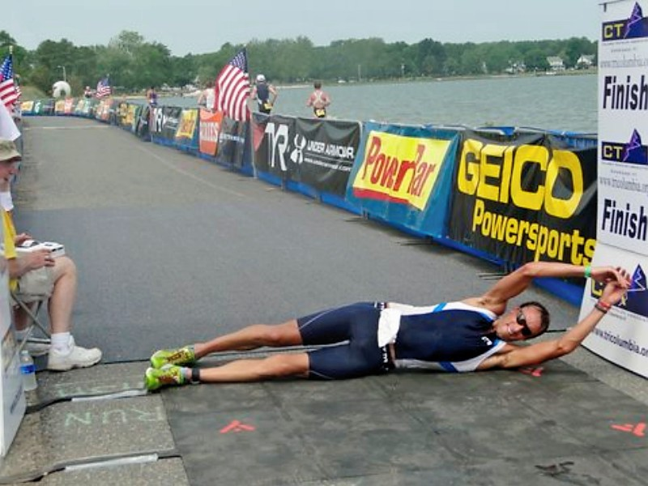
The Blazeman Spirit Award was given to April Colescott, her letter sent in by a student of hers' according to Jennifer, our daughter, was the letter that met and exceeded what the tenants of the blazeman spirit is all about. Congratulations April. See below for more on the award.
Thanks again to all that have rolled across the finish lines in your races...that is a way an athlete can spread awareness...
Our next event is the Providence 70.3...where we shall expo and volunteer at the finish line. We hope to see several of you there and I am sure Blazeman Warrior and meteorologist Mark Searles will have an abundance of sunshine for race day!!!
Please look for our ad in the inaugural issue of LAVA magazine, due out the end of July with the design credit going to Kelly and Paul Fahey, my right hand couple! Thank you both...I could not do it with out you!!!
Till we meet again,
Fondly,
Mary Ann Blais
Jon's Mom
Blazeman Foundation for ALS

2010 Blazeman Spirit Award recipient: April Colescott
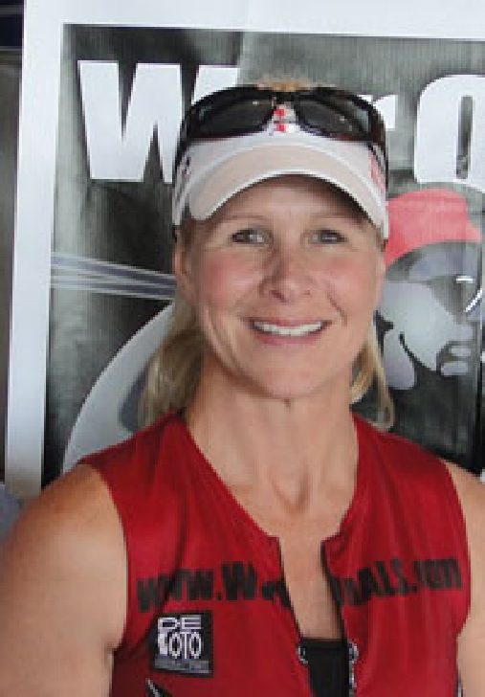
We received multiple nominations for April, and it was the one written by her personal training student, Rick Speas that made the connection to the Spirit Award.
Rick wrote " April Colescott is an amazing person and athlete. She possesses the unique ability to challenge individuals to excel in life and to face life's challenges with courage and a determination to overcome and succeed. I have been one of April's students at the YMCA for about a year now. I am 48 years old and I am in the best physical condition of my life. She challenges me to do things in her classes that I never dreamed I could accomplish. She instilled in me a self-confidence and I have a try-anything confidence in her. If April tells me to try some exercise, however ridiculous it may seem to me, I will give it my best effort. She helped me to believe that I can do whatever she asks me to try. There is more to April than just her physical ability and incredible understanding of how to get the best out of her students. April's enthusiasm and energy are contagious. She makes challenging classes fun and exciting. She teaches life lessons in the process of teaching exercise classes. She is an amazing motivator and encourager. She has a tremendous heart for those that have been through or are going through some of life difficulties. She helps people to see beyond their circumstances. She is open about her faith and challenges people to look to God in their lives. April has an incredible love for racing. She counts herself truly honored to be part of a team of unselfish athletes who race because others cannot. The team is made up of individuals from all over the world who have been touched by the horrible disease of ALS and through Jon Blais "The BLAZEMAN" they have discovered the calling and the avenue in which to administer God's love and His word. I have heard her say, "We give because they need us...we race because they can't and we fight for FREEDOM from a disease with no cure" Racing on the battlefield (Ironman Course) is an effort to raise awareness of those who have come before and given up their lives and those who will follow. It is the fight for a CURE! April uses her passion for racing, her success in racing and the self discovery she has gained in racing to share with her clients at the YMCA. She shows us through example that YES WE CAN....all we have to do is TRY and we know that she will always be there to help us! One of the things I appreciate so much about April is that she doesn't want her students to be just the best athlete or student they can be, she wants each of us to be the very best person we can be. She works hard to see that we are moving toward that goal. Over the past year, I have seen many students' lives changed and inspired by April's unending compassion, love and motivation. She is a trainer, motivator and friend to all who know her.
A Warm Welcome to our newest Warriors!
We are pleased to welcome the following newest warriors to our family. Thank you, and everyone else, for all you do to help our mission.
Brian Phelps Alan Kleber Michelina Witte
Aaron Cottrell Kaitlyn Mello Dr. David Tinklepaugh
Katie Dale Lamare Benoit
Lindsay Nickel Sami Field-Polisso
Bob and I welcome all of you and wish you success in your races and fundraising and we hope to meet you all at one of our events.

From the Battlefields...

There are good neurologists out there that really care about their patients. This thought, from one of them -
"We lost another young man to ALS this week, and today his dad came in to see me. As I listened to his grief, I was aware of the Blazeman bracelet that has been on my wrist since Quassy. It gives me hope during these moments, to know that you both are out there pushing the fight for ALS. It gives me strength to know that Jon pushed through amazing barriers with dignity in his fight against ALS. I feel an extra capacity for the sorrow, and for that I am grateful. In addition to all you both are doing, and team Blazeman is doing to raise money for research and a cure, you are also providing an amazing reservoir of energy to a neurologist in CT, caring for those stricken with this disease."
Dr. David Tinklepaugh
Neurologist

Northwestern University Research update
Last month's newsletter did not include the Annals Of Neurology link ... I have that now for those that want to read in detail what we have been working on. You can also read a related update on our web site.
This article's first acknowledgement in print was in the June 2010 "Annals of Neurology" (Vol.67 page 747). This is a big step for the Blazeman Foundation for ALS!

We also have decided to continue the Blazeman Post doc position with Kaouther Ajroud PhD instead of bringing on a new fellow. Kaouther has been working on these projects in ALS for the past 2 years and it just makes more sense to keep an experienced fellow instead of bringing on a new person to train.
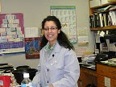

This is all possible thanks to our Blazeman warriors and supporter's efforts in fundraising. We have met the best there is in our journey and our hope is to meet each and every one of you.

Farewell Tom Newton...we are happy we knew you...
On Saturday, June 28, 2010...Tom lost his 5 yr. battle with ALS. We met Tom through Mark Helisek, Blazeman Warrior, at the Inaugural Providence 70.3 in 2008. Tom and his wife, Karin, made the trip up from Long Island to meet us. I remember looking into those beautiful blue eyes and feeling as though I was looking at Jon...

Tom had a great sense of humor which he kept throughout his disease process. We kept in touch...lately mostly via facebook email and chats. My last conversation with him was just a few weeks ago and he was struggling...skin and bone was the term he used.

We are deeply saddened to have lost Tom...we knew that day would come as it does for all PALS...it doesn't make it easier.
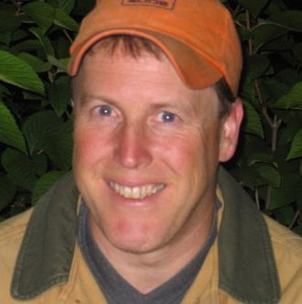
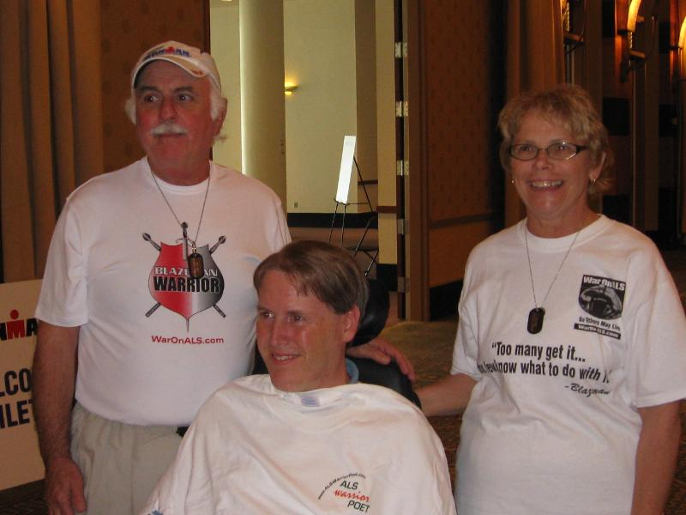
Our thoughts are with Karin...Tom, we know, like Jon...has his FREEDOM!

UPDATE ON OUR WEBSITE
We have made a couple of small changes on the War on ALS website...the community dropdown has been changed to NEWS and MEDIA...the forum has been removed now that the ning site is up and being used.
To all the warriors and supporters that are not aware of the site, it is a great way to communicate with others on races and posting pictures!
Check it out!!!!

Photo Gallery
The 2010 season is already here!
Please keep sending your photos!
We love hearing your stories and seeing you in action!
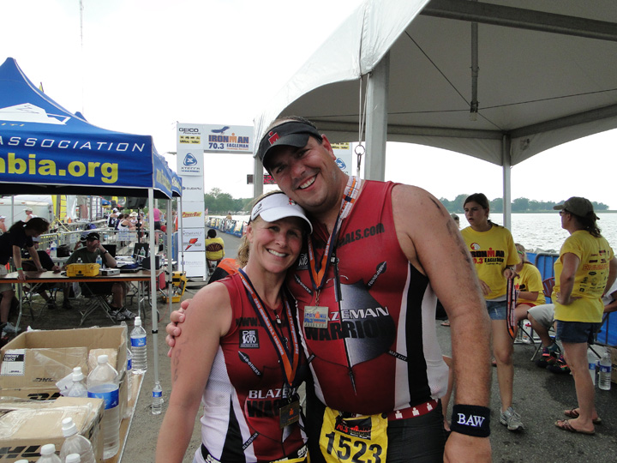
April Colescott 2010 Blazeman Spirit award winner with Chris Miller the 2009 winner!
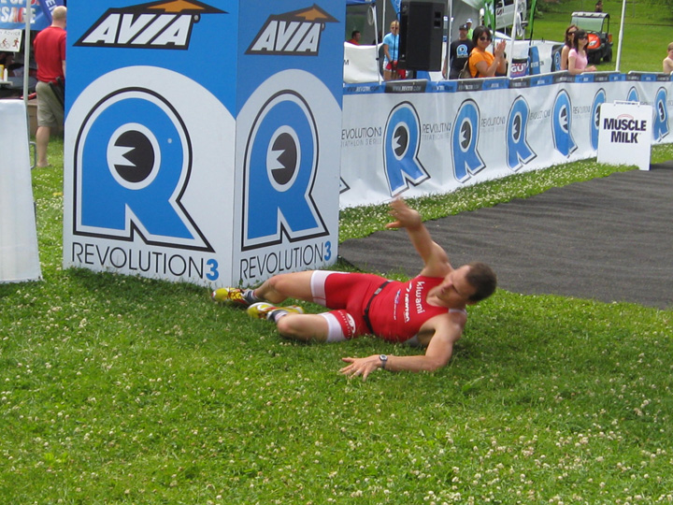
Blazeman Warrior and pro Eric Linkemann at Rev3
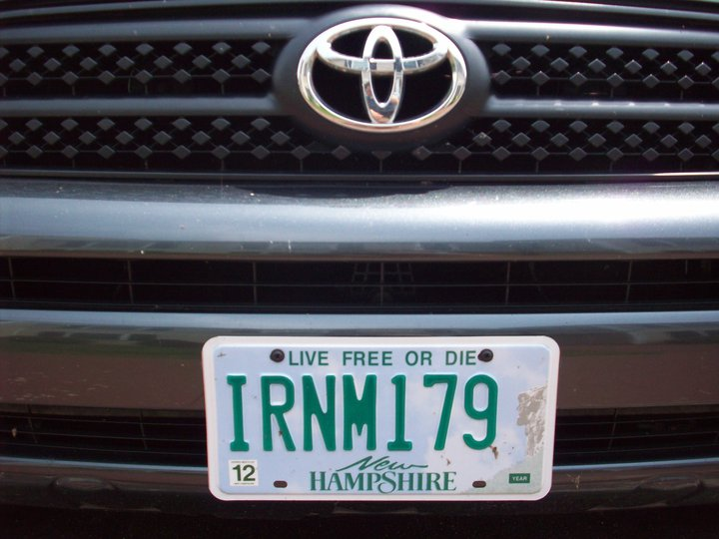
Blazeman Warrior Chris Lake's new licence plate!
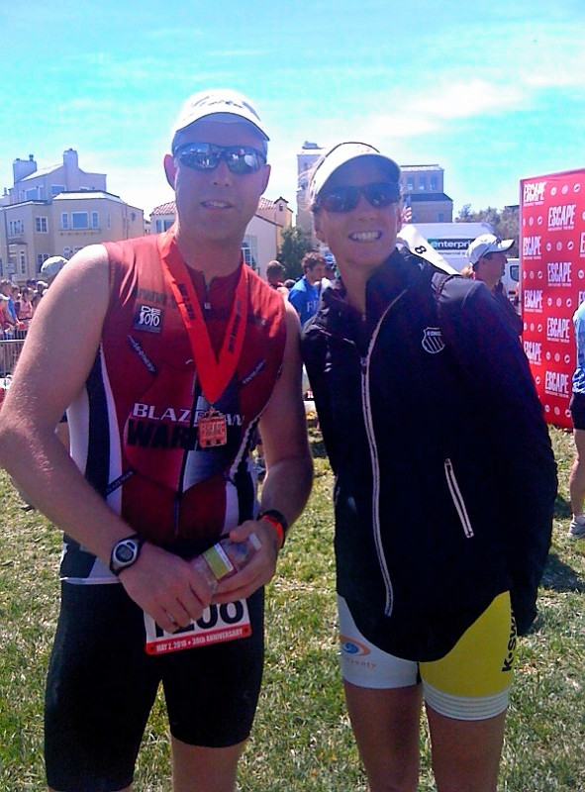
Blazeman Warriors Paul Fahey and Leanda Cave at Alcatraz
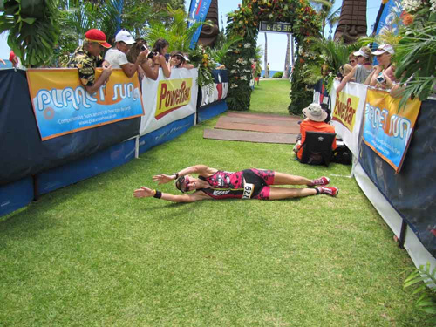
Cherie Gruenfeld wearing #179 at Honu 70.3 (Photo by Lee Gruenfeld)
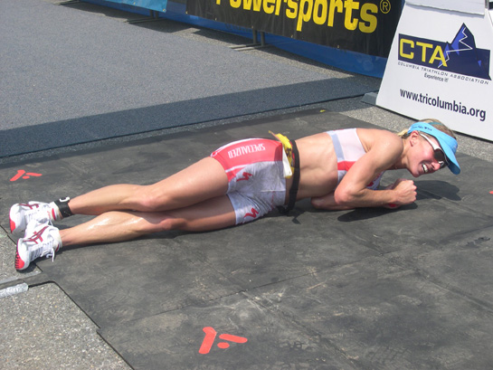Desiree Ficker rolling at EagleMan
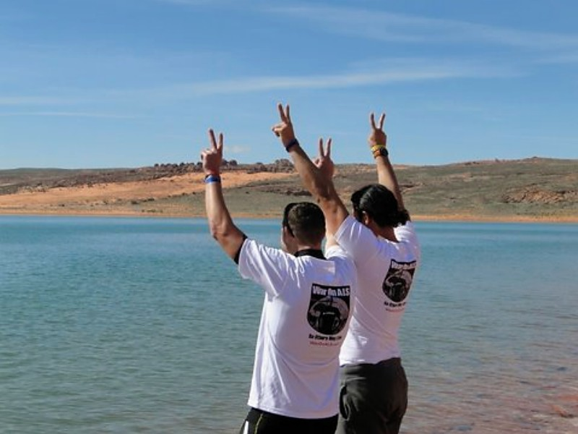
Fausto Rodriques and Yair Shalev leaving Jon at St. George
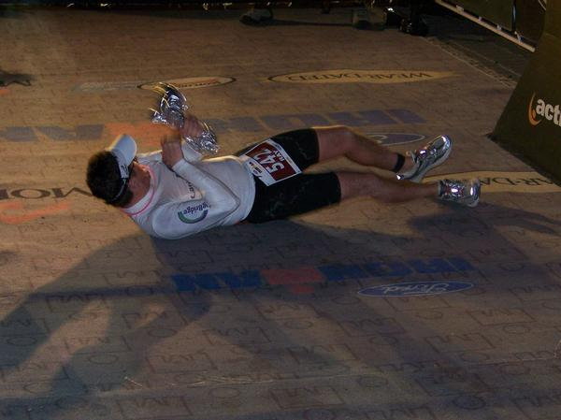
Ironman Ray Mullen doing the Blazeman roll
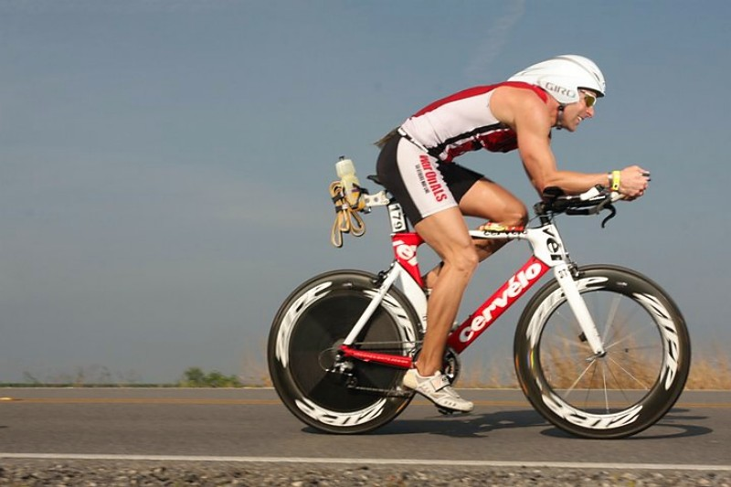
Rodney Ward and Gelrilla at NOLA
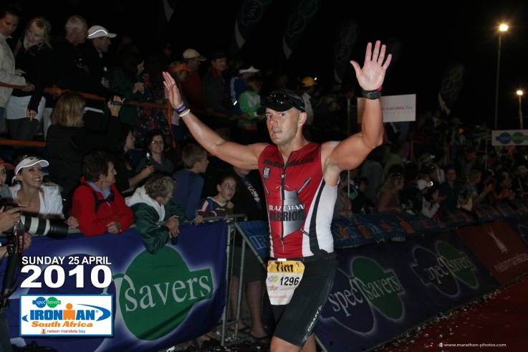
Tim Smit at South Africa 2010
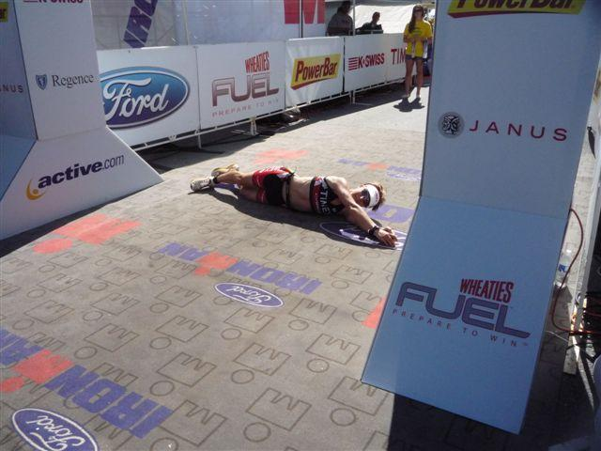
Janelle Morrison rolling for 5th place at
Ironman Coeur d'Alene

