
  Our Sponsors
  Team Blazeman members get great discounts from some of the best brands!
  
  Get your discounts today!
  For more information on Blazeman Warrior Discounts, contact info@waronals.com
  Make a donation today!
  Join Team Blazeman!
  The list of registered
  Blazeman Warriors keeps growing! We are proud to have you representing us on the battlefields!
  Clark Archibald
  John Mcnamara
  Kevin Perkins
  Melissa Merson
  Thomas Martwinski
  Jennifer Bornemann
  Kathleen Fetissoff
  Linda Laird
  Chris Ellinghaus
  Fabrice Le Det
  Petra Le Det
  Nick Logan
  Ran Korolik
  Erik Feeney
  Christopher Giordano
  Charlie Dunne
  Karen O'Riordan
  Mia Richter
  Jennifer Tebbetts
  Debbie Ragals
  Brian Breen
  Dru Bornhoeft
  Cheryl Iseberg
  Richard Volpe
  Christopher Price
  Alexander Ha
  Gregory Hoots
  Tricia Ryan
  Domnick Nelson
  David Knight
  Caryn Blanke
  Douglas Munsee
  Alexis Andrianopoulos
  Glenn Hines
  Philip Clark
  Susan Langevin
  Karen Duffy
  Mike Duffy
  Brian Duffy
  Kevin Long
  Steven Perunovich
  Sean Dutra
  Michael Ricci
  Cathy Ruf
  Ed Bullock
  Ryan Van Praet
  Doreen DiMeglio
  Judy Pratt
  Michael Keim
  Barbara Altemus
  April Colescott
  Gabe Fiscus
  Ken Fanelli
  Larry O'Connell
  Caryn De Filippo
  Jennifer Brady
  Diego Avalos
  Megan Knepper
  Brian Kochanek
  Paul Nowicki
  Ron Salmon
  Barry Conrad
  Christopher Demers
  Jennie Eddy
  Marty Peterson
  Jack Keenan
  Dennis Joyce
  Rob Duguay
  John Plumley
  Kimberly Magee
  Sean Waklee
  Christine Suter
  Collette Bates
  Brad Culp
  T. Connelly
  Michael Carr
  Richard Higgs
  Sean McNamara
  Jason Biggs
  Henry Hoyle
  John Purvis
  Leah Roberts
  Robert Maldonado
  Bill Peloso
  Shelley Farmer
  Michele Solomon
  Daniel Molloy
  Michael Ireland
  Michael Hicks, Jr.
  Leanda Cave
  Ryan Close
  Courtney Greene
  Thomas Simmons
  Colin Lake
  Tim Smit
  Jordan Bryden
  Kim Williams
  Chris Parker
  Shawn Mahoney
  Lisa Unger
  John Ryan
  Dana Ryan
  Conn Jackson
  Michael Mathers
  JD Mathers
  Nancy Nicklas
  John Wolski
  Adolfo Roa
  Jen McGuiggan
  Charlie Komar
  Alexander Karn
  Tarcisco Alvarez-Rivero
  Rodney Ward
  Mark Helisek
  Paul Mandell
  Bob Gebbie
  Jerry Sappington
  Kimberly Daley
  John Daley
  Celeste Callahan
  Michael Swyt
  Kimberly Sass
  Jeremiah Crandell
  Christie and Mark Di Pietro
  Susanna Di Pietro
  Paul Fahey
  Vernon Johnson
  Mary Miller
  Cami Stark
  John Wright
  Chris Tidmore
  Anna Jenkins
  Chris Stafford
  Brian Layman
  Sean Chick
  Kevin Davidson
  Jane Dempsey
  Fernando Sumaya
  Mary Rye
  Octavio De Albornoz
  Christopher Stafford
  Todd Verkest
  Brent Layman
  Kevin Davidson
  Octavio Gonzalez
  Kendall Wueste
  N Gaunt
  Eric Hammerschmitt
  Dana Adams
  Christopher McKenna
  Sara Waterson
  John Cordes
  Tom Fichtner
  Christine Fichtner
  Addie White
  Mike Hume
  (If you just took the time to read through all these names but didn't see yours, I'm so sorry. Please tell me
  by clicking here)
  TEAMS
  Beat ALS
  Canadian Triathletes
  Clan Westchester
  D3 Multisport
  OC Blazeman 179
  ParkCity Clan
  Providence Triathlon
  Steve Perunovich Family & Friends
  Team Kochanek
  Team Long
  Team Newton's War on ALS
  Team Polar
  Team raceAthlete
  Coonbottom Tri Club
  The Nelson for Blazeman Team
  Tim Smit's War on ALS
  Carol's Clan
  Fichtner Freedom
  Jan's Team
  King's X
  Team Beckford
  Team Fat Larry
  Team Tough as Nails
  Walter's Warriors
  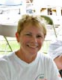
  Hello Blazeman Warriors,
  Well the summer is behind us and we are getting ready for the Fall season.
  July and August held many races including Irongirl (another trip to lovely Maryland where Vigo did what he does best) and our own RI 70.3. Below you shall see some pictures from these races including Ken Fanelli who wore #179 at the Providence race. Bob and I had our first experience at volunteering at the finish line-hard work but very happy to do so.
  Another Blazeman Warrior, Deb Ragals, wore #179 at the very popular Lake Placid Ironman in July. Deb met Jon shortly after he was diagnosed at an event in California and they became good friends. She is an active Blazeman Warrior and has been a wonderful host to us when we attend the Westchester Triathlon (NY) each year where the Friends of Claire Collier (PALS) support ALS.
  In case you haven't noticed we have a new newsletter editor family-Paul and Kelly Fahey. Paul, a Blazeman Warrior, was instrumental in formatting this newsletter from the onset. The Blais family is looking forward to this new partnership! Below you can read about them "in their own words".
  Finally, good luck to you all at your upcoming races and keep the emails and pictures coming! We love seeing and using them for the foundation newsletter, website and expo display board. You make our job so much easier and we love hearing from you!!
  Till next time....
  With strength, honor and affection,
  Mary Ann Blais
  Jon's Mom
  Blazeman Foundation for ALS
  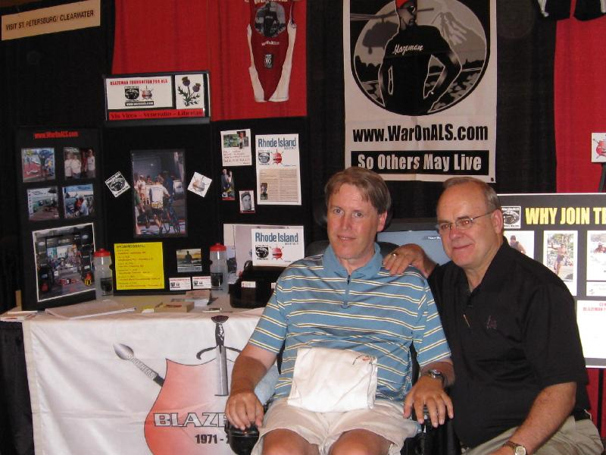
  Warrior of the Month - Tom Newton
  Tom Newton set out to meet Bob and Mary Ann Blais at the RI 70.3 this past July. When he arrived, he drove his wheelchair around the corner to meet them and said, "it took but an INSTANT for a rush of love to hit me like a freight train, and even less time for me to know your COMMITMENT to kick this disease's ass is TOTAL! Thanks again for being there."
  No, Tom, thank you. For your courage facing this disease.
  Tom is an ALS patient from the same spirit as the Blazeman...he's a true "ALSWarriorPoet", not deterred by any complications to travel. His determination and courage is what pushes us forward. Tom, and all the (PALS), people with ALS are why Team Blazeman and the War On ALS, exist. We will win this war, but, we must always be mindful that, "those who have gone before us can not steady the unrest of those to follow", to use Tom's words,"the time for thinking is over, action is what's needed"..."so others may live".
  For his courage and determination, Tom has been deemed an "honorary Blazeman Warrior."
  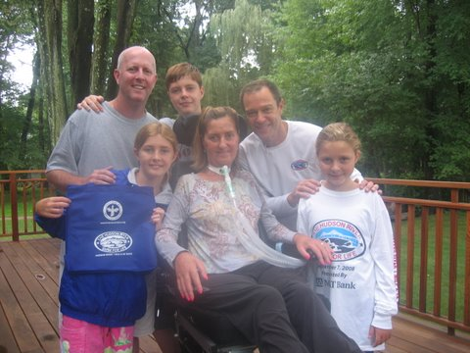
  Meet Claire Collier
  This is a photo of Claire and her family. Jon met her in 2006 at the Westchester Triathlon and she remains a good friend to the Blazeman Foudation to this day. Those close to Claire continue to be inspired by her resilience and strength to fight despite her illness. So it was a natural decision to pick out the most challenging part of the Westchester Triathlon course, a hill where many athletes feel like giving up, and naming it after a true hero who has NEVER given up-Claire. Her strength and courage will inspire and motivate each triathlete to make it to the top of that hill. It's called Claire's Climb (click here to learn more).
  Meet You at #179!
  by Paul Fahey
  I recently had a few moments to kill before a race and found myself standing in the transition area (I was number 51) wondering who else around me knew about the Foundation. We didn't have a BMF table there so I walked over to the only other place I could think of...the bike rack space for the person with #179.
  So, then I got to thinking that this specific "place" exists at most races. Perhaps a good place for Warriors to gather, say hi, wish each other luck and maybe even have a quick pre-race battle cry to psych ourselves up.
  It's a great way to tell someone who doesn't know what their number 179 means. A rallying point for us Warriors. A gathering place. A thinking place. If nothing else, a simple place that reminds us of why we're here. So, I'll look for you at #179.
  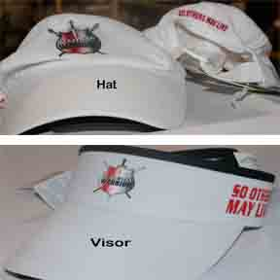
  Blazeman Gear Available online!
  You asked the question and we have answered the call! Our new eStore is now up and running.
  Polos, Fleece, Pullovers (summer's over for some of us!), Hats and more!
  Here, you can purchase various items to show your support of the Foundation and warriors will be able to order additional uniforms at their registration level (coming soon). More items will be added shortly, so check back often. Many thanks to Robert Andelman and the folks at Nightmare Graphics for their continued support!
  Shop now, click here!
  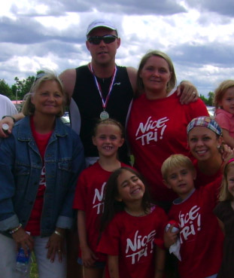
  Behind the Scenes - The Newsletter Team!
  I first heard the Blazeman story the way many of you did - through TV coverage. And again, like more than 40,000 of you I watched the video online here. I watched them again with my wife, Kelly. And again with our kids. (and again and again) Jon's story was an invitation to us to dig deeper and race for something bigger than ourselves. But that just wasn't enough. We knew we just had to get involved so I simply sent an email to some of the board members asking how. After they thanked us they asked, "well, what can you do?" The answer, for the past year, has been this newsletter. My bride, Kelly, and I are PR and Marketing folks who've collaborated on the writing and design of this with other folks on the board. It has been very rewarding for us to know that we're applying our talents to help the Blazeman Foundation tell its story. We look forward to telling them again and again until, someday, there's a cure for ALS and we can all go to bed early for a change. But until then, keep rolling, "get it on film" and tell us so we can tell the world. Peace.
  - Paul Fahey
  L-R: Paul's Mom, Linda. Paul Fahey, Chloe, their friend Sophie (black hair), Kelly, Harris and Paul's sister, Kate at the 2007 Tinman 70.3
  The Forum is Open on Our Website
  Got a question? Wondering what other people think about a topic? The WarOnALS web site forum is now up and running! Sometimes called a bulletin board or message board, a Web forum is an online center for ongoing discussions of specific topics and issues. The WarOnALS forum was specifically developed to help bring our community of warriors together online and help each other share ideas, thoughts, questions and advice. What's on your mind? Click here to see several discussions underway.
  Photo Gallery
  Check out these photos of our Warriors on the battlefields across the country and around the world! Please keep sending them! We love hearing your stories and seeing you in action!
  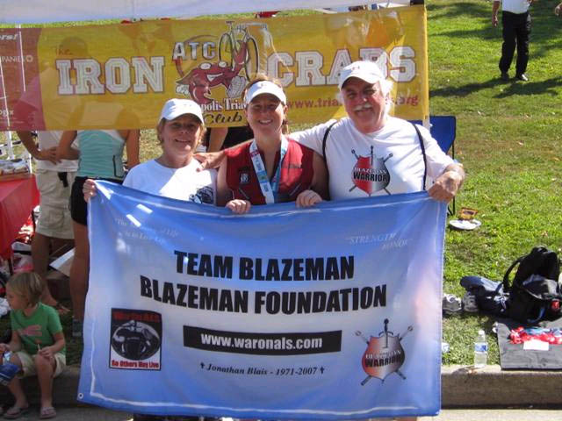
  Jennifer Bornemann, a very special warrior, raced with #179 at Iron Girl Columbia 2008 with Bob and Mary Ann.
  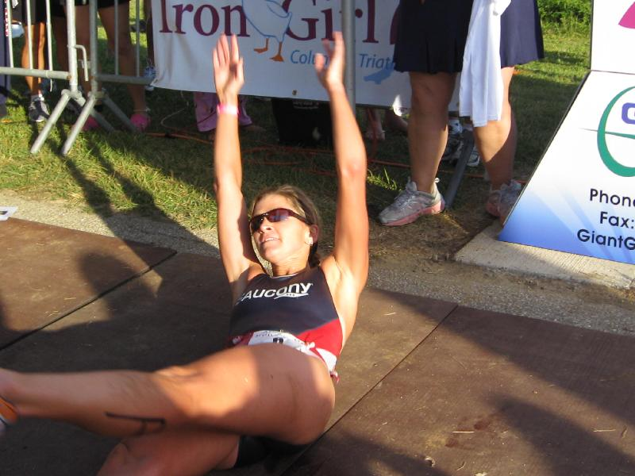
  Pro Triathlete Dede Griesbauer rolling a spectacular first place finish at IronGirl.
  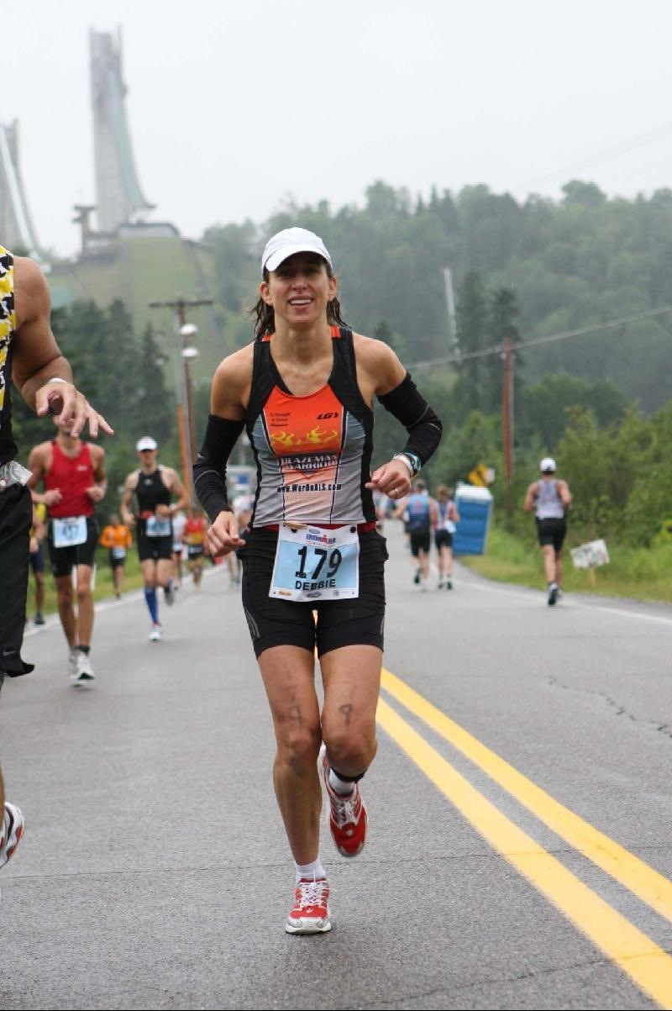
  Deb Ragals also with #179 running a very soggy IM Lake Placid
  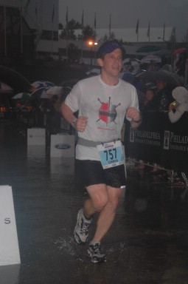
  Chris Tidmore, whose roll at IM Lake Placid produced a wave of water. See, I told you it was soggy.
  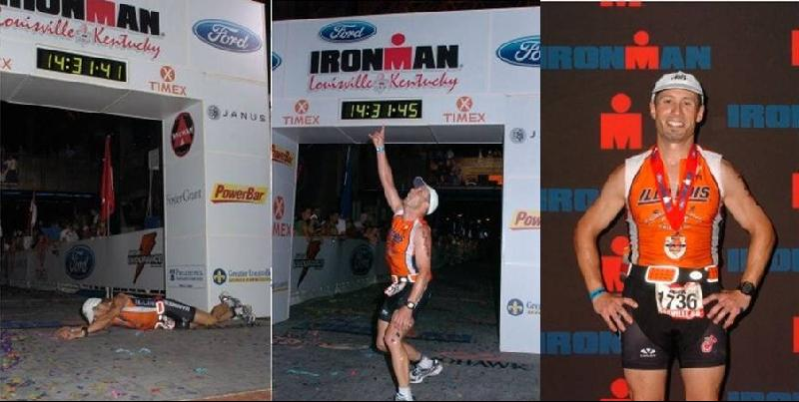
  Andrew Carl Singer at Ironman Lousville last week (who was wishing for rain to help relieve the 104 degree heat index!)

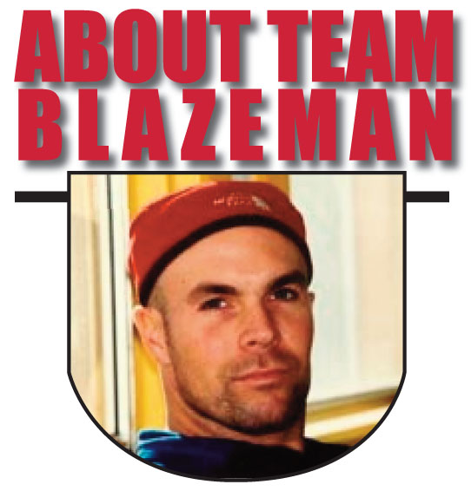
On May 2, 2005, twenty-year Multi-Sport veteran Jon Blais a.k.a. "Blazeman" at age 33 was diagnosed with the fatal motor neuron disease ALS (Amyotrophic Lateral Sclerosis). Blazeman dubbed himself the "ALS Warrior Poet" and brought his battle to the big island of Hawaii on October 15th that year, where he became the first person with ALS to complete the Ironman World Championships. It was his last race. In 2006, a number of athletes, inspired by Jon's 2005 efforts, rolled across the finish line in Hawaii in honor of Jon and his battle against ALS. In 2007, the Blazeman Foundation for ALS expanded Team Blazeman, comprised of "Blazeman Warriors" who have committed to raising awareness and funding a search for a cure for ALS..."So Others May Live."

Forward email
This email was sent to jjamurphy@charter.net by blazemanmom@comcast.net.  Update Profile/Email Address | Instant removal with SafeUnsubscribe™ | Privacy Policy. | Email Marketing by  
War On Als | 20 Commerce Way, Unit 12 | PMB 283 | Seekonk | MA | 02771

