Spring Greetings to our Blazeman Warriors and Supporters!
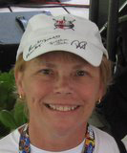
Most of us have seen a very mild winter this year but now we wonder what is around the weather corner.
As I write my letter this month I "wonder" if this will be the year for some much needed big breakthrough in the disease we call ALS. Every time I get an email from someone that has been touched by this horrific disease it tears me apart. Having gone through the ALS nightmare with Jon, we know it does not end when the inevitable happens. It never goes away. Because there is no cure. Imagine the day when a person is diagnosed with ALS and the neurologist can say, "let's discuss your treatment options." That will be a great day in our war on ALS!

Until then, I'm discouraged when people raise money to find a cure for a disease which already has one! I think that's why ALS is such a "hard sell" for families that haven't been touched by ALS, because they probably assume ALS has a cure, too. Yes, bmom has had some tough moments when it comes to the world of non-profits, fundraising and the broken promises... I admit it! Now that I have gotten that off my chest...

I would like to tell you about my weekend with the Macinnes Family. I met Sue and Doug after Scott Tinley connected us via email. I had just seen the video that Mark Allen did for Doug on Lava Magazine. At the time I thought how ironic it was that ST became very important to both Jon and Doug's family (Jon's story is for another time). I must say I was anxious about the trip to Chicago; really connecting face to face brings back lots of emotion. Doug has a great family, very loving and totally supportive. When I introduced Doug recently in the newsletter I apparently had him living in Indiana...I apologize, Doug lives in a beautiful house in Illinois!

Doug and Sue's son Chris has transformed their house into a handicap accessible home. Doug and his canine sidekick, Gus, can easily navigate inside and out.

We all know that this family is dealing with a disease they never thought they would have to deal with...Just as Jon said back in 2005...they are doing just that, "with humor, some chaos, and lots of love!" Thanks for letting me get to know you!

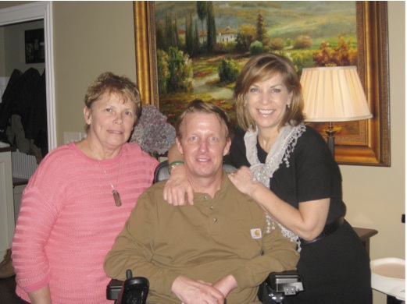This is me with Doug and Sue Macinnes

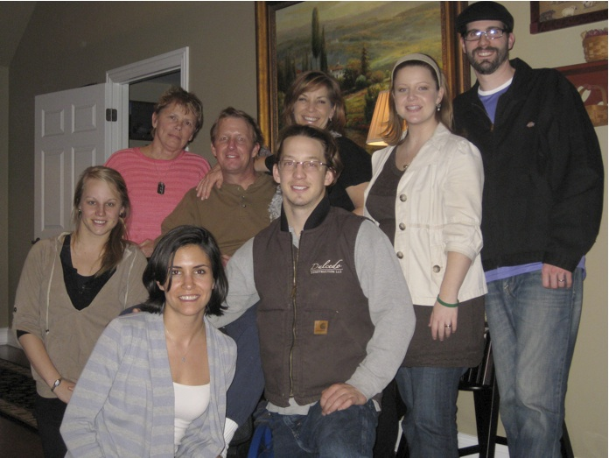The whole Macinnes Family!
(Gus, his canine sidekick, was sleeping)

Lastly this month, I want to tell you that the final tally for the Cycle for ALS is not complete yet but Bob and I want to thank you all again for your great help fundraising for ALS research. Please know that we are very grateful for all your support!

'Til next time...

MaryAnn
Jon's mom

Dr. Siddique Announces
Multiple New Research Presentations

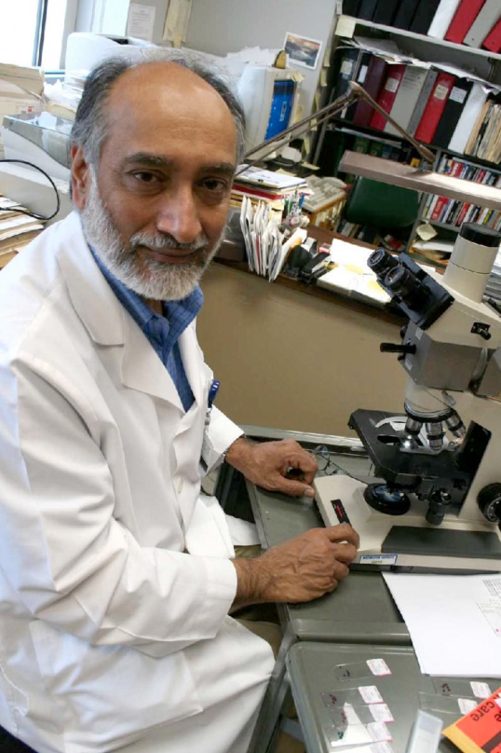
Dr. Teepu Siddique wrote an invited editorial for the January issue of "Lancet Neurology" on the implications of chromosome 9-linked C9ORF72 mutations in ALS and frontotemporal dementia and his commentary article on the importance of UBQLN2 and p62 cellular recycling pathway in ALS and frontotemporal lobe dementia appeared in the February issue of the journal "Muscle and Nerve." Recently Dr. Siddique has given several invited lectures, including Bringing neurodegeneration to heel: lessons from Lou Gehrig disease, a public seminar sponsered by the Neuroscience Program of Lake Forest College. Upcoming lectures include New Drug Targets for ALS at Benedictine University Feb 28 and Proteins in conflict and neurodegeneration, for the annual Genetics and Genomics Cluster Symposium March 30 at Northwestern. Additionally, Dr. Siddique will be the Latran Keynote Speaker at the European Network for a Cure for ALS (ENCALS) symposium in May, speaking on Cause to mechanism: the molecular funnel of neurodegeneration.

Dr. Teepu Siddique's Les Turner ALS Research Laboratory team has had two abstracts accepted for platform presentation and two for poster presentation at the upcoming American Academy of Neurology Annual Meeting to be held in New Orleans from April 21-28. One of those abstracts will be featured in a special "Integrated Neuroscience" session, while another received special notation by the Science Committee for being a significant advance based on animal research.

Dr. Siddique's proposal to the Society for Neuroscience for a symposium on neurodegeneration has been accepted for their November meeting. This is the second time in three years a proposal of his has selected. More details will follow.

Additionally, Dr. Siddique has been awarded a 5 year RO1 grant from the NIH for his project Disease mechanisms in human ubiquilinopathies. Except for an 8 month gap, Dr. Siddique's work has been continuously funded by the NIH since 1985.

Your Donations at Work: Update from Wake Forest University

The Blazeman Foundation for ALS has awarded its second grant to Wake Forest Baptist Medical Center for research into Amyotrophic Lateral Sclerosis (ALS).

Researchers at Wake Forest Baptist are studying whether the drug AICAR, already approved by the U.S. Food and Drug Administration for other purposes, can make nerves less susceptible to ALS. Previous funding from the Blazeman Foundation enabled researchers to verify that AICAR produces certain key results at the cellular level. The new grant of $11,300 will support the next step in finding out if the drug can be effective against ALS.
The study is being conducted by Carol Milligan, Ph.D., professor, and Ramon Jimenez-Moreno, Ph.D., research fellow, in the Department of Neurobiology and Anatomy at the Wake Forest School of Medicine
"Developing new treatments is a long process that grows in scale until eventually you have trials with patients," Milligan said. "But it all starts with basic science research to test the merit of an idea. Finding the money for this kind of study can be tough - someone has to take a chance on your work. If what we're doing continues to pan out, the Blazeman Foundation will have helped lay the foundation that might lead to a way to help treat individuals with this terrible disease."
"We're excited about the promising results," said Bob Blais, who runs the Blazeman Foundation with his wife, Mary Ann. "Looking for new ideas and supporting the science behind them is why our son Jon started the foundation."
"Jon always knew the multisport community would carry on his fight," said Bob Blais, who added that it is "destiny" that researcher Jimenez-Moreno is an amateur multisport competitor. "As athletes and caring people, the Warriors live by the same spirit Jon did. If the study at Wake Forest works out, they'll be log-rolling across the finish line."

The Blazeman Spirit Award
2012 EnduraFit Ironman 70.3 Eagleman

The Blazeman Foundation for ALS is currently accepting nominations for the Blazeman Spirit Award to be presented at the 2012 EnduraFit Ironman 70.3 EagleMan.

The Blazeman Spirit Award is given annually to a participant in the EagleMan Ironman 70.3 who most exemplifies the spirit of Jon "Blazeman" Blais. While many are familiar with Jon's heroic performance in the 2005 Ironman World Championships in Kona, Hawaii, few are familiar with Jon's professional life as a special education teacher at the Aseltine School in San Diego, CA. Here, Jon focused his energy on helping kids who were emotionally challenged and learning-disabled. This is also where he became better known as "The Blazeman." Jon did amazing work with the kids. Through summer recreation programs and outdoor activities, his students learned to overcome obstacles and become stronger through hard work and determination. The Blazeman Spirit Award keeps Jon's memory alive by recognizing an individual who inspires others to become a better person; leads by example; and has a passion for the journey of life.

The winner will receive:
- A complimentary 2013 entry to the EnduraFit Ironman 70.3 EagleMan
- An Eagle Award, the emblematic symbol of EagleMan called "Blaze", and certificate,
- Complimentary Ironman level membership to Team Blazeman.
Nominations are due by May 1, 2012. The winner will be announced during the pre-race expo/event expo on Saturday, June 9th, 2012.

To read about previous winners and download application information please visit our website.

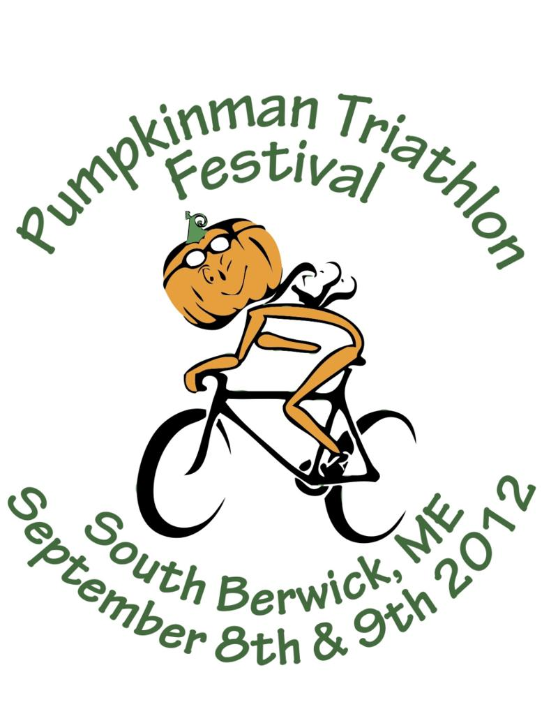
Two Great Races Offering Slots to Benefit the Blazeman Foundation
Pumpkinman Triathlon
South Berwick, Maine on September 8th and 9th.

Athlete's wishing to race and fundraise for the Blazeman Foundation for ALS may do so though the event website. Donations also gladly accepted through the website! There are a total of 75 Blazeman Slots available for the various events.


EnduraFit Ironman 70.3 Eagleman Triathlon
Cambridge, Maryland on June 10th.

The slots are $500.00 and the proceeds are earmarke d for our recently announced research project at the University Of Maryland's Brain And Tissue Bank. Thank you to the athletes who've already registered:

Ryan Stilles
Greg Perangelo
Joseph Stephanak
Charles Williams

A special thank you to Rob Vigorito and the CTA for giving us this opportunity. Please visit this web site for more information.

Anyone interested in obtaining a Blazeman slot can contact me directly via email.

Thank you! We are looking forward to seeing you at these events!

Warrior of the Month: Joe Goddard
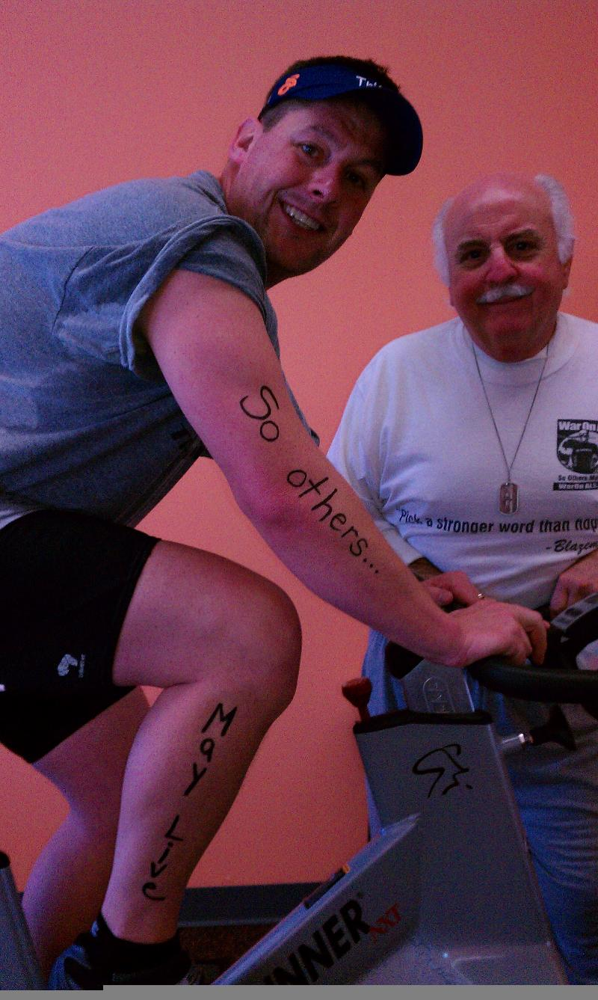
"A little bit for me. A little bit for Jon. And a little left over for the tri club."
This is why Joe Goddard is training for his first Ironman-distance race. Joe is training for the Rev3 Cedar Point 140.6 race this September. For Joe, this will bring a finish to a long personal journey that began on the couch a few years ago.
"I have a great group of friends. We've gone through a lot together, each of us starting from the couch and culminating with the event this Fall."
Like many of us, Joe saw Jon's story at the 2005 Ironman Kona on television. At the time, the story had an impact on him. "I was really impressed that Jon was moving forward at all cost. That inspired me to set off on my own positive path and reach my goal of becoming an Ironman. He had such determination...he was pushing through all of the obstacles that ALS laid at his feet."
But it wasn't until a couple years later at the Ironman Providence that Joe really connected with the Foundation. "Well, I just happened to be standing next to Bob Blais and we struck up a conversation. That's how it all started. I told him I was inspired by Jon's story and I really wanted to get involved and give back." Joe asked Bob how he could help and Bob said, "have you ever done any spinning?" What a coincidence, Joe said, I'm a spin instructor!
Four years later, Joe's organized several Cycle for ALS events and the Run for PALS 5k race with more than 600 participants raising more than $14,000 dollars for the Foundation.
"ALS is an awful disease. Everybody knows about cancer and there are thousands of worth events and organizations to help. But ALS has no cure. Nobody survives.
And hardly anybody is aware of it. We need to do more. Raise awareness and fund the research we need to have an impact. I'm glad that my events are helping make a difference in this battle."
"Last month, I spun 112 miles during our Cycle for ALS event in honor of the distance that Jon raced at Kona. I'm taking that determination to my own race this Fall."
For keeping the determination alive and helping to grow the BMF Foundation in so many ways, we are honored to feature you as our Warrior of the Month, Joe.

A Warm Welcome to our newest Warriors!

We are pleased to welcome the following newest warriors to our family. Thank you, and everyone else, for all you do to help our mission.

Michelle Womble and Kim Mendoza.
These 2 new warriors have joined in memory and honor of Michelle's dad who lost his battle to ALS in 2011. Both will be doing a Half Ironman in Marbella, Spain on April 15th which is close to the military base in Rota, Spain where they are stationed.
A big welcome to you and we hope to see you at a race this year...please visit our ning website and start communicating with other warriors and supporters.

From the Battlefields...as spring approaches!

The Greater Hartford ¼ Marathon is approaching fast. Register online today!

This event is a great way to get back to running and support the BMF ALS research projects! Thanks Kelly Burns Gallagher!

Blazeman Foundation Supporter, Garen Riedel, is competing in the 2012 Boston Marathon...Garen lost his mom, Leslie, to ALS. We wish him a great race!

Blazeman Warrior, Dr. David Tinklepaugh, was to compete this year but has been given a waiver for next year. David's dad recently passed away and he has not been able to train. Our thoughts are with you, David, during this difficult time.

Photo Gallery
Thank you so much for sharing your highlights and favorite moments from the 2011 and 2012 season!
But don't stop now! Please keep sending your photos!
We love hearing your stories and seeing you in action!
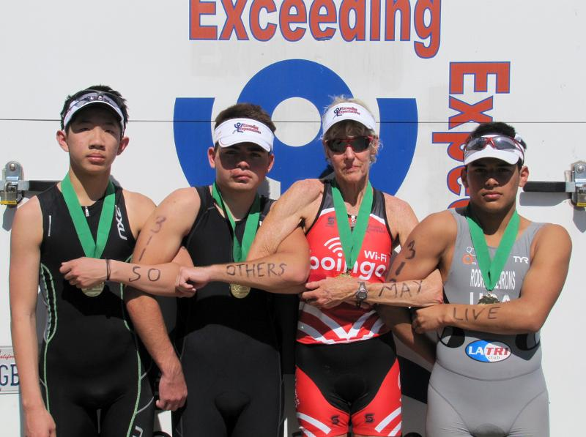

Gruenfeld and her Exceeding Expectations Kids; Archi Lai, Anthony Patterson (he wasn't in a bar fight...fell off his bike yesterday), Cherie and Josh Rodriguez-Irons at the Desert Triathlon

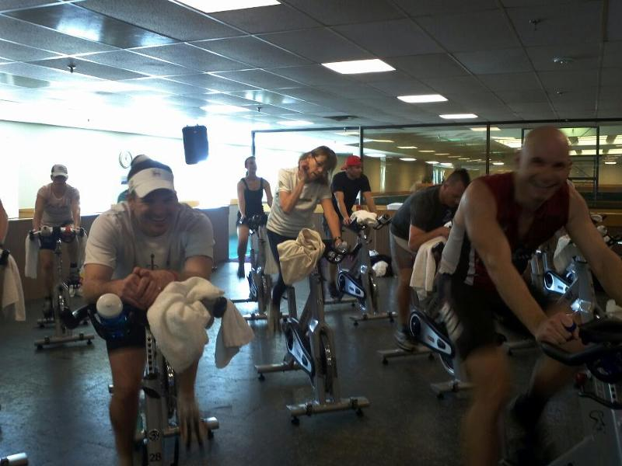Denver Cycle 2012. Ray Mullen (l) and Paul Serafini (r). Photo by Lisa Decker

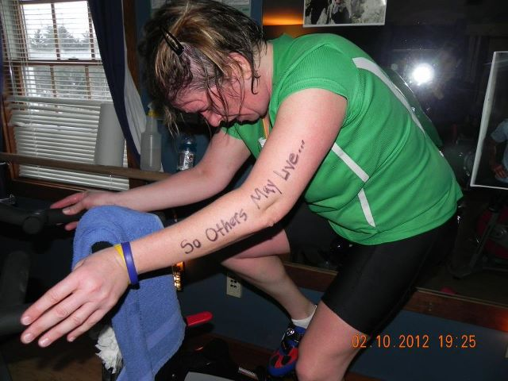
Kirstin's cycle event in New Hampshire

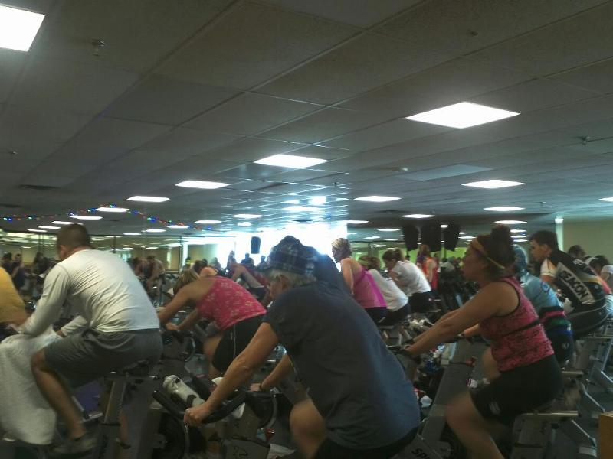
Massive Cycle Class for ALS in Denver

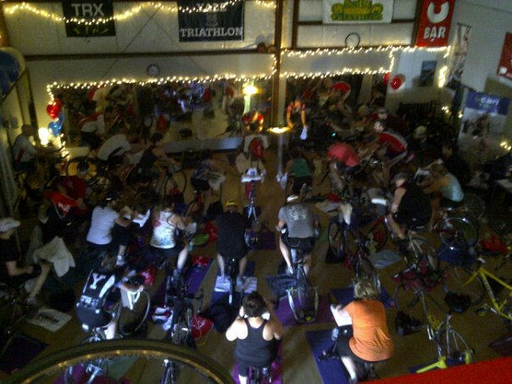Multisport Academy Cycle with Clayton Tebbetts

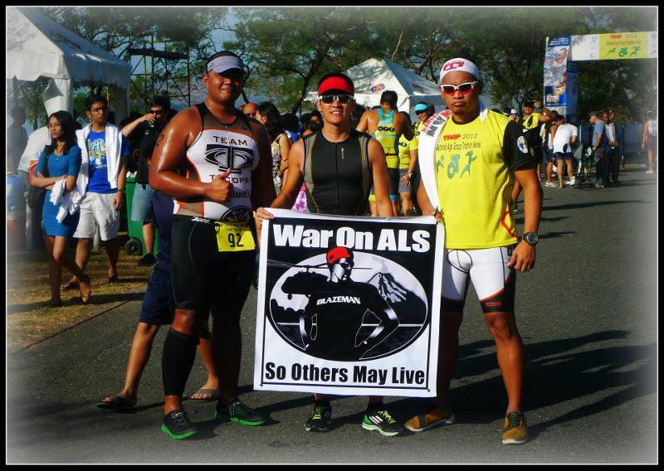Team Tactical Option at the National Age Group Triathlon Subic Bay, February 2012
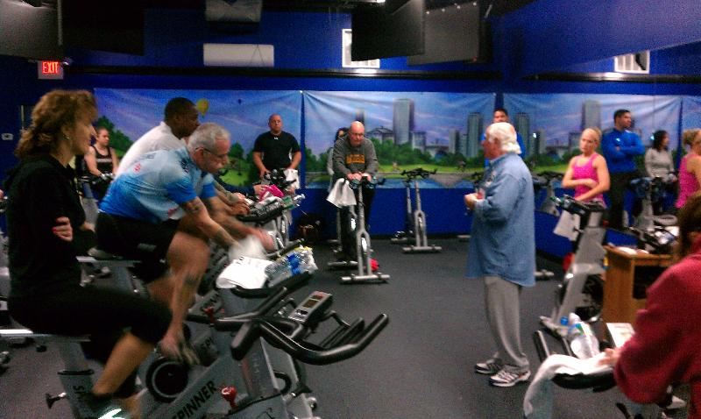
Joe Goddard's Cycle at Spinworks

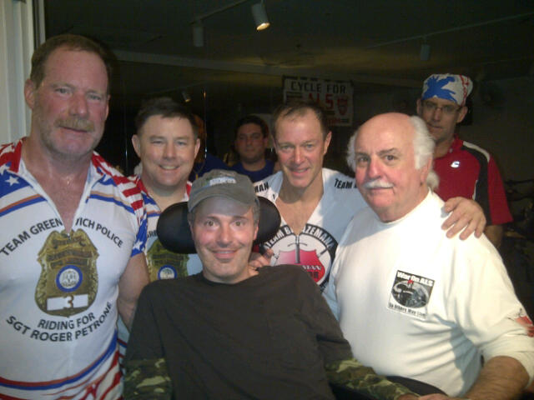Scarsdale Cycle with PALS Roger Petrone,
Phil Gormley and Roger's great friends

