Greetings from the
Blazeman Foundation for ALS!

Another May is here...can't believe it has been four years since Jon passed. In many ways it is like yesterday and in some ways it seems like an eternity...and it does not get easier.

The 29th we shall have the 1st annual RUN FOR PALS here in Seekonk, Massachusetts starting and finishing at Jon's high school. We hope many of you will participate in this event to raise ALS awareness in the town where Jon grew up. ALS is still an unknown entity to most people unless one has been touched in a personal way. That needs to be changed if we ever want to find
a cure!

On May 13th the Blazeman Benefit was held in Tracy, Minnesota, organized by Danielle Johnson and Tim Smit. We are told it was a huge success that had 12 families that have been touched by ALS along with a big crowd in this small Midwestern community. I immediately thought how refreshing this was for these families...no black tie event and quite affordable. We are told the event was a big success and very appreciated, especially by the ALS families. Thank you Danielle, Tim, Julie Roberts and Kayla!!

Some of the Blazeman Warriors have expressed some frustration when requesting #179 at the WTC races...we want you to know that we are working together with the WTC to address what has transpired recently and work towards bringing this back to a more efficient process. I shall keep you all informed as we progress.

Last, but not least, if the spirit moves you at 8:30PM EST on the 27th, a shout of FREEDOM...FREEDOM FROM ALS...Let the world hear you!!!!

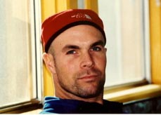

We miss you Jon...
In Strength, Honor and Freedom,
Mary Ann and Bob
Jon's Mom and Dad

Reminders from
the Blazeman Foundation!
The website scroll for May honors PALS, past and present...take a moment and look at the faces of ALS.

Visit our estore on the www.waronals.com ...our shirts, socks and hats make great Father's Day and Graduation gifts!!

Check out our schedule of events on the website for updates...we would love meeting you all at one of these events!

Our research projects are available on the website...your fundraising dollars at work...

Questions about the Blazeman Foundation for ALS? Feel free to call our toll free number (1-877-429-9363) which rings into our home/office.

Jon's War on ALS ... written in 2006

In this month of May...ALS month...I always like to repeat a piece from Jon... This piece was written by Jon at a time he knew his computer days were ending...his final call to the Multi-Sport World...

In his own words...

Dear Multi-Sport World...

You have only just begun to put your best training forward. It remains to be seen that the Blazeman's WAR ON ALS will be won. What IRONMAN fans witnessed in KONA in 2005, was something far more than the world had ever imagined, and now more than ever...I need to see it through. The WAR ON ALS is on and the assembling of "TEAM BLAZEMAN" and the support of the Multi-Sport World. The fight is on and it will be WON with you...Team Blazeman's ALS WARRIORS will bring what they have been calling "A REASON TO HOPE" for the past 70 plus years...this "Bulldozer" disease known as ALS to and END.

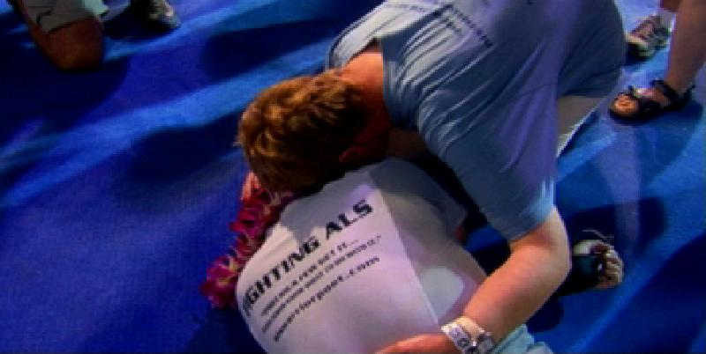
"This is where you will win the battle...in the
playhouse of your mind."

From the bottom of my heart and from all the corners of my mind, the Blazeman wants you, his...ALS WARRIORS to know...what this means to what remains of him and even more important than that...to know that this "yet to be discovered" world of people fighting ALS needs and awaits you...the Triathlete to be "rolling" across finish lines now more than ever, keeping the ALS Warrior Poet's spirit alive.

In the year 2006...and in the hopeful less than years to come, I pray that it will be filled willed continued efforts of Multisport Warrior Poet Passion...over 20 million people dead and suffering salute you.

In Strength and Honor,
Your ALS Warrior Poet
-blazeman

The Blazeman Benefit!

In Danielle Johnson's own words
on the Blazeman Benefit...
The Blazeman Foundation made its mark in Southwest corner of Minnesota the evening of Friday, May 13th. This special evening was shared with over 150 local individuals to drive awareness and help win the war on ALS. The evening entailed a silent auction and special music by local artist Ms. Kayla Daniels, Nashville's country music artist, Ms. Julie Roberts. In addition, another very special lady was there, Ms. Loie Dale who has been battling ALS for the last 8 year. It was a very impactful evening for all as we learned from this small community as they shared there encounters with this horrible disease! This inaugural event helped raise $5,418 and we look forward to planning next year's event to make it even bigger and better.

In Tim Smit's own words...
Full house tonight...more stories of ALS impacting families!!! One courageous mom of 4 who is and has been fighting ALS for over 8 years...At least 12 separate families impacted by ALS under one roof helping to fight this war. Phenomenal evening!!!

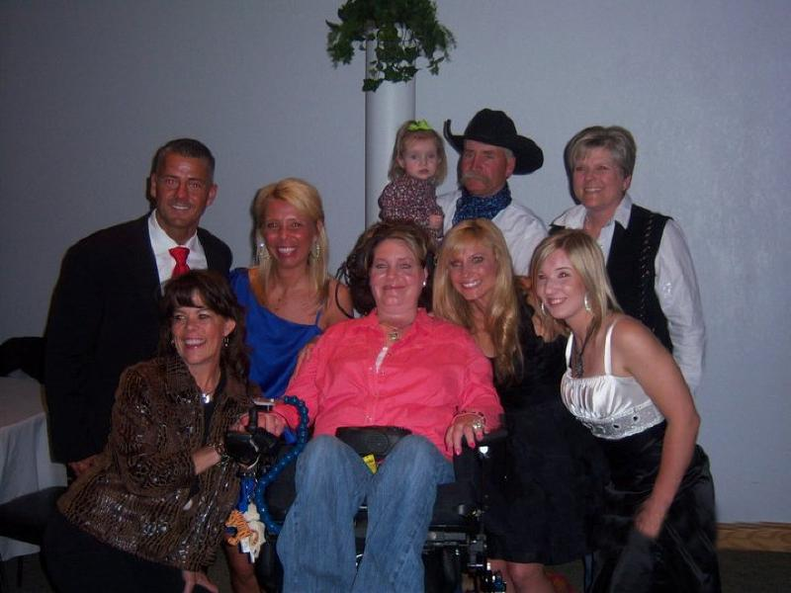
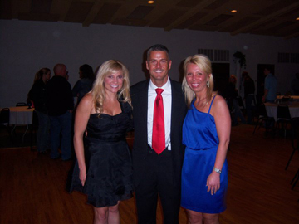

A Warm Welcome
to our newest Warriors!
Joshua Nelson Kevin Arens

Jerry Palmer Bryan Reese

Nicholas John Abbey Reedus

Joseph Devorick John Rather

A little history of the
Blazeman Foundation for ALS
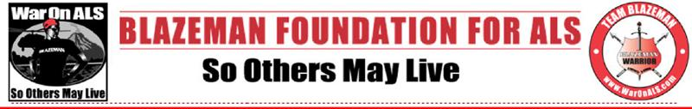
In Jon's own word's when he decided he needed
to form his own foundation..."so others may live"

GENESIS OF BLAZEMAN FOUNDATION:
Blazeman foundation gave rise out of efforts from Jon's own determination and perseverance, his family's commitment, a family of ALS Warriors, and response from a Multi-Sport Movement answering his call waging War on ALS. On May 2, 2005 another one of their own, twenty-year Multi-Sport veteran Jon Blais a.k.a. "Blazeman" who at age 33 was diagnosed with the fatal motor neuron disease ALS (Amyotrophic Lateral Sclerosis). Blazeman donned himself "ALS Warrior Poet" bringing his journey to finish Ironman on the big Island of Hawaii on October 15th that year. It was his last race. Blazeman, no longer able to compete, took his War on ALS around the globe and back to Ironman in 2006. In 2007, Blazeman Foundation Board of Directors began engaging this Multi-Sport Movement known as "Blazeman Warriors" who wage war in Blazeman's
War on ALS.

I did Ironman to put ALS on the map. - Blazeman

"So Others May Live"

"BLAZEMAN WARRIOR"
10 COMMITMENTS...
Teach People about PALS (People with ALS) | Tell Others About "Blazeman's War on ALS"
Join Forces with the "Multi-Sport Movement" | Contribute Efforts to the "Blazeman Foundation"
Recruit Others to Become a "Blazeman Warrior" | Volunteer with other "Blazeman Warriors"  at Events
Purchase "Blazeman Warrior" Gear & Apparel | Train & Race Wearing "Blazeman Warrior" Gear
Accept the "Janus Charity Challenge" for ALS | Race Like it's Your Last... with a "Log-Roll" Finish!


Mr. Ben Fertic, President of Ironman:
Challenges Triathletes to recruit five people
to compete in their first Triathlon
and to volunteer at a Triathlon this season!

Interested in joining the Multi-Sport Movement
in Blazeman's War on ALS?
Become a "Blazeman Warrior" today..."So Others May Live"

To Become a Blazeman Warrior click here! www.waronals.com

Photo Gallery
Thank you so much for sharing your highlights and favorite moments from the 2010 and 2011 season! But don't stop now! Please keep sending your photos!
We love hearing your stories and seeing you in action!
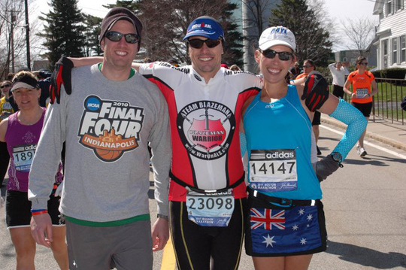
Glenn Hines at the Boston Marathon

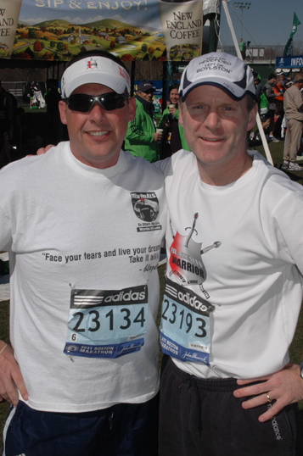
Joe Goddard and Jeff Galvin at Boston Marathon

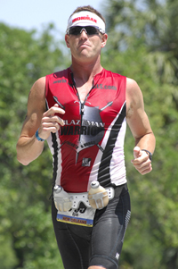
Ryan McCready at NOLA 2011

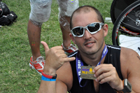
Saul Mishkin at Florida 70.3

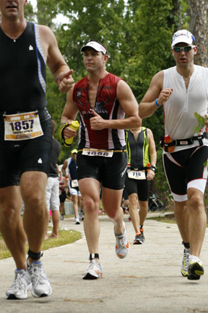
Yair Shalev at Florida Half Ironman 2011

