Happy New Year Blazeman Warriors, Friends and Supporters
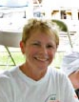
I hope everyone is enjoying the beginning of 2011! I had meant to get this newsletter out sooner but the knee replacement I had last month knocked me off my feet literally!
Bob and I want to thank you all for your support this year...for Jon's foundation it has been a good one, thanks mostly to all the great fundraising our warriors have done. This year also brought us a race director that named us as their charity of record...more about that later.
We met so many wonderful people at the events this year...so many tell us that Jon inspired them to do triathlon. He would be happy knowing that. This year also brought an Iron Blazeman CD, thanks to Mark Mason who poured his heart and soul into this project. Thank you again to all the athletes and musicians that made this possible.
Thank you also to Brooks and Chrissie Wellington for your support of Chrissie racing shoe. We look forward to Kona 2011 seeing Chrissie racing again. Congrats also to Chrissie being bestowed an MBE by the Queen of England. Her talents lie way beyond triathlon...we can only imagine what her next challenge will be.
We don't know what 2011 will bring for the Blazeman Foundation for ALS...but nothing would give us more happiness than to be a big step closer to find a treatment for this disease.
Bob and I will soon be planning the events to attend in 2011...as much as we would like to attend more we always feel we need to keep our expenses to a minimum so we can satisfy our research commitments.
Please email or call us with your questions and suggestions...any feedback would be appreciated!!!!
Happy New Year to you all and may 2011 bring you all health and happiness!
Mary Ann Blais
Jon's Mom
Blazeman Foundation for ALS
PS - I have exciting late-breaking news! I just found out there are eight slots still available at the Subaru EagleMan Ironman 70.3! Click here to register and race for the Blazeman Foundation. But you have to be quick!!

The Blazeman Warrior Bike Shirt!
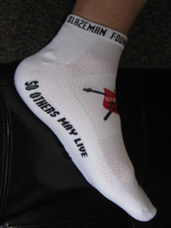
For those that have asked we have a new bike shirt with our new design. As you can see on our Blazeman Warrior Mark Searles it has a nice clean look with the Team Blazeman logo.
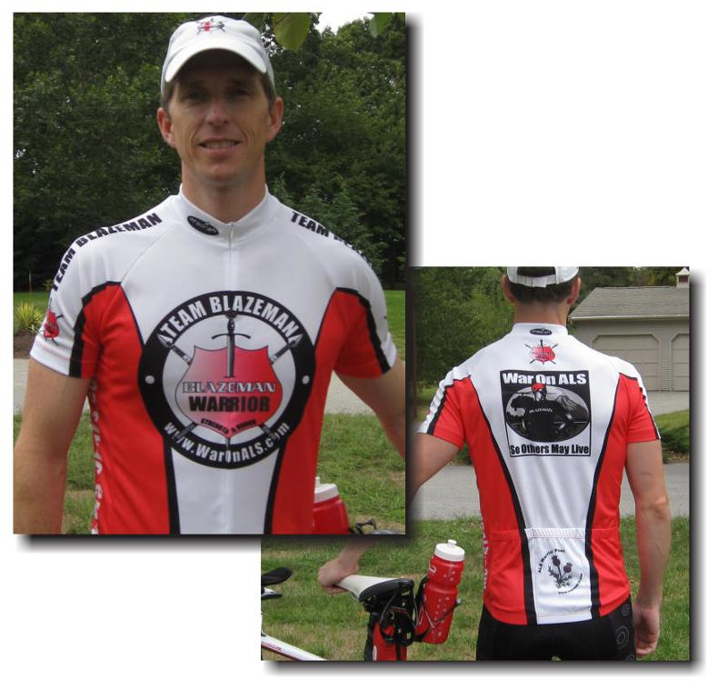
It is available on our estore with matching sock. Both are available now for the 2011 season. Keep checking our estore page on www.waronals.com.
These items have been designed and produced because you asked for them...we hope that you continue to help us raise awareness by wearing
our gear.

A Warm Welcome to our newest Warriors!
We are pleased to welcome the following newest warriors to our family. Thank you, and everyone else, for all you do to help our mission.
Jonathan Bottoms Tanya Brown
Dr. Jay Pitman Jason Lafave
Dan Kazup Kimberly Hager
Bob and I welcome all of you and wish you success in your races and fundraising and we hope to meet you all at one of our events.

Ironman Inspirational Moments...

Back in early December on Facebook, Ironman put this out on their page:

IRONMAN NBC will air the Ford IM World Championship next Sat. (12/18) + we'd love to hear what Ironman broadcast stories have most impacted you over the yrs. Have you been brought to tears? Does a certain story help you when training times get tough? Share your favorite story + one of you will help us narrow down the most popular...lar. The related charity will receive a $500 donation from IM. Can't wait to hear what inspires you!lar. The related charity will receive a $500 donation from IM. Can't wait to hear what inspires you! The related charity will receive a $500 donation from Ironman...
Well, Jon won and we are so thrilled to know he rates so highly among the readers. There are so many inspirational stories out there...Jon is in great company. Thank you to the Ironman team that put his story on film in the most touching way...we are grateful to have that footage to help us continue to spread ALS awareness and raise the most needed funds for research.
The Blazeman Foundation for ALS thanks all the readers who voted for Jon...putting his face on ALS.

We're making February
"War on ALS Month"

Annual Blazeman Foundation for ALS Cycle-a-thon
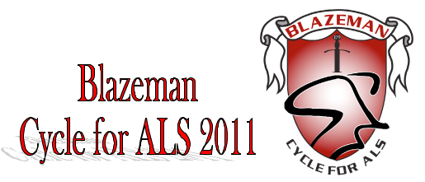
The foundation is gearing up for another great event in February under the direction of Donna Dourney.

Organize your own Cycle for ALS event or take part in one of the planned events in your area. We encourage folks all over the country to organize their own event, it's a simple process and can be accomplished with very little effort and lots of help from us. It can be scheduled any time in the month of February. All you need to do is find a place to spin and invite as many people as possible to participate. If you're lucky enough to live in a warm climate, an outdoor ride is also easy to organize. Indoor facilities such as YMCA's, health clubs, cycle shops, sporting goods stores or spin studios are great locations for visibility and the use of spin bikes. Enlist the help of spinning instructors to make it creative and motivating.

Use your imagination, be creative and make it different than a regular spin class and you'll have a line of people waiting to be a part of it.

We're here to help you organize a successful event and will provide each event organizer with the following:
· A Blazeman Foundation Fleece
· A Cycle for ALS Banner
· Information on the Blazeman Foundation for marketing
& sponsorship
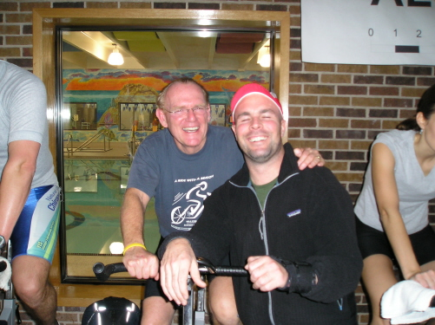
Jon attended the very first one in Chicago in 2006 and they have been a very big part of our fundraising effort. Please consider joining in this years nationwide event and help make it the most successful ever!!!!

Please contact Donna Dourney at dldourney@gmail.com if you would like further information or to organize an event in your area. Can't join us in person? Make a gift to support the event online by clicking here!

Remembering Phil Hutchins
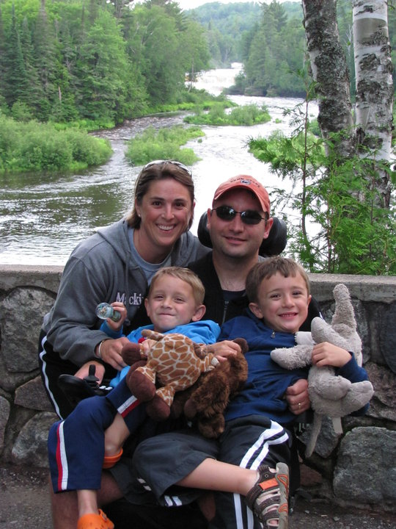
On December 14, 2010 we received word that Phil had lost his 16 month battle with ALS.
Phil leaves his wife Kerry and two young sons, Joshua and Mathew...he like Jon loved the sport of triathlon...he was 37 years old.
Life for ALS patients and their families is especially cruel...Phil had lost his dad to ALS and now we all worry for the future of his two young boys. Phil's passing confirms our passion for ending this horrific disease...please help us find a cure!
Kerry, Joshua and Mathew, our thoughts are with you and our commitment is renewed in this War on ALS...

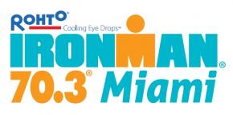
Thanks to the Miami 70.3!
This past October the Blazeman Foundation for ALS was the charity of record for the Miami 70.3 . This was a first for the Blazeman Foundation for ALS and we sincerely thank Wilber Anderson, Alan Kleber and John Marshall for their support and hospitality.
The money raised has allowed Jon's foundation to move forward and support a research project at Wake Forest University. I shall follow up in the next newsletter with some detailed information on this project.
Thanks again to the Miami 70.3 for this wonderful honor...Jon would be so pleased!

Photo Gallery
The 2010 season has come to an end but 2011 is just beginning! Please keep sending your photos! We love hearing your stories and seeing you in action!
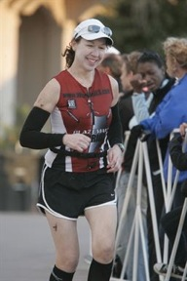
Blazeman Warrior Laurie Beland from IMAZ.
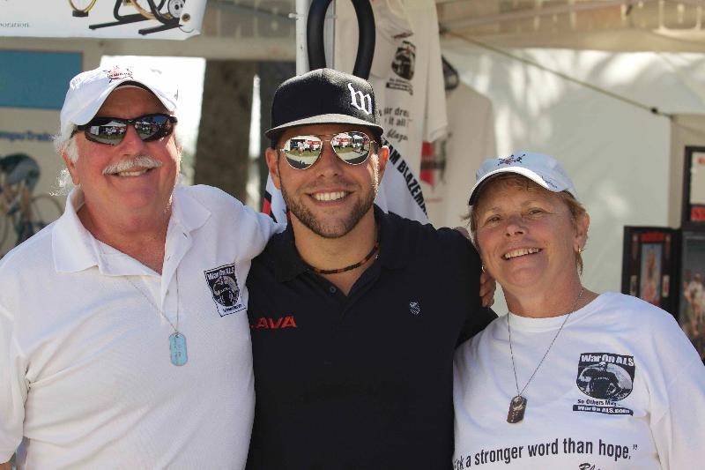
Brad Culp (Lava Magazine), Bob and I at Clearwater 2010
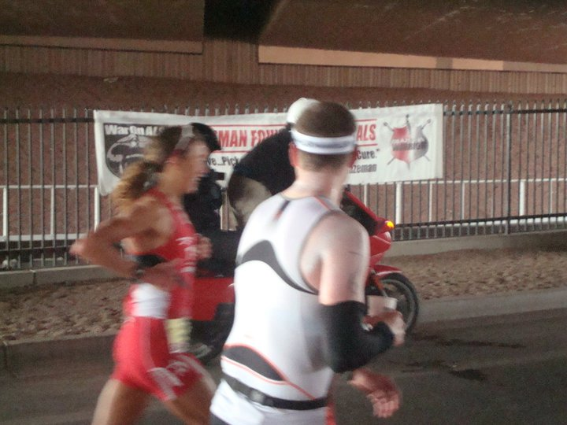
Chrissie Wellington running by our foundation banner at IMAZ 2010
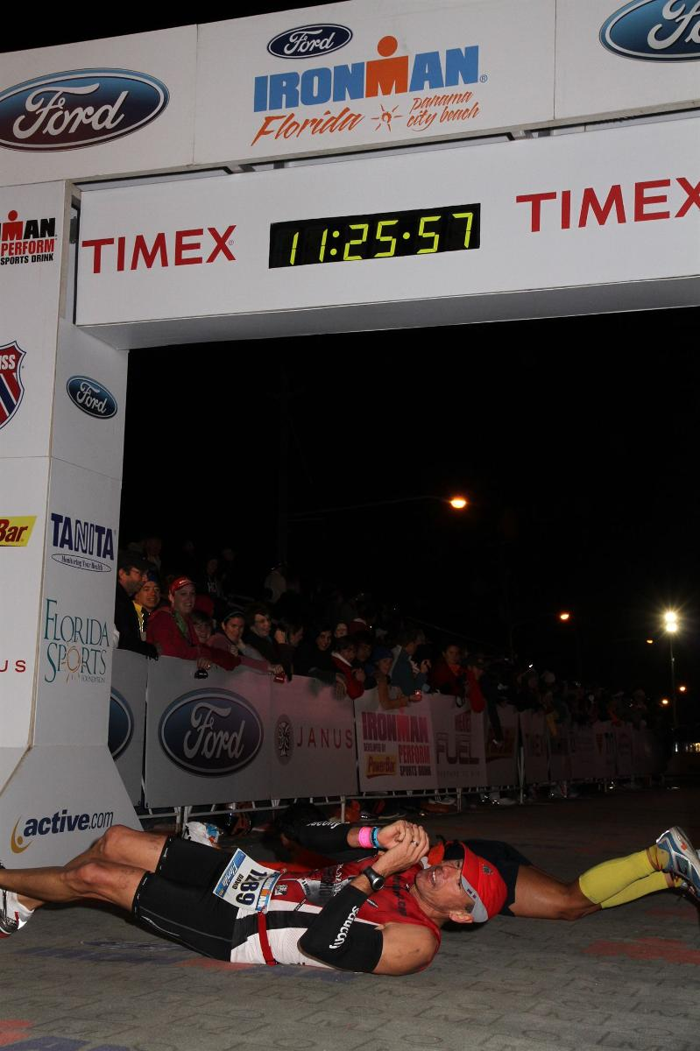
Dave Howard and Fausto Rodriques rolling in tandem at IM Florida
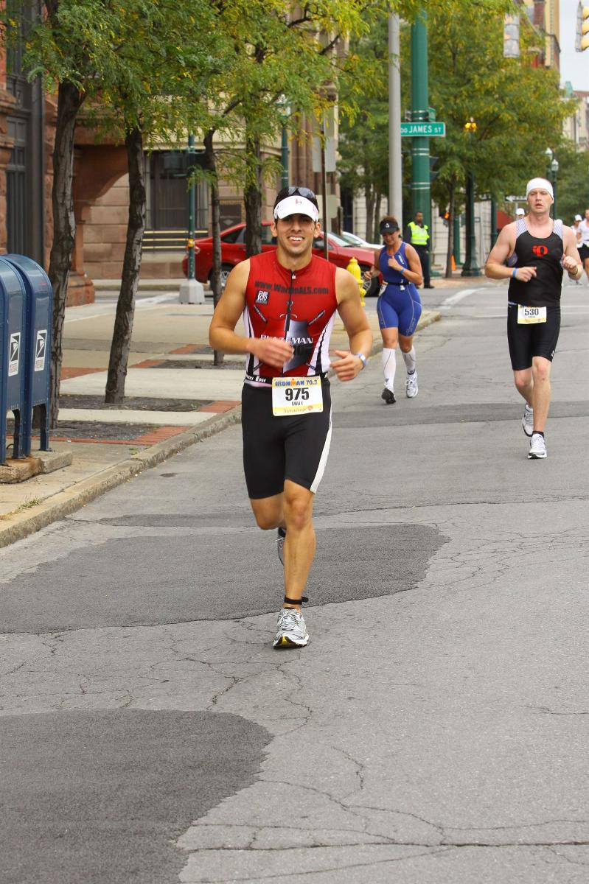
Matt Tibaldi running strong!
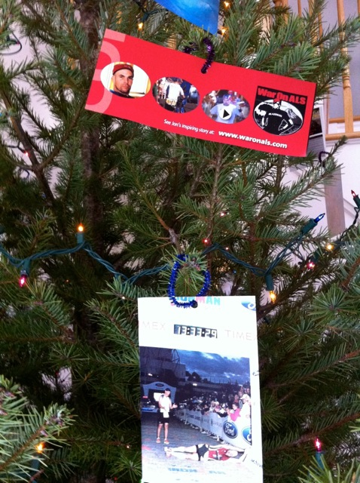
Sean McCarthy's Christmas Tree. Festive!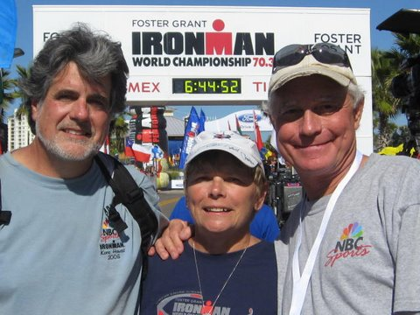
Terry and Robert of NBC Sports Film Crew. Great Friends of ours!

